Carpal bones
As a team you need to model the carpal bones of the wrist using the wax you have been given (warming it up between your hands makes it malleable). Use the template below to help you, along with the skeletal models. All the carpal bones you make should articulate together when you have completed the task.

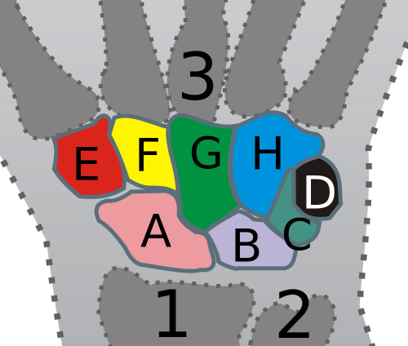
There are eight carpal bones in each wrist:

Proximal row:
A = Scaphoid
B = Lunate
C = Triquetrum
D = Pisiform

Distal row:
E = Trapezium
F = Trapezoid
G = Capitate
H = Hamate

- Radius (2) Ulna (3) Metacarpals

