Anatomy of a human synapse

Supervisor: Professor Tom Gillingwater (Edinburgh Medical School: Biomedical Sciences, University of Edinburgh)

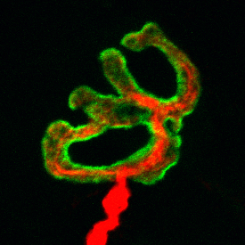

Confocal micrograph of a neuromuscular junction from a mouse interscutularis muscle, immunohistochemically labelled to reveal the motor neuron (red) and acetylcholine receptors on the skeletal muscle fibre (green).

The establishment and maintenance of network connectivity, through the formation of appropriate synaptic connections, is a fundamental determinant of function in the mammalian nervous system. Any attempt to understand the complex structure and function of the nervous system therefore requires a precise and detailed characterisation of synaptic connectivity, both in health and during disease. However, the vast majority of our current understanding of the form and function of synapses arises from studies of animal models (principally mice and rats), with surprisingly little currently known about human-specific aspects of synapses. This project aims to fill this important gap in our understanding by generating morphometric and molecular insights into an experimentally-accessible human synapse: the neuromuscular junction (NMJ).

Based on our preliminary data, it appears that the human NMJ is dramatically different to comparable synapses in other species, including mice. We therefore predict that our detailed analyses will reveal unique, human-specific cellular and molecular aspects of the NMJ that have not previously been fully appreciated. These insights will play a significant role in developing our understanding of what makes the human nervous system so unique amongst mammals, and will also be critical for the successful translation into human patients of therapies designed to protect NMJs (and other synaptic populations) that have been developed and tested in animal models.

