Dr Melissa Andrews’ Public Engagement and Outreach
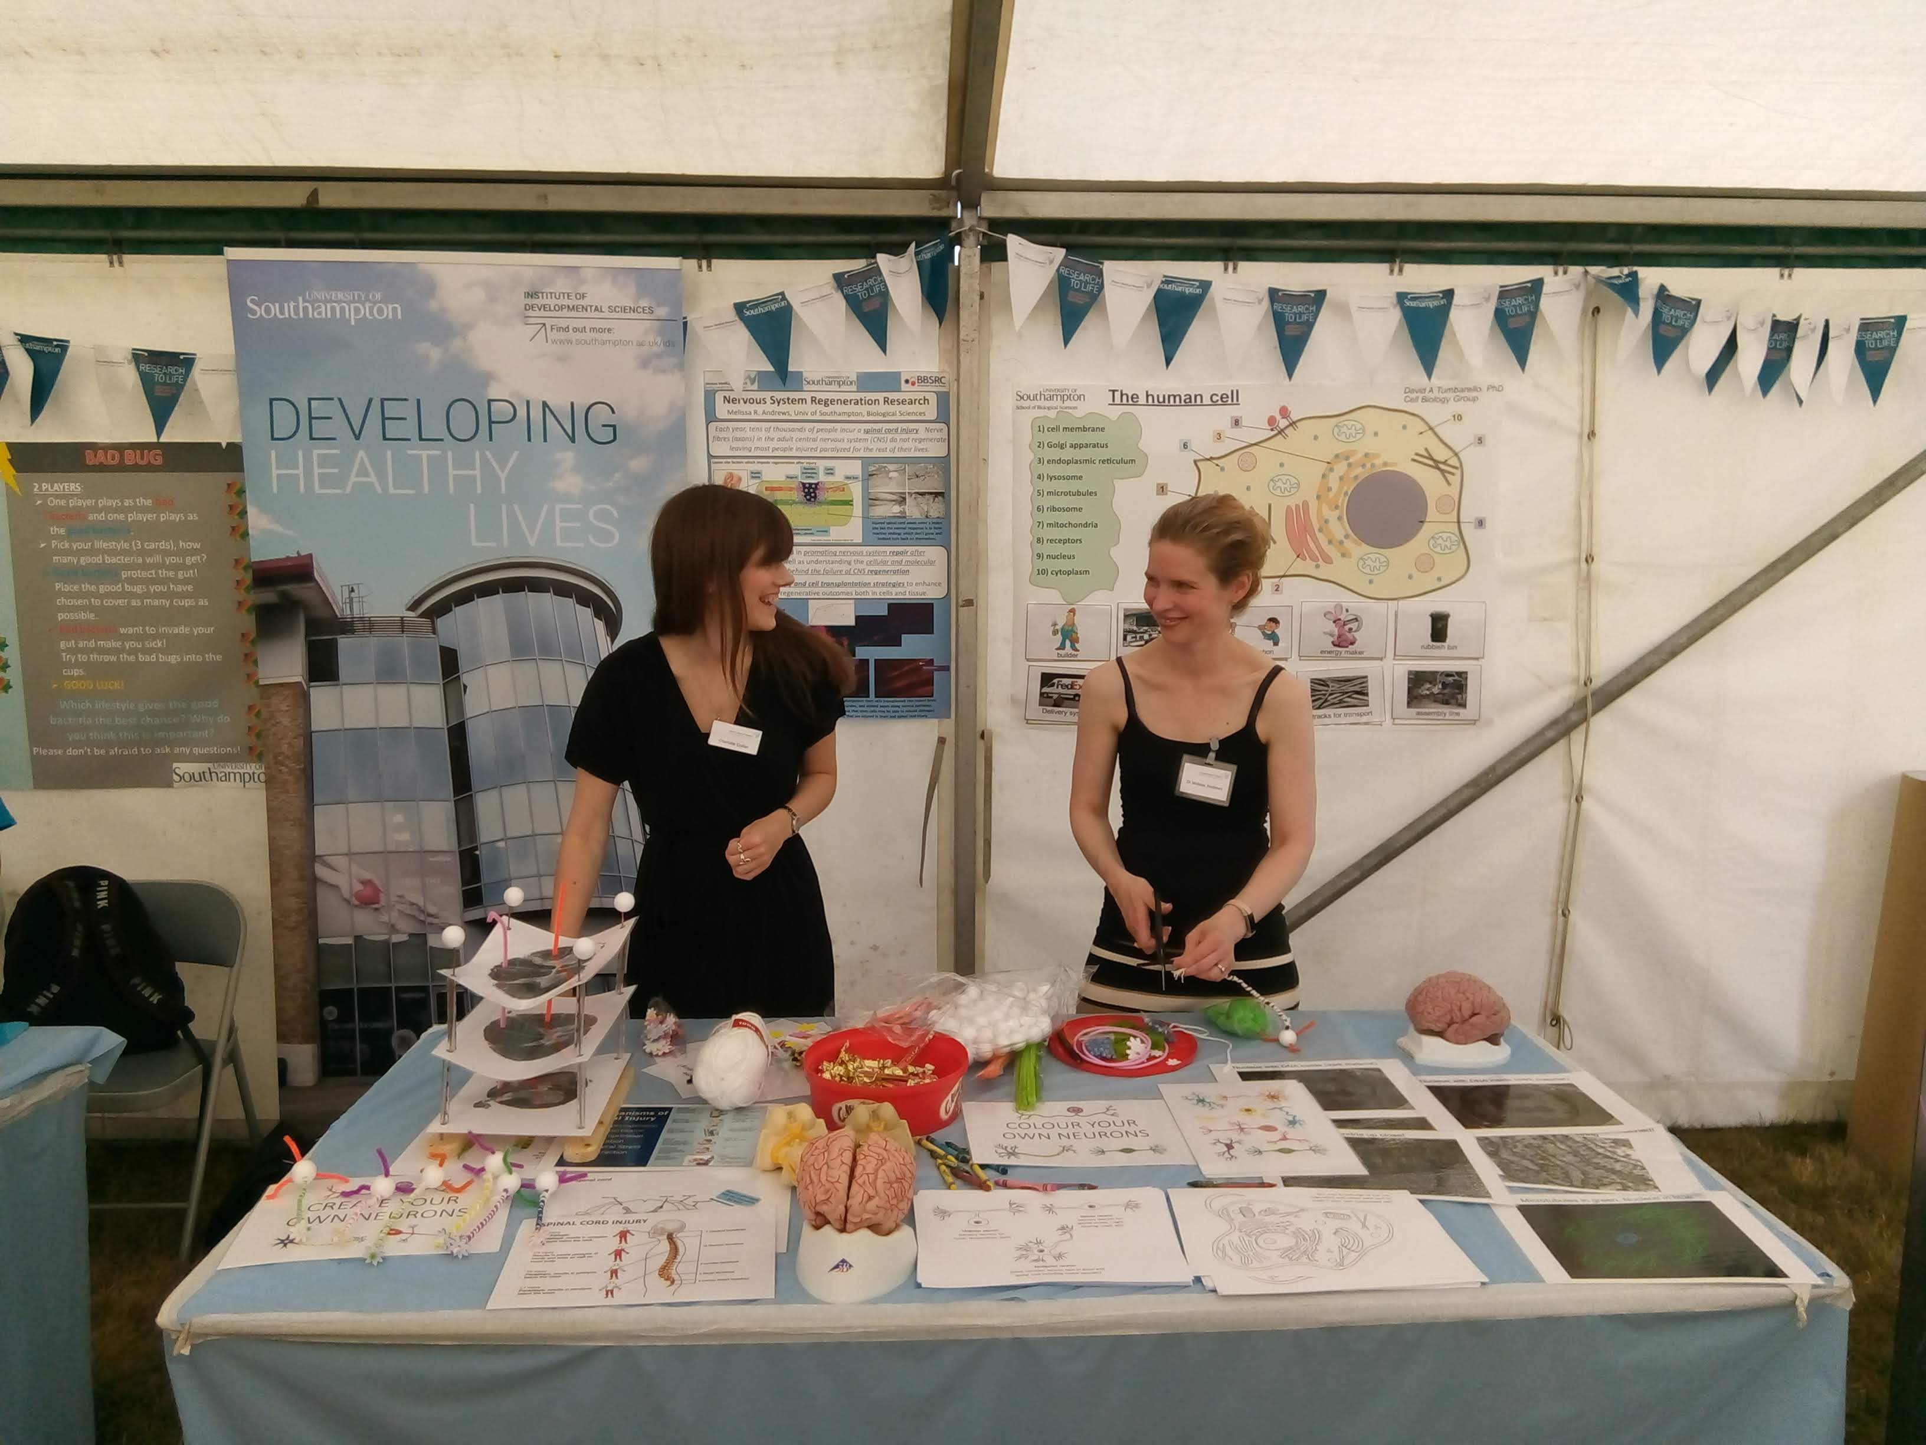
Picture from the morning of New Forest and Hampshire County Show Public Engagement and Outreach event (26 July 2018) making preparations for the neuroanatomy display. Pictured (left) Miss Charlotte Collier, PhD student at University of Southampton, and (right) Dr. Melissa Andrews, Lecturer in Systems Physiology at the University of Southampton.

File: Andrews Public Engagement- Photo word

