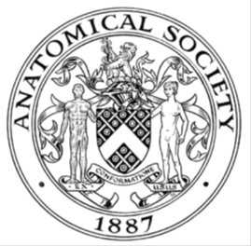
_______________________________________________________________________________________
AWARDEE REPORT FORM
_______________________________________________________________________________________

NAME |  | Matthew Shaw
TWITTER HANDLE* optional
UNIVERSITY |  | University of Birmingham
NAME OF AWARD |  | Symington Bequest Fund
PURPOSE OF AWARD conference/event attended/organised (full name) with city and dates.
Attendance and poster presenter at Early Career Anatomists Conference. University of Brighton and Sussex, 24th and 25th August 2023.

REPORT: What were your anticipated benefits?
This was an excellent chance to disseminate and discuss the initial results of a pilot project for my PhD. This will form the basis of not only my PhD but my first manuscript for publication.
COMMENTS: Describe your experience at the conference / lab visit / course / seminar/ event.
The conference was an excellent event over two days beginning with workshops on Day 1 about learning and teaching strategies in the classroom, incorporating Ultrasound into pre-clinical anatomy practicals, and an insight into the role of the anatomy technician and the process of embalming.

Day 2 saw a series of talks comprised of 3 sessions:
Session 1 – I found Prof. Claire Smith’s (University of Brighton & Sussex) talk on publishing and her role as a reviewer and editor one of the most interesting and useful talks of the day considering my current position in my career and on the cusp of submitting my first research article. An interesting mention goes to a student talk from Imperial College London regarding the use of pre-recorded Complete Anatomy tutorials, which I may incorporate into my own teaching.

Session 2 – Emily Green (University of Newcastle) discussed outreach for World Anatomy Day which is a special interest of mine as I am the Outreach Lead for the Human Anatomy Unit at Birmingham. We have since with the help of my colleagues put together a series of activities and events for students on World Anatomy Day this year using the guidance and resources provided by Emily and the University of Newcastle. My interesting mention for session 2 goes to Saira Akhtar (Veterinary School of London) and her approach to sustainability by using simple changes like carbon neutral disposable gloves.

Finally session 3 saw an interesting talk on the role of an Anatomical Pathology Technologist by Gemma Norburn. This was a fascinating insight into the technical roles required in mortuaries in the NHS and Gemma’s experience during the pandemic. The special mention for me was the point of view of Ross Munro that the role of Anatomy Demonstrator should be incorporated into a career progression framework including formal pedagogic learning during the job, which I would personally endorse.

This was a really well thought out event with a series of workshops and talks balanced perfectly for people in their early career to listen and to contribute.
REPORT: In relation to skills, what were the most important things you gained? (does not apply to equipment grant. For public engagement/outreach awards what did your audience gain and how did you evaluate success?
Knowledge of publishing ‘pitfalls’ from Prof. Claire Smith. In addition to instilling the importance of publishing to promotions, I learned the intricacies of what to put into an article submission.

REPORT: How do you think you will put this learning experience into practice in the future? For public engagement/outreach awards how with the materials/knowledge generated by this activity be used in the future?
Examples of teaching strategies in the workshops were some of the most immediately applicable moments. For example, we discussed how to teach the anatomy of the peritoneum and we devised a teaching plan including drawing the peritoneum first, then reviewing basic embryology and finally using the simple strategy of abdominal organs wrapped in cling film or using Complete Anatomy.

Another example of how I used this opportunity is that I learned the importance of creating a publishing timeline for my article submission which is something I put into place during my annual Personal Development Review.

Data Protection/GDPR: I consent to the data included in this submission being collected, processed and stored by the Anatomical Society. Answer YES or NO in the Box below
Yes
Graphical Images: If you include graphical images you must obtain consent from people appearing in any photos and confirm that you have consent. A consent statement from you must accompany each report if relevant. A short narrative should accompany the image. Answer N/A not applicable, YES or NO in the box below
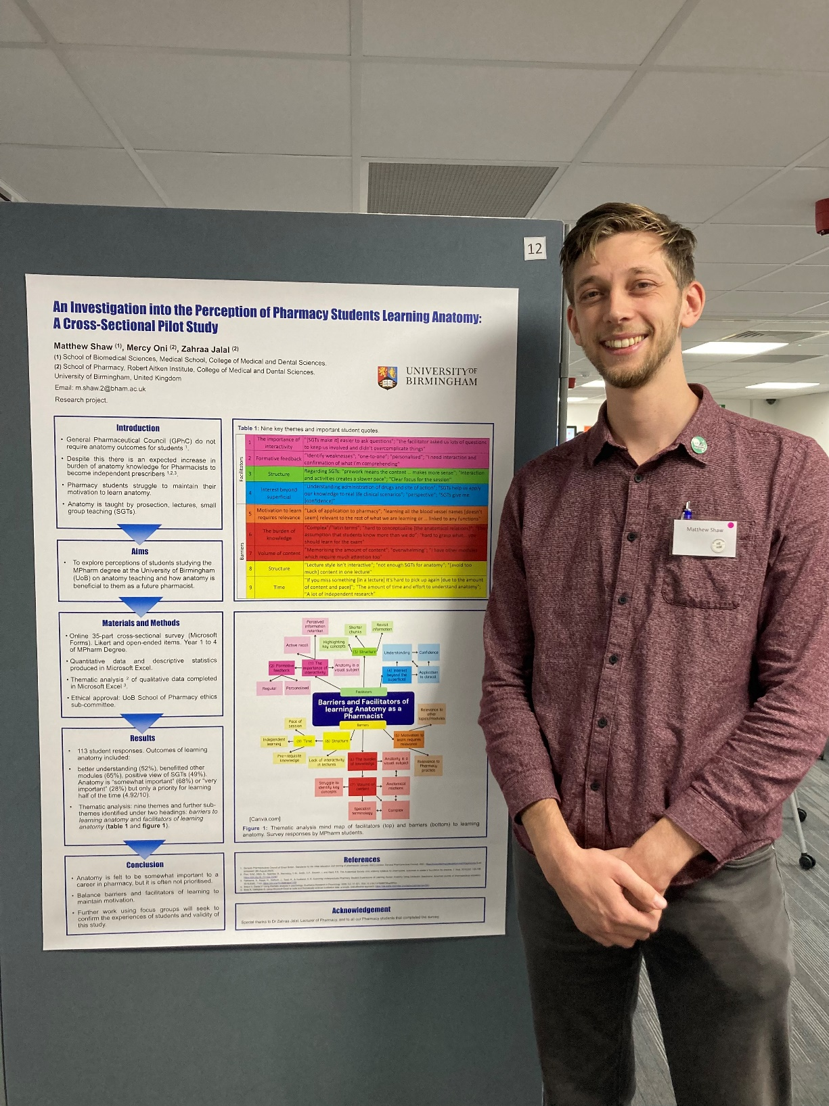
Matt appearing next to his poster titled “An investigation into the perception of Pharmacy students learning anatomy: a cross-sectional pilot study.” Presented on Friday 25th August 2023. Photo credit: Matthew Shaw
Consent obtained? YES
Copyright: If you submit images you must either own the copyright to the image or have gained the explicit permission of the copyright holder for the image to be submitted as part of the report for upload to the Society’s website, Newsletter, social media and so forth. A copyright statement must accompany each report if relevant. Answer N/A not applicable, YES or NO in the box below
Image copyright held? YES

SIGNATURE | MATTHEW SHAW |  | DATE | 29/09/2023
If submitted electronically, a type-written name is acceptable in place of a hand-written signature

File: AS-Award-Report-Form-220922 – International Conference

