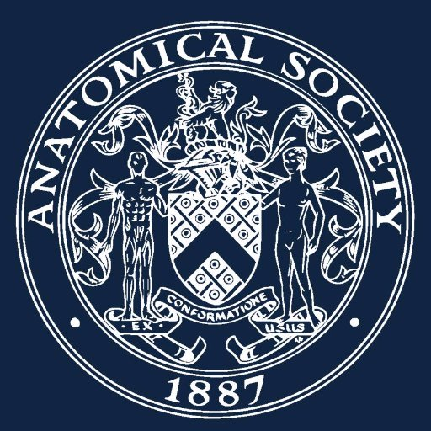

Application for Education Innovation Prize

Normally, an award will be made each year by the Anatomical Society to recognise and reward innovation and excellence in anatomy education. The award is intended to reward anatomy educators at any stage of their career who have developed and implemented an innovative, standalone project in the field of undergraduate or postgraduate education that has had sustainable impact on the students’ / trainees’ learning and experience.

As well as completing this application form, you should submit a single page CV and a single page letter of support from a senior faculty representative.

1. Applicant details
Title (Dr/Mr/Ms/Mx etc.)
First name
Last name/Family name
Email
Twitter Handle*
Optional
University/Employer
Current Position
If you are leading the application on behalf of a team, please provide the names, titles, and positions of individual team members.

2. Main Application: Details of your Innovation Project
Please give a detailed description of the innovation and why it is outstandingly innovative and excellent.
(A) Background and purpose of Innovation: Describe why the innovation was required. (250 words)

(B) Describe the innovation and why it is original/highly creative. How does it improve upon current approaches? (500 words)

(C) Evidence of the impact of the innovation on anatomy education. (500 words)

D) Sustainability of Excellence: Explain how you plan to sustain/ transfer/upscale this innovation for future wider reach and impact. (250 words)

3. Supporting statement
Supporting statement attached
Single page CV attached
4. Applicant declaration
I confirm that I have read, understood and agree to abide by the terms and conditions of the scheme and guarantee that any award made by the Anatomical Society will be used for the specific purposes for which it is granted. The award is made by the Education Committee of the Anatomical Society. All decisions are final and cannot be appealed.

I also confirm that all information provided in this form is complete and accurate to the best of my knowledge.
Signature |  | Date

Send completed form, together with supporting documentation, to:
Dr Hannah Shaw ShawHM1@cardiff.ac.uk using the subject line AS Innovation Prize 2022/23

File: AS Education Innovation Award Application Form -updated – v1- 030223_030223_TW SC HMS.docx

