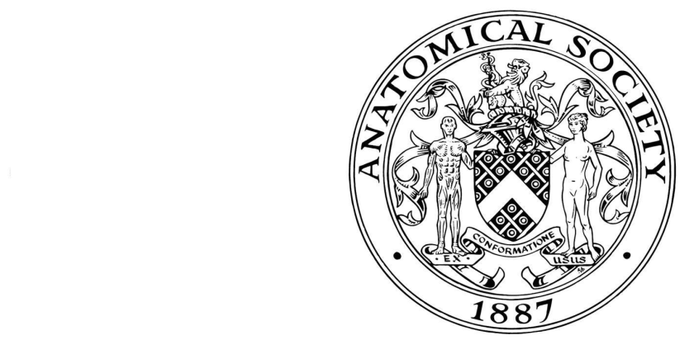
Application Form – Anatomical Society Anatomy Training Programme
2018-19
You should read ‘How to Apply’ and the ‘Brief Module Overview Documents’ on the website at http://www.anatsoc.org.uk/Education/AnatomyTrainingProgramme.aspx or under ‘Education’ and ‘Anatomy Training Programme’ before you apply. All sections of the form must be completed. Please return your completed application form BY E-MAIL to the Anatomical Training Programme Management Board c/o maryanne.piggott@kcl.ac.uk.
Deadline for receipt of the Application Form is 1 August 2018 if you intend to join the programme commencing 1 September 2018.
IMPORTANT:
Registration on the Programme or distribution of the module material will only be completed on receipt of the Training Programme fee OR with a note from your institution stating that they will pay the full fee (to be sent to the Honorary Treasurer of the Society – see below).

- ABOUT YOU

- APPLICANT’S DETAILS |  |  |  |  |  |  |  |  |  | Contact Address
Title: (Dr/Mr/Mrs/Miss/Ms, etc.)
First names in full
 |  |  |  |  |  |  |  |  |  | Postcode
Preferred first name
 |  |  |  |  |  |  |  |  |  | Telephone number (including code) |  |  |  |  | Ext
 |  |  |  |  |  |  |  |  |  | Day
Surname/family name |  |  |  |  |  |  |  |  |  | Eve
 |  |  |  |  |  |  |  |  |  | Email address
Your date of birth (example 23 March 1975)
Day |  | Month |  |  | Year
Country of residence
Nationality

- UNIVERSITY/COLLEGE EDUCATION AND PROFESSIONAL QUALIFICATIONS

From month/year | To month/year | University/college attended | Full-time  Part-time | Subjects read | Qualifications | Dates and classes of awards

If any of your qualifications were obtained under a name different from the one given in Section 1, please enter the name here.

First name Surname

- PRIZES, SCHOLARSHIPS OR DISTINCTIONS

- EMPLOYMENT

From month/year |  | To month/year | Position held and place of work | Name and address or employer

- FACILITIES
Please state the teaching/ research facilities (e.g. library, electronic resources, laboratory, cadaveric material) you will be using and the name and address of the institution(s) where they are located. Indicate against each whether or not you already have access to these facilities (e.g. as an employee of the institution).

- DETAILS OF APPLICANT’S MENTOR
The applicant must have the agreement from a person willing to act as his/her mentor (normally a senior academic at applicant’s own institution) before applying for the course. Please ask your mentor to complete this section.
Title (Professor/Dr, etc.)
First name(s)

Surname

Institution name

Institution Address
Postcode

Telephone number (including code)
E-mail address
Signature
Date

- LINE MANAGER/HEAD OF DEPARTMENT APPROVAL
The applicant must have the agreement of his/her line manager or departmental head before applying for the course. Please ask your line manager/head of department to complete this section.

Title (Professor/Dr etc.)
First name(s)

Surname

Institution name

Institution Address
Postcode

Telephone number (including code)
E-mail address
Signature
Date

- FURTHER STUDY
Are you undertaking or have you already undertaken study for a Postgraduate Certificate in Higher Education of equivalent? Please provide details.

Institution | Title of Course | Commencement date of the programme of study | Award | Date of Award

- REFEREES
Name two people whom the Anatomical Society can consult in confidence about your application. One should normally be a tutor or other member of the academic staff of the university or college at which you studied and the other, your most recent employer. Please say if your referees know you by another name; for example, women using a married name should indicate whether their maiden name should be quoted when referees are approached.

1 Name |  | 2 Name
Address |  | Address
Telephone |  | Telephone
Email |  | Email
Position held |  | Position held

- PROGRAMME OPTIONS FOR APPLICANTS BEGINNING SESSION 1 SEPTEMBER 2018

- PLEASE INDICATE WHICH MODULES YOU WILL BE UNDERTAKING:
You may apply for a single module, two per year, the whole Programme, or any subset.

MODULE CODE | TOPIC | YEAR | CREDITS | FEE (£) | RESIDENTIAL SCHOOL (compulsory) | INTENDED MODULES (please tick applicable)
ATP1 | Limbs | 2018/19 | 20 | 250 | July 2019
ATP2 | Head and neck | 2018/19 | 20 | 250 | July 2019
ATP3 | Trunk | 2019/20 | 20 | 250 | July 2020
ATP4 | Neuroanatomy | 2019/20 | 20 | 250 | July 2020
ATP1 | Limbs | 2020/21 | 20 | 250 | July 2021
ATP2 | Head and Neck | 2020/21 | 20 | 250 | July 2021

The fee includes tuition costs and course material, but does not include travel expenses, accommodation or meals on the Residential Programmes. The Society reserves the right to amend the fees for future courses.
Successful completion of all modules will lead to the award of a Programme Certificate. Successful completion of a module will lead to the award of a Module Certificate.

- RESIDENTIAL SCHOOL

Please note that attendance at the relevant Residential School(s) is normally compulsory. To help our planning, please indicate whether you will require accommodation, and if you have any dietary requirements (or any other requirements we should know about).

Accommodation

Dietary requirements

- PAYMENT

Payment for the Anatomy Training Programme should be in pounds sterling (£) to the following account:
Bank name: Coutts & Co
Bank account: Anatomical Society
Bank account number: 00469750
(or IBAN: GB46 COUT 1800 0200 4697 50)
Sort code: 18-00-02
NB: Please quote ‘TrainProg_Surname_First name’ as your reference.

Anatomical Society members may apply for an annual bursary of up to £350 per module (up to a maximum of two years) towards the fees and cost of the Programme. The Bursary Application Form is available on the Society’s website: http://www.anatsoc.org.uk/Awards/GrantsandPrizes/AnatomyTrainingProgramme.aspx

- FURTHER INFORMATION

- FURTHER INFORMATION
This information is to help The Anatomical Society ensure that appropriate services are provided at the applicant’s host institution. It will not be used for the purposes of selection.

Have you any additional requirements that might affect your study? | No |  | Yes |  | Please tick one box

If so, please enclose a separate letter giving details.

I understand that the information I provide will be treated as confidential by the Anatomical Society and will be made available to Anatomical Society staff and to agents of the Anatomical Society as appropriate, solely for the purpose of providing me with appropriate facilities and for statutory purposes. I hereby consent for the information to be processed for this purpose.

The information you provide will be held on Anatomical Society databases. It will be used for relevant Society mailings and used to process your application and stored in accordance with the Data Protection Act 1988 and subsequent legislation.

I consent to the data included in this submission being collected processed and stored by the Anatomical Society | No |  | Yes |  | Please tick one box

The Anatomical Society reserves the right to withdraw any offer made on the basis of information that proves to be untrue or misleading.

All Programme material in whatever form/format is for the trainee’s sole use and is protected by the appropriate legislation and best practice. Material where used by a trainee must be fully referenced and acknowledged.

Please make sure that you have completed ALL SECTIONS of the application form and return the form to the e-mail address at the top of the form by 1 August 2018 to join the programme for 2018-2020. In order to be considered for the Programme, please E-MAIL the application form as detailed above.

Applicant’s Signature |  | Date

Equal Opportunity Form

In order to monitor its equal opportunity policy, the Anatomical Society routinely collects information about its applicants. Please complete this section about ethnic origin on the application form.
You are under no obligation to complete this section of the form, and if you choose not to, your chance of being offered a place will not be affected.

Ethnic origin code (Please circle the most appropriate code)
White | Black or Black British | Asian or Asian British | Mixed | Other
1 English | 6 Caribbean | 9 Indian | 14 White and Black Caribbean | 18 Other Ethnic background
2 Welsh | 7 African | 10 Pakistani | 15 White and Black African | 19 Information refused
3 Scottish | 8 Other Black background | 11 Bangladeshi | 16 White and Asian
4 Irish |  | 12 Chinese | 17 Other Mixed background
5 Other White background |  | 13 Other Asian background

Which of the following describes how you think of yourself? (Please tick one option):

Male

Female

In another way

File: ATP-Application Form-2018-20-v3FINAL– 290518

