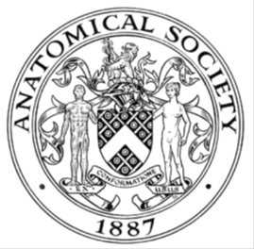
_______________________________________________________________________________________
AWARDEE REPORT FORM
_______________________________________________________________________________________

NAME |  | Eleanor Walder
UNIVERSITY |  | Cambridge University
NAME OF AWARD |  | Barclay-Smith Travel Grant
PURPOSE OF AWARD conference attended (full name) with city and dates
Anatomical Society Summer Meeting 2016 (Joint with BACA)
Brighton and Sussex Medical School, 19th-21st July

REPORT: What were your anticipated benefits?
I was looking forward to meeting fellow students interested in anatomy, whether medical students or PhD students, as well as the opportunity to network with academics. The opportunity to present my work, discuss it and receive feedback with like-minded people was also exciting. Finally, I was interested to discover more about concepts in anatomy and academia I had not previously studied or considered.
COMMENTS: Describe your experience at the conference / lab visit / course / seminar.
The 2016 Summer Meeting of the Anatomical Society was my first conference, and I had no idea what to expect. I was especially eager to meet other students, and to present my work to leaders in the field.
The first sessions encompassed different methods of teaching in anatomy. As a student, it was fascinating to discover the hard work and creative thought that goes into teaching, and the research behind this. A particular highlight of the first day for me was the workshop on the Anatomy of a Tweet, which was simultaneously great fun and informative. It is exciting to see academia keeping up with new social media trends, and even using it for academic purposes. After more talks in the afternoon, including an extremely interesting lecture on the history of the Journal of Anatomy, it was time for the student social, generously paid for by the Anatomical Society. Despite not knowing anybody upon arrival, everyone was friendly and I felt very welcome. Conversation ranged widely, occasionally skimming anatomical topics! Following a dinner of pizza, we moved to the beach to watch the sun go down over the pier – a very memorable night.

The next day was the BACA meeting, and as such had a more clinical perspective. As a medical student who has studied almost exclusively basic science so far but is about to enter Clinical School, this was an intriguing insight into what I might study in the coming years. The KeyNote speech by Mr Phil Thomas was compelling, describing the development of techniques for Gender Reassignment surgery and how this has affected outcomes. The Gala dinner followed, with a trip to the pier and a free go on the ride of your choice. Within the beautiful Art-Deco setting of the Palm Court restaurant, we once again had the opportunity to socialise with like-minded people.
The first set of talks, on brain changes as a result of learning, on the final morning covered more familiar topics for me, having studied Neuroscience and Psychology this past year. I was fascinated to learn more about changes in myelination as a result of learning, which complemented one of my modules on glia. It was also interesting to discover how anatomy is taught in countries with poor access to cadavers, and how this is changing. I was able to present my poster in the session on the final day, and had the opportunity to discuss my work with academics both in my field and in other fields. My poster An experimental test in vivo of the molecular basis of spinal nerve segmentation in the chick embryo was rather different to the other work presented, but visitors seemed interested despite the lack of relevance to the theme of the conference! The final set of talks described the use of digital media in anatomy teaching and learning, including discussion of various apps, and an incredible 3D modelling system using real human specimens. A closing talk announced the prizes, and I was shocked to discover I had won the Cave Prize for my poster. I really enjoyed the opportunity to present my work at the conference and this was the icing on the cake for me. (Picture of me with my signed anniversary copy of the Journal of Anatomy given as a prize)
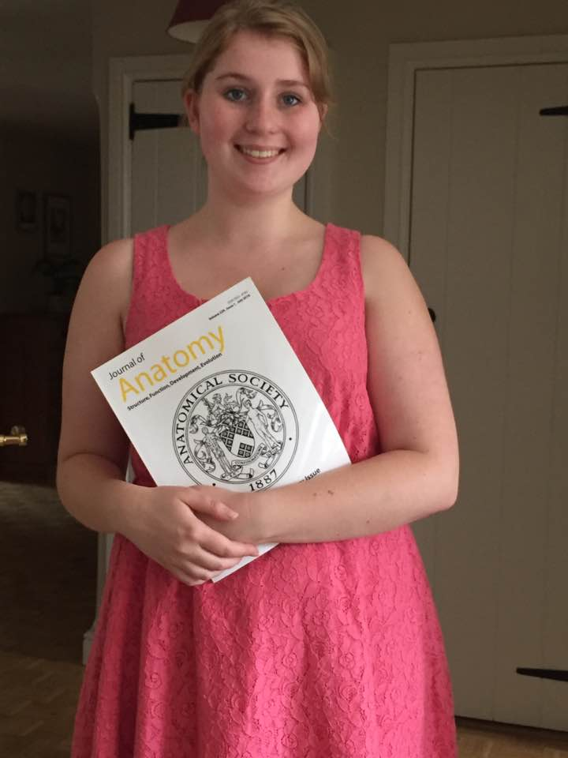
I had a wonderful time at the conference and learned a lot, and I can’t wait for the next one!
REPORT: In relation to skills, what were the most important things you gained? (does not apply to equipment grant)
I believe I improved my skills at discussing and defending my own work, as well as thinking critically about others’ work. From observing talks, I also learned how to present work clearly. My misconceptions about a conference were also challenged – it was very friendly and a lot of fun whilst still being scholarly.

REPORT: How do you think you will put this learning experience into practice in the future?
I will use these experiences to improve how clearly I put across my work, and to explain and discuss questions calmly and with clarity. I believe I could present my work as a talk now, having seen how to create a good presentation.

SIGNATURE | Eleanor Walder |  | DATE | 13/08/2016
If submitted electronically, a type-written name is acceptable in place of a hand-written signature

File: AS-Award-Report-Form-BLANKCO-SEAL-date110216

