

**­­­­­­­­­­­­­­­­**

**UNDERGRADUATE SUMMER VACATION SCHOLARSHIP AWARDS – FINAL SUMMARY REPORT FORM 2016/17**

*NB: This report will be posted on the Society’s website therefore authors should NOT include sensitive material or data that they do not want disclosed at this time.*

**Name of student:**

Isabelle Poulson

**Name of supervisor(s):**

Dr Thomas Butts

**Project Title: (no more than 220 characters)**

Developing tools for the manipulation of BMP signalling during late cerebellum development

**Project aims: (no more than 700 words)**

The aim of this project was to improve our understanding and knowledge of cerebellar development through the use of a new experimental approach - the Tol-2 targeting system¹. This system was used to manipulate BMP signalling through the design and construction of a DNA vector which would be incorporated into the genome of chick embryos. The system was found to be more successful as it allows the continued expression of the transgene in comparison to typical electroporation techniques which fail to express the transgene after several days. This is due to the failure to incorporate the transgene into the genome¹. Through creation of this construct, we hoped to be able to further study the development of an important component of the cerebellum, granule cell neurons.

The cerebellum is a highly foliated structure at the posterior of the brain, which has many functions especially in the coordination of the body and fine motor control2. The cerebellum is home to a large number of neurons, the most abundant of which are the granule neurons of the granule cell layer. These differentiate from granule cell progenitors which occupy the external granule layer during development. Once proliferation of these progenitors halts, the cells leave the cell cycle and differentiate into granule cell neurons of the internal granule layer. The development of these neurons in relation to the BMP signalling pathway, found to be involved in many embryonic developmental processes including those in cerebellar development³, was the main focus of this project.

To uncover the role of BMP signalling in granule cell neurogenesis, we aimed to design and build a construct using the Hifi Gibson Assembly protocol. The construct would be designed using online tools and built step by step in the laboratory using several lab techniques such as PCR, gel electrophoresis and spectrophotometry. To allow manipulation of the BMP signalling pathway, the DNA construct designed would express the inhibitory transcription factor SMAD-6. SMAD-6 is known to be a SMAD inhibitor due to its lack of the conserved domain MH1 (Mad homology 1), therefore resulting in the ability of Smad6 to disrupt BMP signalling⁴. We hoped by disrupting this BMP signalling pathway, a better understanding of the signalling pathway, especially in relation to granule cell neurogenesis, would be revealed.

As well as designing and building our DNA construct we also aimed to spend time throughout the project observing chick embryos under the microscope. This would allow us to find the most successful method for input of our construct, when built, into the chick embryo. To do this we would look at embryos at different embryological days to identify which day would allow us to most successfully integrate our construct into the hindbrain of the chick.

After completion of this summer project, the project will continue through electroporation of the SMAD-6 containing construct in upcoming weeks. This electroporation will use an electrical current passed between a positive and negative electrode to input our construct into the cerebellum of a chick embryo. This will validate whether BMP signalling causes the granule cell progenitors to leave the cell cycle and undergo neurogenesis. Improved understanding and knowledge gained through the completion of this project will allow a more thorough understanding of the cellular processes involved in granule cell neurogenesis and BMP signalling, as well as those involved in functioning of the brain as a whole. To better understand the brain will inevitably improve our ability to treat the brain when these cellular processes go awry.

¹ Sato, Y., Kasai, T., Nakagawa, S., Tanabe, K., Watanabe, T., Kawakami, K. and Takahashi, Y. (2007). Stable integration and conditional expression of electroporated transgenes in chicken embryos. Developmental Biology, [online] 305(2), pp.616-624.

²Koziol, L., Budding, D., Andreasen, N., D’Arrigo, S., Bulgheroni, S., Imamizu, H., Ito, M., Manto, M., Marvel, C., Parker, K., Pezzulo, G., Ramnani, N., Riva, D., Schmahmann, J., Vandervert, L. and Yamazaki, T. (2013). Consensus Paper: The Cerebellum's Role in Movement and Cognition. The Cerebellum, 13(1), pp.151-177.

³Tong, K., Ma, T. and Kwan, K. (2015). BMP/Smad signaling and embryonic cerebellum development: Stem cell specification and heterogeneity of anterior rhombic lip. Development, Growth & Differentiation, 57(2), pp.121-134.

⁴Nishimura, R. (2003). The role of SMADS in BMP signalling. Frontiers in Bioscience, 8(6), pp.s275-284.

Project Outcomes and Experience Gained by the Student (no more than 700 words)

This project allowed me to design and build a DNA construct in order to test our proposed idea that BMP signalling is involved in granule cell neurogenesis. We began the project by designing this construct using online tools and carried out the different steps of the construction over the 10 weeks. Future work on this construct will end in electroporation of the construct into chick embryos in order to observe the effects this interruption to BMP signalling will cause on development of the cerebellum.

To improve my understanding of embryology, I was given the chance to study the chick embryo using microscopic and imaging techniques. This allowed me to look at the embryo in more than one perspective and observing the chick embryos at different embryonic days aided my understanding of the different stages of embryology. This experience allowed me to apply my knowledge of embryology gained from my undergraduate degree and apply it in a practical scenario, improving my understanding beyond measure, with the chance to observe microscopic chick embryos a huge learning experience. This not only improved my understanding of embryology in relation to the chick but further improved my embryological understanding of human development. In addition to the value gained in respect to my understanding and education, regularly using the dissecting microscope to observe the embryo also greatly increased my interest for embryology and science as a whole.

Throughout the duration of my project my understanding of molecular biology has greatly improved, with a thorough understanding of basic molecular biology required throughout the project. The project allowed me to improve on the previous skills I have learned throughout my undergraduate degree thus far, as well as greatly improving my lab skill set, which will drastically benefit me in the final year of my degree, as well as in a possible scientific career in the future. The experimental techniques explored in this project have also given me a greater understanding of the wide range of approaches available in scientific research and online tools and software have shown the importance of bioinformatics in such research. Although I had previous experience with most of the techniques used in this project, such as PCR and gel electrophoresis, this project allowed me to become more confident when using them, allowing me to use them independently of the help of others.

Experience of the day to day workings of a research lab was also eye opening. With all previous knowledge of working in a lab gained from lab modules undertaken in my undergraduate degree, to have the chance to compare this experience to the workings of a real lab setting was extremely useful. This has meant that I am better informed to make a decision in the next path to choose in my career.

Overall the experience of completing a summer project within a university research lab has been hugely rewarding. The new skills I have developed throughout the project as well as the knowledge of the functioning of a research lab will no doubt aid me in my future endeavours.

Please state which Society Winter or Summer Meeting the student is intending to present his/her poster at:

**Winter 2017 Dundee meeting**

**Proposed Poster Submission Details (within 12 months of the completion of the project) for an AS Winter/ Summer Meeting – (no more than 300 words)**

The cerebellum is a highly foliated structure at the posterior of the brain, responsible for coordination and fine motor control. The cerebellum contains a large proportion of the total neurons in the brain with the most abundant of these neurons being the granule neurons. During development, these neurons leave the cell cycle and differentiate from granule cell progenitors in the external granule layer of the cerebellum into granule cell neurons found in the internal granule layer. While there is abundant suggestive evidence of a role for BMP signalling in this process, functional studies in vivo have proved difficult to achieve, owing to the late formation of the external granule layer during development.

In order overcome this, we aimed to manipulate the BMP signalling pathway using a novel inducible system that uses the Tol-2 transposase to incorporate inducible constructs into the chick genome. We designed and constructed a vector expressing a SMAD inhibitory transcription factor, SMAD6, known to disrupt BMP signalling.

Introduction of this construct into the developing embryonic chick cerebellum using *in ovo* electroporation will allow the effects of manipulation of the BMP signalling pathway to be observed and therefore the role of BMP signalling in granule cell neurogenesis to be explored.

**Brief Resume of your Project’s outcomes**: **(no more than 200-250 words)**.

*The title of your project and a brief 200-250 word description of the proposed/completed project. The description should include sufficient detail to be of general interest to a broad readership including scientists and non-specialists. Please also try to include 1-2 graphical images (minimum 75dpi). NB: Authors should NOT include sensitive material or data that they do not want disclosed at this time.*

Developing tools for the manipulation of BMP signalling during late cerebellum development

The aim of this project was to improve our understanding of cerebellar development through manipulation of the BMP signalling pathway in the cerebellum. In particular, we wanted to explore the role of BMP signalling in the proliferation and differentiation of granule cell neurons, the most abundant neurons of the cerebellum. Granule neurons differentiate during later stages of cerebellum development, and for this reason have traditionally been difficult to target genetically. In order to achieve this we aimed to use a drug-inducible Tol-2 transposase system in the chicken embryo as a novel experimental approach to target granule progenitors specifically in late development. We have designed and built a DNA construct in the lab that will be integrated into the genome and will, upon induction, manipulate BMP signalling.

In order to build this construct, we have placed the SMAD6 gene and GFP downstream of a drug-responsive bidirectional promoter. This transcription factor is known to inhibit the BMP signalling pathway (figure 1) and further work on this project will involve this construct being electroporated into chick embryos and induced at different stages of granule neuron development.

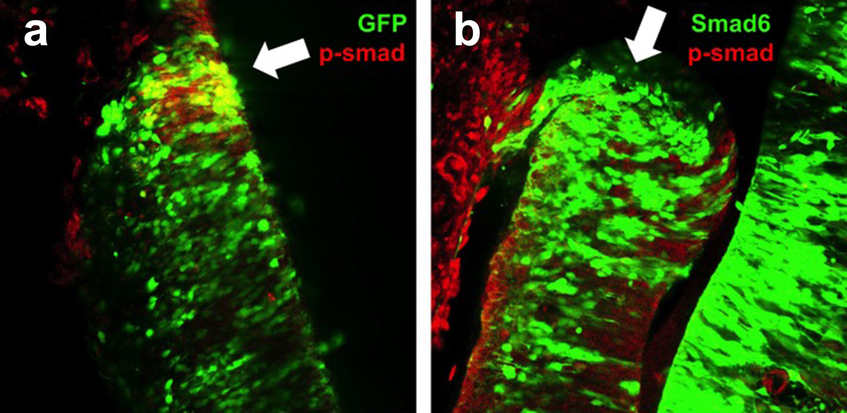Figure 1. Decreased BMP signalling (indicated by phospho-Smad immunostaining, red) in the cerebellar rhombic lip (white arrows) of chick embryos at embryonic day 5, following electroporation of inhibitory Smad transcription factor-Smad6 at embryonic day 3. a) Control electroporation of GFP. b) Electroporation of GFP + Smad6.

*Signature of student..........* *.......Date……17/10/2017……..*

*Signature of supervisor………………………………….............. Date……19/10/2017…….…*

END OF FORM

----------------------------------------------------------------------------------------------------------------------------------------

*File: USVRS-AwardandBursaryTemplateLetter 2017-v3FINAL 120517- Dr Thomas Butts*