Myoepithelial and immune cell dynamics in the mammary terminal duct lobular unit during postnatal development

Supervisor: Dr Kate Hughes
Co-Supervisor: Prof Clare Bryant
Institution: University of Cambridge

Within the bilayered structure of the mammary gland, myoepithelial cells form the basal epithelial layer, express alpha-smooth muscle actin, and have contractile properties necessary for milk expulsion. Myoepithelial cells are recognised to be of significance in the progression of both mammary neoplasms and mastitis. However, in spite of their critical role in milk expulsion, and the importance of myoepithelial cells in mammary pathological processes, very little is known about the contribution of this cellular compartment to the postnatal cycle of mammary development and remodelling associated with puberty, pregnancy, lactation, and post-lactational regression. This project will elucidate the role and cellular interactions of myoepithelial cells in the mammary microenvironment in health.

By defining the periods during which myoepithelial cells are dividing, the relationship of myoepithelial cells with immune cells, and the impact of hormones and growth factors on myoepithelial cell behaviour, the project will provide a deeper understanding of the role of the mammary basal epithelial compartment. This data will facilitate future identification of functions and interactions of myoepithelial cells that can be used in translational medicine to develop novel therapeutic strategies for mastitis and mammary neoplasia.

This research will also seek to define the mammary microenvironment in non-traditional model species that are promising alternative models to rodents. Whilst rodents provide highly tractable model systems, the mouse mammary gland is fundamentally different from the human breast. This project will exploit the similarities between the mammary gland of non-traditional model species and the human breast to delineate the replication patterns, cellular interactions, and role of myoepithelial cells in these species.
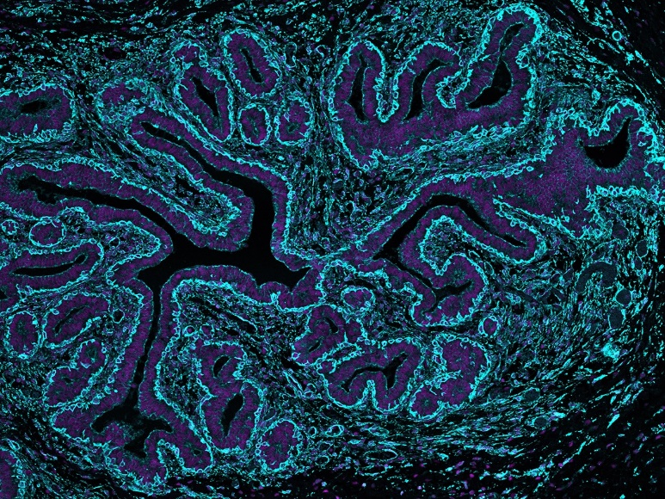

Immunofluorescence staining can be used to delineate the myoepithelial compartment. Neonatal lamb mammary gland. Alpha smooth muscle actin (cyan); nuclei (DAPI; magenta).

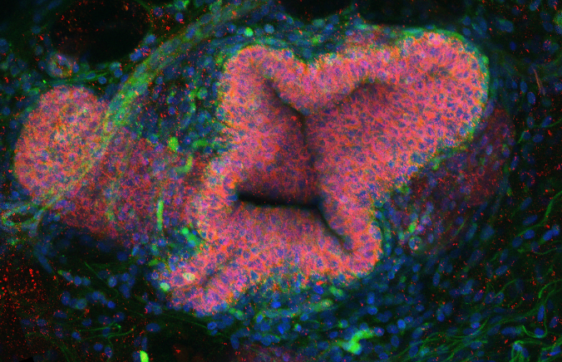

3D confocal microscopy of optically cleared ovine mammary tissue with immunofluorescence for a macrophage marker (green); E-cadherin (red) and nuclei (DAPI; blue). Image represents 3D maximum intensity projection.

