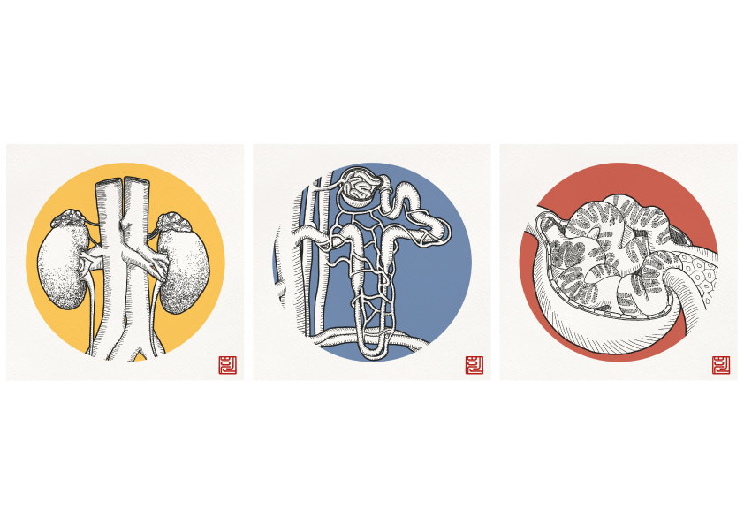
File: Joint Runner-Up Best Image Award – Daheen Lee – v1 - 170722

