

**­­­­­­­­­­­­­­­­**

**UNDERGRADUATE SUMMER VACATION SCHOLARSHIP AWARDS – FINAL SUMMARY REPORT FORM 2015/16**

*NB: This report will be posted on the Society’s website therefore authors should NOT include sensitive material or data that they do not want disclosed at this time.*

**Name of student:**

Elias Kassapis

**Name of supervisor(s):**

Dr. Daniel Wehner

**Project Title: (no more than 220 characters)**

Anatomy and molecular composition of the spinal lesion site in zebrafish

**Project aims: (no more than 700 words)**

The aim of the project was to investigate elements of macrophage-mediated tissue remodelling induced in the zebrafish spinal lesion site in response to spinal cord injury. This will help us uncover some of the factors that effectuate spontaneous CNS regeneration in these animals and aid the effort of understanding why this does not occur in mammals, including humans. Greater understanding of the matter may prove useful in future design of therapeutic treatments against traumatic CNS injury.

My hypothesis was that macrophages invading the lesion site promote axon regeneration by modulating ECM deposition in the spinal cord lesion site of zebrafish.

To test this hypothesis, I used in situ hybridization to investigate mRNA expression of 13 genes coding for ECM components in the presence and absence of macrophages, before and after spinal cord injury in zebrafish embryos.

Wild-type zebrafish embryos were used as controls and were compared with IRF8-/- zebrafish embryos, which do not develop any macrophages or microglia.

I used a larval spinal cord lesion paradigm recently established by the Becker group in which regeneration can be observed within 2 days and the spinal lesion site is substantially translucent, allowing the observation and analysis of its anatomy.

The 13 genes tested were previously identified by the Becker group in unpublished work to be specifically upregulated in the spinal lesion site of zebrafish in response to injury. These included 10 genes coding for Collagens, 2 genes coding for Fibronectins and a gene coding for Matrix Metallopeptidase 9 (MMP9).

**Project Outcomes and Experience Gained by the Student (no more than 700 words)**

**Project Outcomes**

Each gene was stained individually in different sets of IRF8-/- and wild-type embryos. After staining, embryos were observed and imaged under a stereomicroscope using a digital camera. Degree of staining was assessed by observation and allocated within three categories: strong staining, weak staining and no staining. Tables A and B shown below display my results:

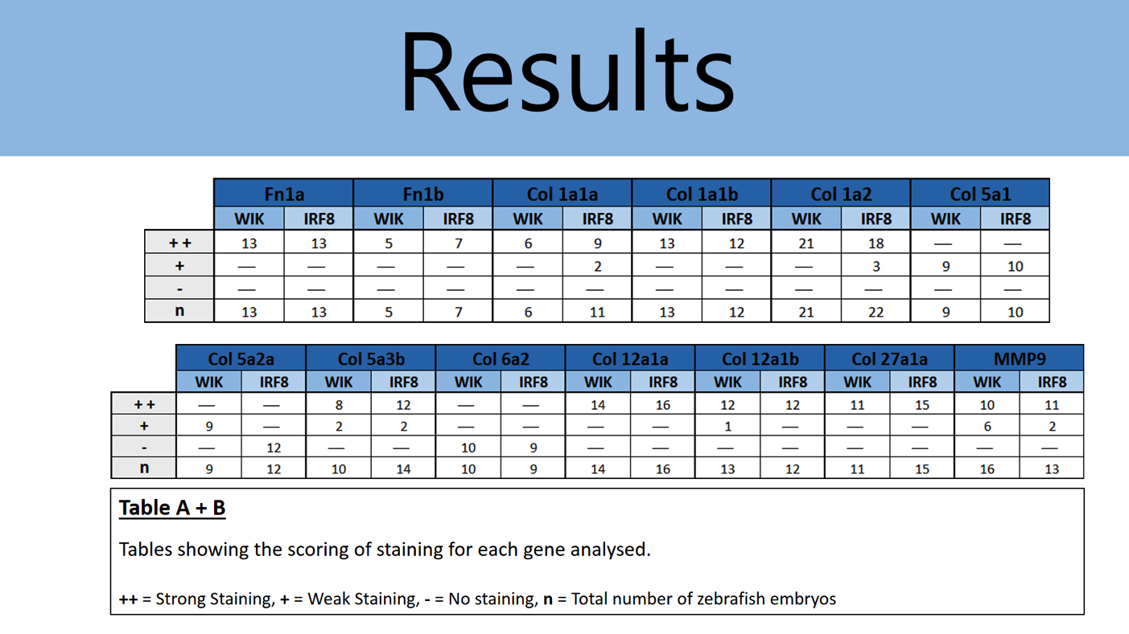

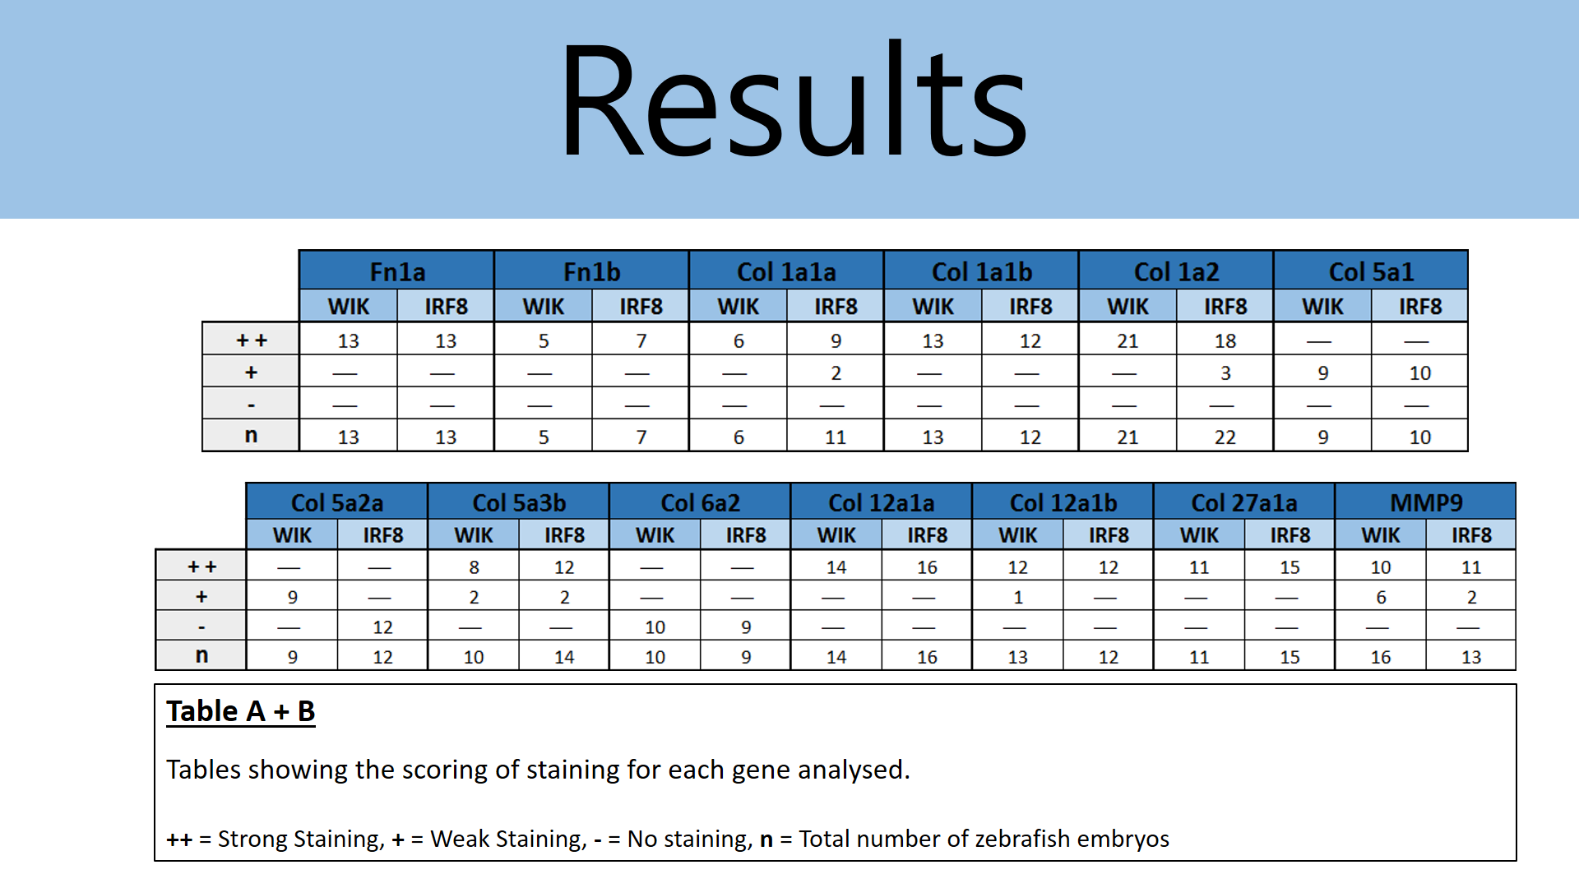

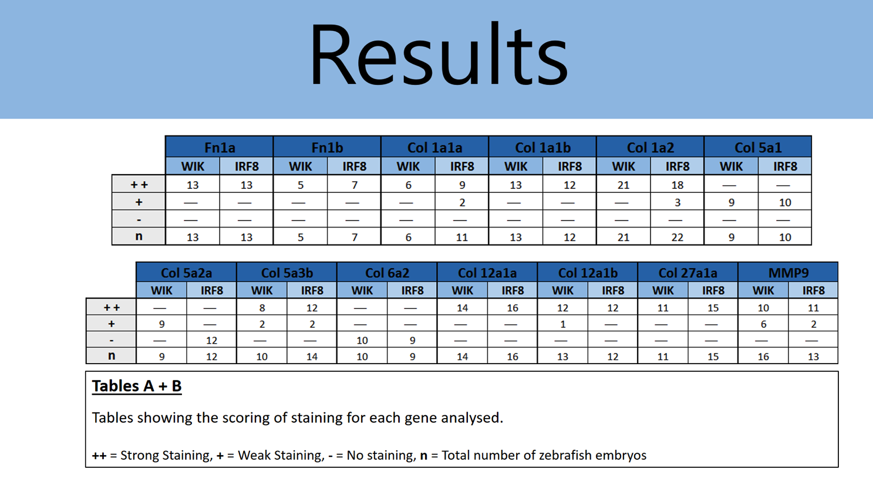

The only gene that showed considerable change in staining of the IRF8-/- embryos in comparison to control (wild-type) embryos was Col 5a2a. The mutant embryos showed minimal to no staining whereas wild-type embryos consistently showed light staining.

However, upon repetition of the experiment, similar staining was observed in both zebrafish lines, as shown in the table and figure below:

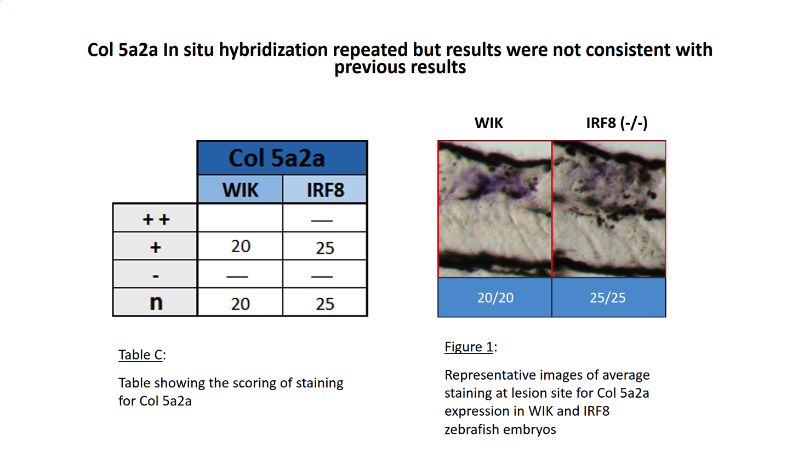

**Experience gained by student**

This project has provided me research training in the fields of neuroanatomy and neural regeneration. It has trained me in fish husbandry, histochemistry techniques (in situ hybridization and whole-mount immunohistochemistry) and microscopy (including confocal microscopy).

Furthermore, the project accustomed me with skills such as figure preparation, data interpretation and systematic record keeping as well as experimental design.

Please state which Society Winter or Summer Meeting the student is intending to present his/her poster at:

The Anatomical Society Summer 2017 Meeting

**Proposed Poster Submission Details (within 12 months of the completion of the project) for an AS Winter/ Summer Meeting – (no more than 300 words)**

Submitted by the end of January 2017

**Brief Resume of your Project’s outcomes**: **(no more than 200-250 words)**.

*The title of your project and a brief 200-250 word description of the proposed/completed project. The description should include sufficient detail to be of general interest to a broad readership including scientists and non-specialists. Please also try to include 1-2 graphical images (minimum 75dpi). NB: Authors should NOT include sensitive material or data that they do not want disclosed at this time.*

**Anatomy and molecular composition of the spinal lesion site in zebrafish**

The aim of this project was to investigate the expression levels of 13 genes coding for ECM components (previously found to be involved in spinal regeneration) in the presence and absence of macrophages.

These genes included genes coding for collagens, fibronectins and Matrix Metallopeptidase 9, which are suspected to be components of an axon growth-promoting substrate in the lesion site of zebrafish.

Results showed that the absence of macrophages did not appear to affect the upregulation of expression of these genes observed at the lesion site in response to spinal cord injury. However, this is at the transcriptional level, therefore does not rule out modulation of these genes by macrophages downstream of transcription. Furthermore, these experiments must be repeated to confirm the current findings

**Other comments: (no more than 300 words)**

The original project was slightly changed, because I encountered some technical difficulties during my placement, disrupting the experiments described originally. However, the project conducted was still focused on the anatomical characterisation of the spinal lesion site of zebrafish - instead of investigating the effect of collagen XIIa ablation on axonal regrowth during regeneration, I investigated the deposition of ECM components in the spinal lesion site in the absence of macrophages.

*Signature of student.......................................................Date…………..*

*Signature of supervisor………………………………….............. Date………….…*

END OF FORM

----------------------------------------------------------------------------------------------------------------------------------------

*File: USVRS-AwardandBursaryTemplateLetter 2016-v1FINAL-110516 – Professor Catherina Becker*