Midlothian Science Festival ‘Punching Anatomy’ – 8.10.2019

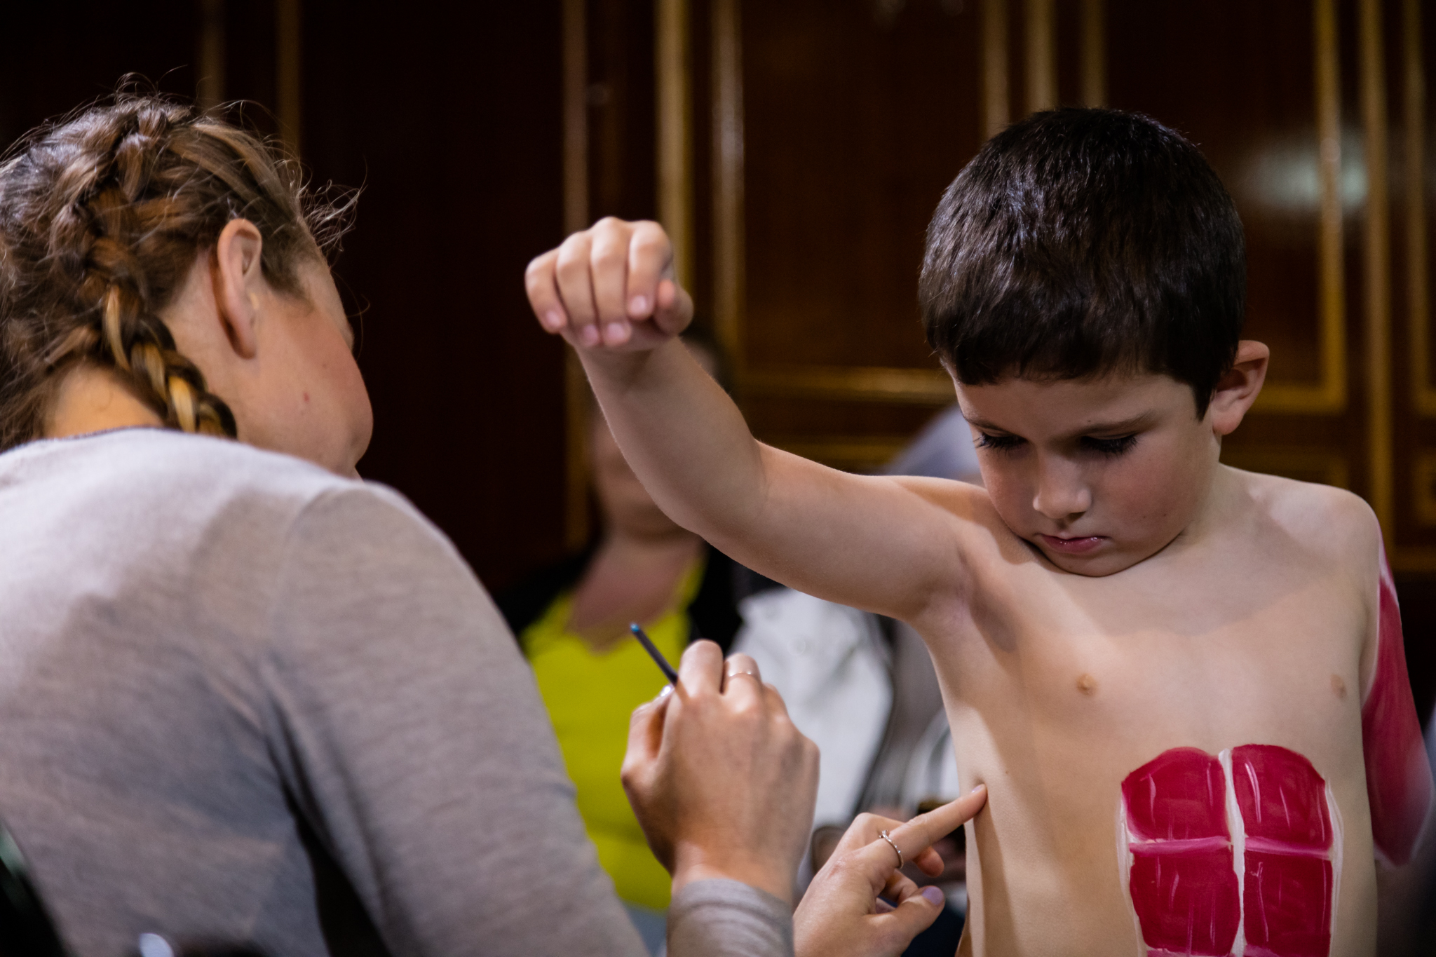
Pictured (left) Miss Ines Boehm, Anatomical Society funded PhD student at University of Edinburgh, pointing out serratus anterior, the boxer’s muscle, to (right) a young member of the Easthouses boxing club at the event ‘Punching Anatomy’ during the Midlothian Science Festival.

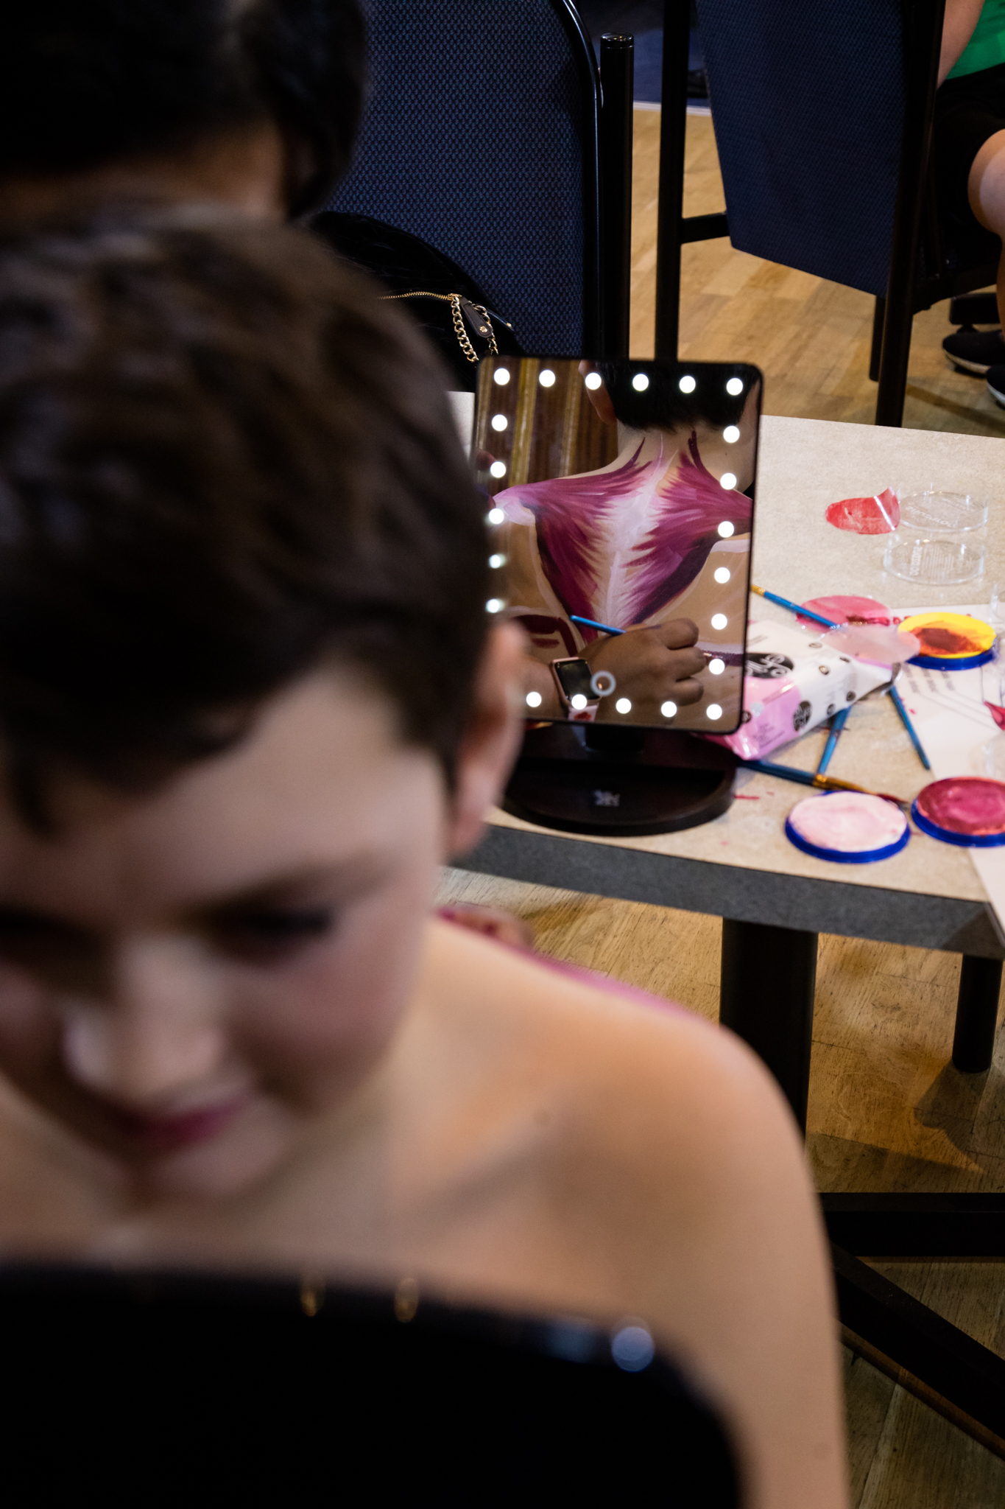
The trapezius is being painted onto a patient member of the Easthouses boxing club, visualising the muscles through reflexions in the mirror at the event ‘Punching Anatomy’ during the Midlothian Science Festival.

