_______________________________________________________________________________________
AWARDEE REPORT FORM
_______________________________________________________________________________________

NAME |  | Miriam Graute
UNIVERSITY |  | University of Edinburgh
NAME OF AWARD |  | Barclay-Smith Travelling Fund
PURPOSE OF AWARD conference attended (full name) with city and dates
Attendance at Anatomists on the Edge 2017, Galway, Ireland. 27th June to 29th June.
REPORT: What were your anticipated benefits?
The anticipated benefits were that I would be able to present a poster on the project I completed in the Paxton lab last summer. This project was funded by the Undergraduate Summer Vacation Research Scholarship of the Society. Further anticipated benefits were chances of networking, practicing my science communication skills and learning from talks given in a variety of fields within anatomy.
COMMENTS: Describe your experience at the conference.
I enjoyed the poster session and was positively surprised about the genuine interest in my work and poster. I particularly appreciated the academic comments and questions I received. I was very interested to talk to other conference delegates about their work. The food and music provided in the evenings were good, and interacting with the American contingent at the Gala dinner was good experience.
REPORT: In relation to skills, what were the most important things you gained?
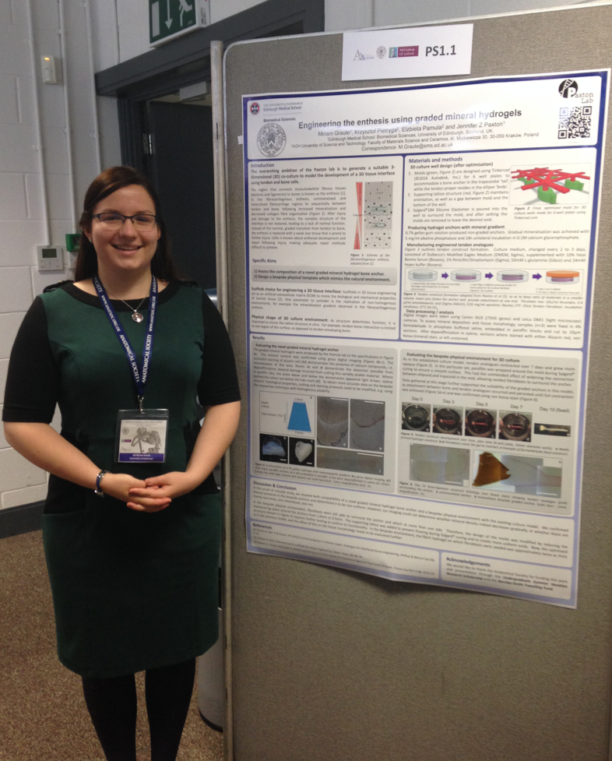
I improved my presentation skills while exhibiting my poster, in particular tailoring my explanations to each visitor. Other communication skills were improved during coffee break interaction with other delegates.

This was the first conference I have attended “in my own right” and on the basis of my work. I found this crucial in reorienting the way I present and introduce myself. More specifically, it marks a change from focusing on “my undergraduate studies” to “my work”, (i.e. the research I have completed).

(Figure 1: Miriam Graute with her poster)

REPORT: How do you think you will put this learning experience into practice in the future?
I have made specific practical notes on new insights I gained from talks, which I wish to try out in the lab, given the opportunity. The next time I prepare a poster, I will be better able to imagine its audience and thus improve my design.
SIGNATURE | Miriam Graute |  | DATE | 03 July 2017
If submitted electronically, a type-written name is acceptable in place of a hand-written signature

File: AS-Award-Report-Form-BLANKCO-SEAL-date110216

