Event Title: Neuroanatomy Workshop within the Neuroscience to Neurology Conference
Date: 18th February 2017 Institution: Edinburgh University Neurological Society
On the 18th February 2017, the Edinburgh University Neurological Society (EUNS) hosted their 5th Annual Neuroscience to Neurology Conference featuring an Anatomical Society Neuroanatomy Workshop. EUNS is a student-led society which aims to provide additional opportunities for students interested in the brain and nervous system. Our Conference is an excellent opportunity for students who have conducted undergraduate research to present their findings and network with science, medicine and psychology students. This multi-disciplinary event presented a perfect platform to engage students in an innovative neuroanatomy teaching session.
The afternoon programme of the Conference offered 27 students the opportunity to participate in an interactive neuroanatomy workshop funded by The Anatomical Society. The aim of the workshop was to review the basics of neuroanatomy using paints and modelling clay to design colourful diagrams and polystyrene models. The workshop started with a brief overview of the bony features and muscle attachments of the skull, arterial blood supply, regions of the brain and cranial nerves. An anatomical skull model with accompanying translucent brain was used to identify anatomical landmarks including skull bones and openings. Exemplar air-dry modelling clay diagrams and a large polystyrene skull model were shown to the students in addition to neuroanatomy textbooks. Each student was provided with a blank mini polystyrene skull model and an unlabelled brain diagram mounted on card. Participants then used the exemplars and textbooks to annotate their mini-skulls or diagram. The session fully engaged the students who created a diverse range of fantastic anatomically accurate models!
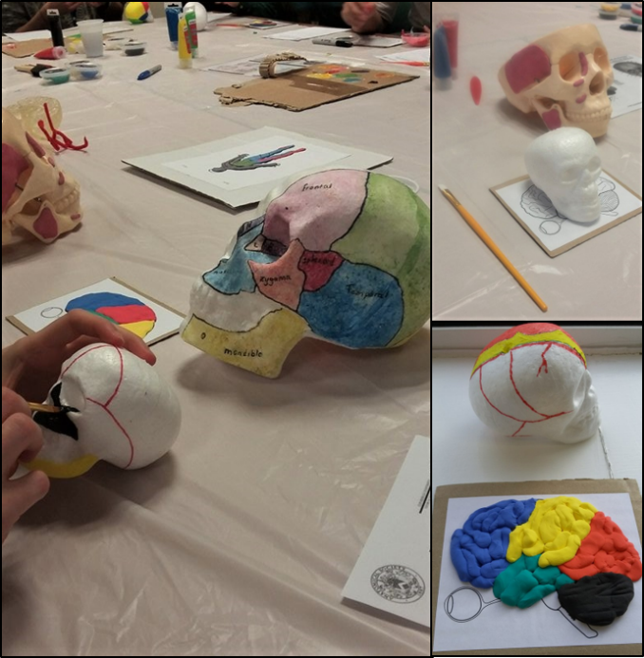
The workshop received very positive feedback from the participating students who appreciated the effectiveness and simplicity of this method for learning neuroanatomy. The attendees included students from various courses and they were encouraged to focus on familiar areas of neuroanatomy at the appropriate level of complexity. Two 45-minute workshops were run during the afternoon of the Conference. If we were to run any similar workshops in the future, we would like to extend the time available to cover more complicated aspects of neuroanatomy in greater depth. The workshop would not have been possible without the craft materials or educational skull and brain models funded by The Anatomical Society. In addition to future workshops, we aim to encompass these new models in the EUNS Neuroanatomy Revision courses for 2nd year medical students. The Anatomical Society also facilitated our own teaching opportunity and the valuable experience of coordinating these workshops. We are very grateful to The Anatomical Society for their support and we wish to thank all student participants for making this event such a success.
Photographs Taken 18th February 2017, EUNS
By Anna Bryans and Hui Yen Teh
Workshop Leaders, University of Edinburgh

