Is defective spinal cord and peripheral nerve vasculature a contributory factor to pathology in Spinal Muscular Atrophy?
Spinal Muscular Atrophy is a predominately childhood form of motor neurone disease. It is inherited and is generally fatal before 3 years of age. We have pioneered research indicating the importance of the vascular system in disease pathology. This project is identifying developmental alterations, which lead to structural and functional problems in a range of essential organ systems in the body. We hope to gain further insight into the mechanisms by which these pathologies arise, towards development of therapies for this currently incurable disease.

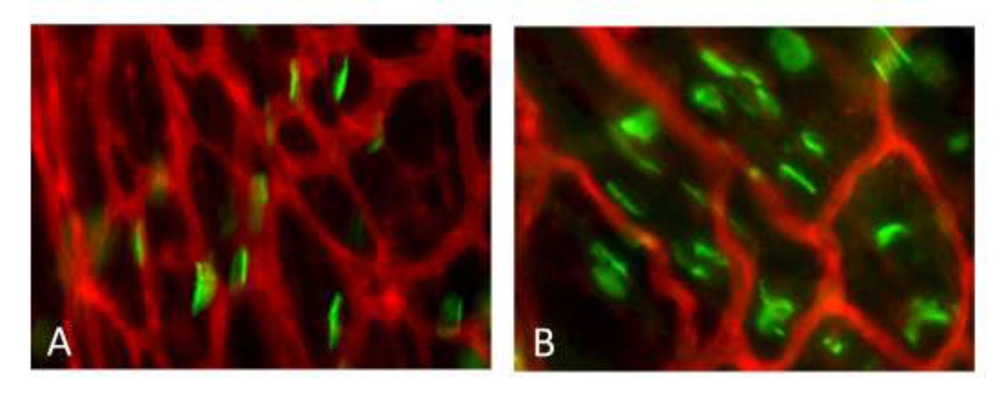

The image shows blood vessels stained red in skeletal muscle, with muscle endplates indicated in green. A, shows healthy muscle, while B shows severe SMA muscle. The dramatic capillary bed defect is immediately apparent.
Professor Simon H. Parson University of Aberdeen
Updated 18th August 2015

