UNDERGRADUATE SUMMER VACATION SCHOLARSHIP AWARDS – FINAL SUMMARY REPORT FORM 2018/19
NB: This whole report will be posted on the Society’s website therefore authors should NOT include sensitive material or data that they do not want disclosed at this time.

Name of student:
Ambreen Muhammed
Name of supervisor(s):
Dr. Charlotte Dean
Project Title: (no more than 220 characters)
Investigating the role of Dishevelled Associated Activator of Morphogenesis 2 (Daam2) in lung development
Project aims: (no more than 700 words)
Background
Dishevelled Associated Activator of Morphogenesis 2 (Daam2) is a gene which plays an essential role in the planar cell polarity pathway (PCP) which is heavily involved in lung embryogenesis and regeneration¹. Emphysema is a disease characterised by the breakdown and stretching of the alveoli in the lung that cannot repair itself². Provided that altered Daam2 expression has an effect on lung development in mice, Daam2 expression could be altered to promote lung development and repair in patients suffering from diseases such as emphysema.
Daam2 is a formin homology domain protein¹ which is involved in the polymerisation of actin and as seen in Figure 1, it acts as an effector molecule for Rho GTPase and an interaction factor of the Wnt receptor Dishevelled.
Figure 1 shows a simplified model of the planar cell polarity pathway
The planar polarity pathway is essential in regulating cell movement and changes in the cytoskeleton of cells; particularly in processes such as lung branching and development.

Aims and Hypotheses
- Investigate the difference in airways between wildtype, heterozygous and homozygous Daam2 mutant mice at embryonic days 14.5
As Daam2 homozygous mutants have 2 defective alleles of the Daam2 gene, they have a fault in the PCP pathway resulting in abnormal morphogenesis. Therefore, airways can be expected to be closed (immature) or under-developed (fewer branches) compared to those in the wildtype. The differences shown between wildtype and homozygous mice will also be compared to the difference between wildtype and heterozygous mice, where only one of the 2 alleles is deleted.
- Investigate the difference in airways between wildtype and homozygous Daam2 mutant mice at embryonic day 18.5
At E14.5 mice lung is in the pseudoglandular³ stage. During this stage, epithelial cells undergo branching morphogenesis³ and the PCP pathway is important for this process. By E18.5 days, the lung is in the saccular stage of development during which the primitive air sacs are forming. The capillary and the lymphatic network also undergo extensive development at this stage.
- Compare the spatial distribution in Daam2 mutants at E18.5 of:
  - Platelet cell adhesion molecule (PECAM)
Platelet cell adhesion molecule is a signalling molecule which is important in maintaining vascular permeability⁴ and adhesion between endothelial cells, it acts as a marker of the vascular network. We investigated whether Daam2 caused changes in the lung vascular network, which could affect lung embryogenesis.
  - Surfactant-protein C (SPC)
Surfactant-protein C is synthesised by alveolar type II cells as a precursor protein and is then modified to a mature secretory protein. This protein is important for maintaining the surfactant layer in the alveoli which is important in gas exchange⁵. SPC protein is used as a marker of alveolar type II epithelial cells. Emphysema is characterised by impaired function of type II epithelial cells, which secrete the surfactant⁵. The comparison of SPC expression in wildtype and Daam2 mutant mice may show differences in alveolar type II differentiation.
  - Smooth muscle actin (SMA)
Smooth muscle actin is present around the airways and is important in both lung development and repair⁶. Smooth muscle cells differentiate from the mesenchyme during development and therefore comparison of SMA distribution around the airways can indicate aberrant development in Daam2 mutant mice³.

Project Outcomes and Experience Gained by the Student (no more than 700 words)

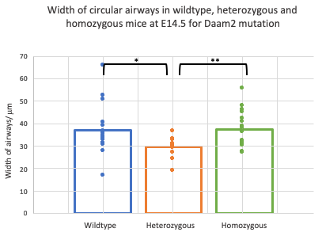
Figure 2 shows significant difference in width of airways between wildtype and heterozygote Daam2 mutants (p=0.048) and significant differences in heterozygous and homozygous Daam2 mutants (p=0.009)

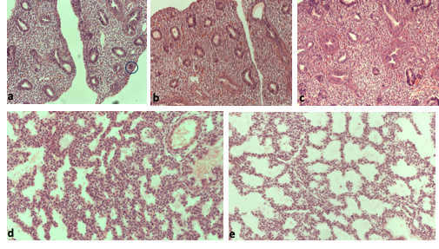
Figure 3 shows the images of mouse lung viewed under a microscope at embryonic days 14.5. a) shows the image of wildtype lung with a closed airway circled, b) shows heterozygous Daam2 lung section at E145.5, c) shows Daam2 homozygous mutant tissue at E14.5, d) shows wildtype lung section at E18.5 and e) shows Daam2 mutant sections at E18.5

The number of closed and open airways were counted in each field of view for the three different genotypes from which the average ratio of closed to open airways were calculated. We hypothesised that there would be fewer closed airways in wildtype indicting more mature tissue however as seen in figure 4, the wildtype mice showed a significantly larger proportion of closed airways to open airways compared to both the heterozygous and homozygous mutants. This could be due to the plane of the sections not being completely transverse resulting in many more airways appearing closed. The heterozygous tissue also showed the greatest spread of closed to open airways, examples of which can be seen in figure 3, image a.
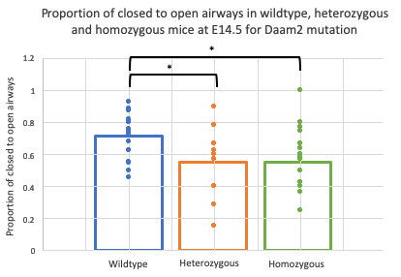
Figure 4 shows the wildtype lung sections having significantly more closed airways compare to open than both heterozygous (p=0.02) and homozygous (p=0.015) mutants at E14.5

E18.5 lung sections were then examined to compare the effect of the Daam2 mutation at a later stage of development. As is seen in figure 5 the airways are significantly wider in the Daam2 mutants compared to the wildtype and this difference is shown more clearly at E18.5 than E14.5 as the airways have developed further. This pattern is clearly shown in figure 3 as image e shows much wider airspaces compared to image d of the wildtype showing narrower airspaces.

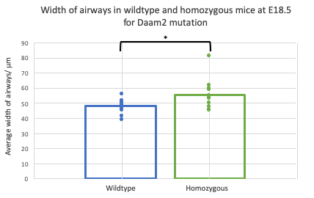
Figure 5 shows a significant difference between the width of airways in wildtype and Daam2 homozygous mutants at E18.5 (p=0.025)

Comparison of the airway width found that the Daam2 mutation effects lung morphogenesis leading to increased airspaces width. The distance from the edge of the lung to the closest airway was measured to determine the thickness of the mesenchyme in wildtype and mutant lung. This measurement can be used to indicate the extent of lung development; increased thickness indicates a more immature lung. Figure 6 shows a very clear significant difference, with the mutant lung showing thicker mesenchyme.
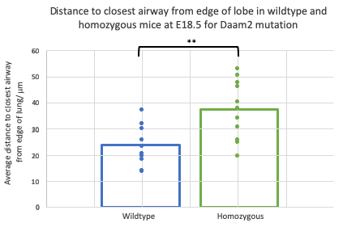
Figure 6 shows the most significance difference found with the homozygous Daam2 mutants having a significantly larger distance between the edge of the section and the closest airway (p=0.001).

Immunohistochemical staining was then carried out to compare the distribution of PECAM, SPC and SMA in wildtype and homozygous Daam2 mutants in E18.5 lungs. Image f from figure 7 illustrates the distribution of PECAM in the wildtype lung, however it does not show the expected staining pattern. We would expect PECAM to label the developing vascular network in embryonic lung which is faintly shown in the homozygous lung (image i) with the dark brown staining around the inside of the blood vessels. Artefacts can also be seen in image f and after staining 4 individual lung sections, we concluded that the PECAM antibody used did not label PECAM effectively in paraffin samples.

Image g shows SPC staining, which marks type II alveolar pneumocytes. The dark brown cells distributed throughout the tissue shows the presence of type II alveolar cells in both wildtype and Daam2 homozygous lungs, indicating that epithelial cell differentiation does occur in Daam2 mutants. SPC positive cells appear less prevalent in Daam2 homozygous cells (j) compared to wildtype, suggesting that the mutation may disrupt differentiation of the type II alveolar pneumocytes.

Image (h) shows SMA distribution in the wildtype embryo. Dark brown staining can be seen surrounding the airways and large blood vessels, labelling the ring of smooth muscle around both structures. Image (k) also illustrates SMA expression around the airways and developing blood vessels but in the Daam2 mutant lung, therefore SMA expression does not appear to be affected in the mutant lung tissue.
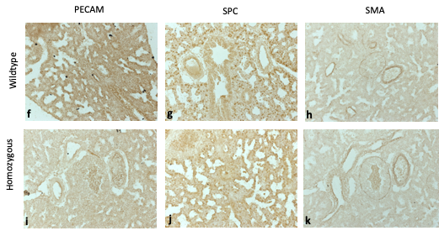
Figure 7 shows lung sections at E18.5 after immunohistochemical staining. The top row shows all the wildtype sections and the bottom, all the homozygous Daam2 mutants. Images f and I show no great difference in PECAM staining, g and j show clear differences in the number of cells stained with pro-SPC. The wildtype has more cells stained and a greater distribution. h and k show little difference in SMA staining.

Experience gained
Throughout this process I developed skills such as structuring a research project, forming a hypothesis and how to test this as well as producing figures and carrying out statistical tests. I also learnt new practical skills such as how to use different light microscopes and imaging software packages to compare embryo lung sections. Finally, I learned how to carry out immunohistochemical staining. Throughout this project I have gained greater insight into research and how to pursue this as a career.
References
- Richards T, Modarage K, Dean C, McCarthy-Boxer A, Hilton H, Esapa C et al. Atmin modulates Pkhd1 expression and may mediate Autosomal Recessive Polycystic Kidney Disease (ARPKD) through altered non-canonical Wnt/Planar Cell Polarity (PCP) signalling. Biochimica et Biophysica Acta (BBA) - Molecular Basis of Disease. 378-390.
- Li Y, Gu C, Xu W, Yan J, Xia Y, Ma Y et al. Therapeutic effects of amniotic fluid-derived mesenchymal stromal cells on lung injury in rats with emphysema. Respiratory Research. 2014.
- Yates L, Dean C. Planar polarity. Organogenesis. 2011. 209-216.
- Lertkiatmongkol P, Liao D, Mei H, Hu Y, Newman P. Endothelial functions of platelet/endothelial cell adhesion molecule-1 (CD31). Current Opinion in Hematology. 2016. 253-259.
- Mulugeta S, Beers M. Surfactant protein C: Its unique properties and emerging immunomodulatory role in the lung. Microbes and Infection. 2006. 2317-2323.
- Leslie K, Mitchell J, Woodcock-Mitchell J, Low R. Alpha smooth muscle actin expression in developing and adult human lung. Differentiation. 1990. 143-149.

Please state which Society Winter or Summer Meeting the student is intending to present his/her poster at:
Anatomical society winter meeting 2019

Proposed Poster Submission Details (within 12 months of the completion of the project) for an AS Winter/ Summer Meeting – (no more than 300 words)
The poster includes title, introduction to the Daam2 mutation and planar cell polarity pathway, followed by what the methods of the investigation were and the results found including figures to present data.

Brief Resume of your Project’s outcomes: (no more than 200-250 words).
The title of your project and a brief 200-250 word description of the proposed/completed project. The description should include sufficient detail to be of general interest to a broad readership including scientists and non-specialists. Please also try to include 1-2 graphical images (minimum 75dpi). NB: Authors should NOT include sensitive material or data that they do not want disclosed at this time.

Project title: Investigating the role of Dishevelled Associated Activator of Morphogenesis 2 (Daam2) in lung development
Project outcomes: Dishevelled Associated Activator of Morphogenesis 2 (Daam2) is a gene that plays an essential role in the planar cell polarity pathway (PCP), which is required for normal lung embryogenesis and repair. Emphysema is a disease characterised by the breakdown and stretching of the alveoli in the lung that cannot repair itself. Manipulation of genes that are critical for lung development may provide a way of inducing repair in lung diseases such as emphysema. We wished to understand the role of a key PCP pathways gene, Daam2, in lung development.
The aim of this study was to determine whether there were any differences in lung architecture of wildtype, heterozygous and homozygous Daam2 mutant mice at embryonic days 14.5 and 18.5. The localisation of platelet cell adhesion molecule, surfactant-protein C and smooth muscle actin were also investigated by immunohistochemistry to determine whether there was any effect on these key proteins in Daam2 mutant lungs.
Results showed no significant differences in airway size between wildtype and mutants at E14.5 however at E18.5, the airspaces are significantly wider in Daam2 homozygous lung, indicating that lung development is abnormal in Daam2 mutant mice. Immunohistochemical staining showed fewer SPC stained cells in Daam2 homozygous again indicating that lung development does not proceed normally in mutants. In contrast, SMA localisation was unchanged in the mutant lungs. Overall, this suggests that the Daam2 mutation leads to altered lung architecture, due to abnormalities in lung development.
Figure A shows the images of mouse lung viewed under a microscope at embryonic days 14.5. a) shows the image of wildtype lung with a closed airway circled, b) shows heterozygous Daam2 lung section at E145.5, c) shows Daam2 homozygous mutant tissue at E14.5, d) shows wildtype lung section at E18.5 and e) shows Daam2 mutant sections at E18.5

Figure B shows lung sections at E18.5 after immunohistochemical staining.

Other comments: (no more than 300 words)

Signature of student: Ambreen Muhammed....................Date…4.11.19………..

Signature of supervisor…Charlotte Dean............ Date…6.11.19.…

END OF FORM
----------------------------------------------------------------------------------------------------------------------------------------
File: USVRS-AwardandBursaryTemplateLetter 2019-v2 GDPR-220519 – Dr Charlotte Dean

File: USSVRS 201819 Report Dean – no sigs for upload

