**­­­­­­­­­­­­­­­­**

**UNDERGRADUATE SUMMER VACATION SCHOLARSHIP AWARDS – FINAL SUMMARY REPORT FORM 2015/16**

*NB: This report will be posted on the Society’s website therefore authors should NOT include sensitive material or data that they do not want disclosed at this time.*

**Name of student:**

Mr Akshay Kumar

**Name of supervisor(s):**

Dr Nobue Itasaki

**Project Title: (no more than 220 characters)**

Role of embryonic hypoxia on cranial skeleton formation

**Project aims: (no more than 700 words)**

During embryogenesis, neural crest cells (NCCs) arise from the neural tube by epithelial-mesenchymal transition (EMT) and differentiate into various cell types. In the cranial region, many NCCs contribute towards facial bones and cartilages, providing the skeletal basis for mandibular and neck structures. A deficit of cranial NCCs results in various congenital craniofacial hypoplasia. The overall aim is to search for any potential clinical approach that would prevent the shortage of NCCs during embryogenesis.

EMT is promoted in cancer by hypoxia, that is exerted by a transcription factor HIF-1α which allows a cell to adapt to a hypoxic environment. Embryos are naturally hypoxic and Dr Itasaki’s group has recently shown that induction of NCCs by EMT is up-regulated by over-expression of HIF-1α and attenuated by blocking HIF-1α. HIF-1α is constantly degraded in the presence of oxygen by prolyl hydroxylase (PHD). By utilising PHD inhibitors, we can produce hypoxic effects, without having to put the embryo in a hypoxic state; this is important as oxygen is crucial to embryogenesis.

I have shown during the academic year 2015-2016 that application of PHD inhibitors enhances the induction of cranial NCCs *in ovo*, when injected in a localised manner. However, it has yet to be clarified where this increased population contributes towards, whether NCCs are biased towards any specific cell fate, and if there is any negative impact on the development of other structures.

The aims of this project were to therefore determine whether cranial NCC fate is biased towards a particular cell lineage. If cell fate bias does occur, then to investigate if this bias is at the expense of normal development, for example if the brain is affected by PHD inhibitor application, as NCCs arise from the future CNS. As well as to investigate pharyngeal arch-derived cartilage structures in the craniofacial region following application of PHD inhibitors, since many of congenital NCC defects show small jaw and other skeletal phenotypes.

**Project Outcomes and Experience Gained by the Student (no more than 700 words)**

**Project Outcomes**

The effect of PHD inhibitors on the induction of NCCs *in ovo* was investigated via the use of RNA *in situ* hybridisation, using a *Sox10* probe labelling early-migrating NCCs. We showed that the induction of NCC was increased with the application of PHD inhibitors *in ovo*. The optimum concentration range for the PHD inhibitors was also obtained through analysis. With the funding provided by the anatomical society, I was able to investigate whether NCCs were biased towards a specific cell fate. It is known that increased levels of HIF-1α favour *Sox9* activation, a transcription factor which encourages cells to adopt a chondrocytic cell lineage. Therefore, following PHD application, day 3 and 4 embryos were harvested and RNA *in situ* hybridisation was performed whereby the embryos were labelled for *Sox9* expression. As expected the levels of *Sox9* expression was increased in all PHD inhibitor-treated embryos, in particular around the maxillary and peri-ocular region. This suggests an increased number of NCCs adopting a chondrocytic cell lineage. Following this, to show definitively that NCCs are biased towards a chondrocytic phenotype,

embryos treated with PHD inhibitors were harvested at day 7 and their cartilages were stained using Alcian blue. It was concluded that application of PHD inhibitors did not affect mandibular growth or palatal growth (as chicks exhibit a natural cleft palate). However, we found that the otic capsule, the progenitor of the bony labyrinth that encapsulates the membranous labyrinth of the inner ear, and considered to arise from 2nd pharyngeal arch, appeared to be increased in complexity. This increase complexity reflects the advanced development of the otic capsule in PHD inhibitor-treated embryos when compared to the control embryos. As cartilages are 3-dimensional structures, and whole-mount staining only allows for a surface analysis, we decided to further investigate this structure by utilising a μCT scanner. This allowed us to obtain sagittal, coronal and horizontal slices of the chick cranium and build structures in 3-dimension. We then reconstructed the complete inner ear in 3D, comprising of the otic capsule and the membranous labyrinth. Overall, the otic capsules in PHD inhibitor-treated embryos were distorted, where both the height and overall size was decreased. When the width was quantified all PHD inhibitors appeared to have reduced the size in comparison to the control, especially in DMOG-treated embryos which showed a significant difference. This altered structure of the otic capsule also affected the membranous labyrinth sitting within it, where the lumens of the semicircular canals of the vestibular system were noticeably narrowed. Furthermore, the height of the anterior loop of the vestibular system was reduced, again most significantly with DMOG. These results suggest that the increase of NCCs by PHD inhibitors is most prominent in the otic capsule.

**Experiences Gained**

I was able to have full control of my timetable, as a result I was able to make more decisions and maximise my time. I also had an incredible experience seeing how the μCT scanner works, and problem solving with this, as no one in the department has ever utilised the μCT scanner with embryos. As a result I gained experience in creating my own protocol for this. Following the μCT scan, I also learnt how to correctly orientate myself through the μCT slices, through identification of anatomical structures, and then analyse μCT slices of the embryo. I was then taught how to render structures in 3-dimension and learnt to appreciate the benefits of this. Finally I can now fully appreciate how valuable collaboration between different disciplines is, as we got in contact with the Life Sciences department in the University of Bristol, where Dr Tom Davies, an expert of μCT scanning and analysis, helped our studies.

Please state which Society Winter or Summer Meeting the student is intending to present his/her poster at:

Winter Meeting (December 2016)

**Proposed Poster Submission Details (within 12 months of the completion of the project) for an AS Winter/ Summer Meeting – (no more than 300 words)**

**Title:**

**Role of embryonic hypoxia and effect of prolyl-hydroxylase inhibitors in development of craniofacial structures.**

**Poster Abstract**

During embryogenesis, neural crest cells (NCCs) arise from the neural tube by epithelial-mesenchymal transition (EMT) and differentiate into various cell types. In the cranial region, many NCCs contribute towards facial bones and cartilages, providing the skeletal basis for mandibular and neck structures. A deficit of cranial NCCs results in congenital craniofacial hypoplasia such as Treacher Collins syndrome.

In adult tissue hypoxia, Hypoxia-Inducible Factor-1α (HIF1-α) permits cell adaption to a hypoxic environment by promoting angiogenesis and anaerobic glycolysis, thus aiding tissue recovery. In the normoxic conditions, on the other hand, HIF-1α is readily degraded by oxygen-dependant prolyl-hydroxylases (PHDs). Because of this, chemical compounds that stabilise HIF-1α, such as PHD inhibitors, are used for stroke therapies. Other functions of HIF-1α include promotion of EMT and metastasis in tumour and up-regulation of chondrogenesis, both of which are promoted in hypoxic microenvironment.

Embryos are naturally hypoxic and the effect of HIF-1α on EMT was translated in embryos by our group. It has been shown that induction of NCCs by EMT is up-regulated by HIF-1α-stabilising PHD inhibitors in chick embryos cultured *ex ovo*. In this study, we investigated the effect of PHD inhibitors *in ovo* at later stages of embryogenesis. Specifically, we examined whether cell fate is biased and whether there is any negative impact on the development of other structures. We found advanced development in the bony labyrinth, or otic capsule, of the inner ear; presumably due to hyperplasia caused by the increase of EMT and promoted chondrogenesis by PHD inhibitors. We then utilised μCT scanning to further analyse this structure. The otic capsule was rendered in 3-dimension and aspects were quantified. Clear changes were noted in the structure of the membranous labyrinth encapsulated within the otic capsule. It was suggested that promoted chondrogenesis have resulted in deformation and constriction of semicircular canals.

**Brief Resume of your Project’s outcomes**: **(no more than 200-250 words)**.

*The title of your project and a brief 200-250 word description of the proposed/completed project. The description should include sufficient detail to be of general interest to a broad readership including scientists and non-specialists. Please also try to include 1-2 graphical images (minimum 75dpi). NB: Authors should NOT include sensitive material or data that they do not want disclosed at this time.*

**Role of embryonic hypoxia on cranial skeleton formation**

During embryogenesis, neural crest cells (NCCs) arise from the neural tube by epithelial-mesenchymal transition (EMT) and differentiate into various cell types. In the cranial region, many NCCs contribute towards facial bones and cartilages, providing the skeletal basis for mandibular and neck structures. A deficit of cranial NCCs results in various congenital craniofacial hypoplasia.

In adult tissue hypoxia, Hypoxia-Inducible Factor-1α (HIF1-α) permits cell adaption to a hypoxic environment by promoting angiogenesis and anaerobic glycolysis, thus aiding tissue recovery. In the normoxic conditions, on the other hand, HIF-1α is readily degraded by oxygen-dependant prolyl-hydroxylases (PHDs). Because of this, chemical compounds that stabilise HIF-1α, such as PHD inhibitors, are used for stroke therapies. Other functions of HIF-1α include promotion of EMT and metastasis in tumour and up-regulation of chondrogenesis, both of which are promoted in hypoxic microenvironment.

Embryos are naturally hypoxic and our group has shown that induction of NCCs by EMT is up-regulated by HIF-1α-stabilising PHD inhibitors in chick embryos. In this study, we examined using late stage embryos whether cell fate is biased and whether there is any negative impact on the development of other structures. We found advanced development in the bony labyrinth, or otic capsule, of the inner ear; presumably due to hyperplasia caused by the increase of EMT and promoted chondrogenesis by PHD inhibitors. μCT-scanning analyses revealed clear changes in the structure of the membranous labyrinth encapsulated within the otic capsule. It was suggested that promoted chondrogenesis have resulted in deformation and constriction of semicircular canals.

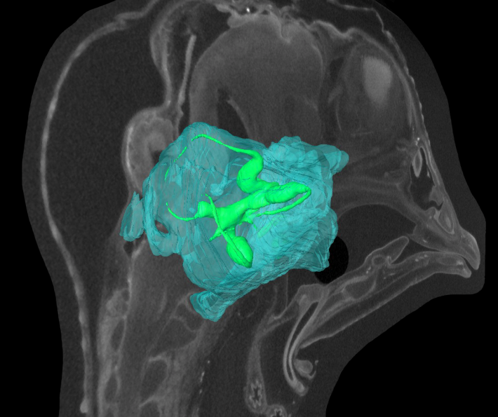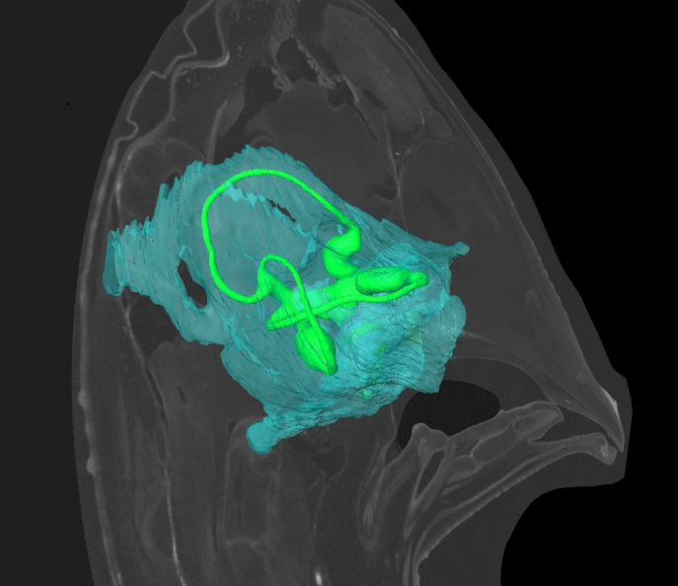

Figure: μCT scanned images of 10-day-old chick embryos with 3D rendered otic capsule (light blue) and membranous labyrinth (green). Left, control DMSO treated embryo; right, a PHD inhibitor CCT1-treated embryo. CCT1-treated embryo shows distorted otic capsule and thin semicircular canals.

**Other comments: (no more than 300 words)**

I would just like to thank the Anatomical society for this incredible and unforgettable opportunity and my supervisor Dr Nobue Itasaki, for the guidance and support she has provided me with.

*Signature of student...................................................Date…*

*Signature of supervisor…………………………………........... Date…*

END OF FORM

----------------------------------------------------------------------------------------------------------------------------------------

*File: USVRS 201516 report Itasaki and Kumar no SIG Website Version*