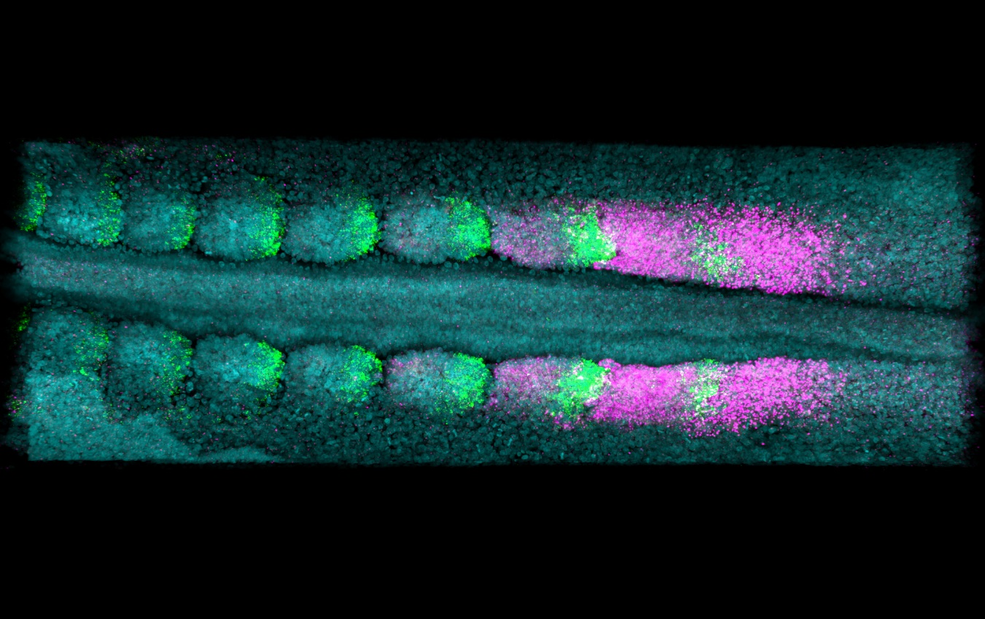

File: Adam Moverley – Somite rostrocaudal identity – v1- 251122

