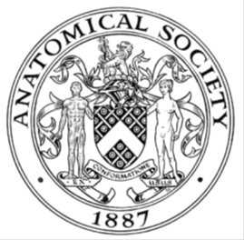
_______________________________________________________________________________________
AWARDEE REPORT FORM
_______________________________________________________________________________________

NAME |  | Andrew O’Malley
TWITTER HANDLE* optional |  | Omalleyfife
UNIVERSITY |  | University of St Andrews
NAME OF AWARD |  | Departmental Seminar Award
PURPOSE OF AWARD conference/event attended/organised (full name) with city and dates.
Hosting of Dr Tomasz Cecot to deliver a seminar on Tuesday 30th April, 10 am at University of St Andrews School of Medicine entitled "Virtual Reality in Anatomical Sciences: Transforming the Way We Teach and Learn.”

REPORT: What were your anticipated benefits?
Minimum number of words between 200-400. Please write in coherent paragraphs.
It was anticipated that Dr Tomasz Cecot’s seminar would share best practices with anatomists (and other health professions educators) in St Andrews and further afield. The focus of Dr Cecot’s visit related to the use of virtual reality in anatomical sciences education, because of his home institution’s (The University of Hong Kong Faculty of Medicine) recent procurement of 120 VR headsets.

This seminar outlined cutting-edge applications of Virtual Reality (VR) in anatomical sciences education. The session provided an overview of the pedagogical advantages of VR, explored its implementation in various anatomical educational settings, and discussed its potential for enhancing student engagement and learning outcomes.

A practical demonstration of the technology was provided to the audience, and the session concluded with a facilitated discussion about how similar innovations could be deployed locally.

Tom’s visit also enabled a series of one-to-one meetings with anatomists at both Universities of St Andrews and Dundee, and also several meetings with our learning technology team and a research group developing VR educational interventions.

Therefore, the major benefit was mutual exchange of information, experiences, and invitation for development of future projects in the area of using virtual models. The use of VR models allows for a deeper understanding of human anatomy, as it provides a three-dimensional perspective that textbooks cannot offer. This immersive experience is expected to improve retention and comprehension among students.

COMMENTS: Describe your experience at the conference / lab visit / course / seminar/ event.
Minimum number of words between 200-400. Please write in coherent paragraphs.
The seminar funded by the Anatomical Society provided a comprehensive overview of the opportunities and challenges associated with integrating Virtual Reality (VR) into anatomy education. As an academic at the University of St Andrews, I worked with Dr Cecot to design this seminar to explore how these advancements could be applied to our curricula locally and elsewhere.

The session featured a detailed presentation on the implementation of VR in anatomy classes at the University of Hong Kong. Dr Cecot highlighted their current innovations, which includes seven VR sessions for medical and dental students, each 1.5 hours long, accommodating approximately 300 students. The presentation covered the results of a pilot study comparing VR to traditional teaching methods, such as physical models, and outlined the process of integrating VR into the curriculum, along with the challenges faced.

Additionally, the seminar explored other VR initiatives in education, including a "virtual hospital" for nursing students and projects designed to enhance caregiver empathy. The latest project introduced was TechMezz, a space that allows students to utilise various technological tools at their own pace, fostering an environment of self-directed learning.

Learning about these developments was extremely useful. It enabled me (and my team) to consider other ways of using our hardware in other ways that we had not previously considered.

I was pleased to welcome colleagues from several Scottish universities, including Dundee, St. Andrews, Glasgow and Aberdeen. The diversity of attendees ensured a robust discussion, with questions addressing technical aspects, the inclusivity of VR, and issues like "cybersickness." The conversation also touched upon the rapid evolution of VR hardware and the significant costs associated with acquiring advanced VR equipment.

I found that a particular highlight of the seminar was the hands-on experience with VR hardware and software, which allowed participants to immerse themselves in the virtual world and gain practical insights into its educational potential in anatomical sciences and medical education more generally.

REPORT: In relation to skills, what were the most important things you gained? (does not apply to equipment grant. For public engagement/outreach awards what did your audience gain and how did you evaluate success?
Minimum number of words between 200-400. Please write in coherent paragraphs.
This visit allowed me to understand better the current needs and expectations in virtual reality (VR) for anatomy education. I learned that in the field of anatomy, there is a strong need for an accurate virtual reality model, which could be manipulated by students and used for easier learning and better retention of anatomical knowledge. The human body's structure is complex, leading to well-known problems in learning this subject, especially in areas such as the head and neck or pelvis. Because of their nature, the digital models can be easily adapted to the needs of the individual students. They can reduce cognitive overload by making structures semi-transparent, changing their colours, or easily zooming in on small and difficult-to-reach spaces. The models can change over time, a feature that is difficult to achieve in traditional plastic models.

The rise of virtual reality models is not a temporary trend, but a reflection of the digital transformation that we witness in our lives. Over the past decades, we have transitioned from the physical world to the digital realm in various aspects, from how we navigate with maps, to how we consume music, capture images, and even read documents like this one.

Additionally, the word “transformation” does not mean that we are going to do something "better" (or "worse"). It is a transformation. We are transforming the physical models into digital ones, with the difficult-to-describe the feeling of "immersion", which is not available on the flat screen. The VR technology is transforming the way we teach anatomy, as we are not using the physical models but the virtual ones.
REPORT: How do you think you will put this learning experience into practice in the future? For public engagement/outreach awards how with the materials/knowledge generated by this activity be used in the future?
Minimum number of words between 200-400. Please write in coherent paragraphs.
Tom’s visit has enabled us to progress our work on VR in St Andrews. We have purchased approximately 50 VR headsets and now feel more educated as to the pros and cons of the technology, as well as practical considerations related to its application.

Our learning technology team appreciated discussing Tom’s experiences with him directly as they had not anticipated some of the specific technical challenges that Tom described. Our VR research project team also benefited from hearing Tom’s views on cybersickness and accessibility.

Our colleagues from neighbouring medical schools were also grateful for Tom’s talk and the facilitated discussion; we discussed the possibility of future collaborations in this area, which we plan to discuss at the next Scottish Anatomists meeting in Glasgow.

Several colleagues (anatomists and others) commented that the session also provided their first experience of VR; this was an exciting day for our staff!

Data Protection/GDPR: I consent to the data included in this submission being collected, processed and stored by the Anatomical Society. Answer YES or NO in the Box below
Yes

Graphical Images: If you include graphical images you must obtain consent from people appearing in any photos and confirm that you have consent. A consent statement from you must accompany each report if relevant. A short narrative should accompany the image. Answer N/A not applicable, YES or NO in the box below
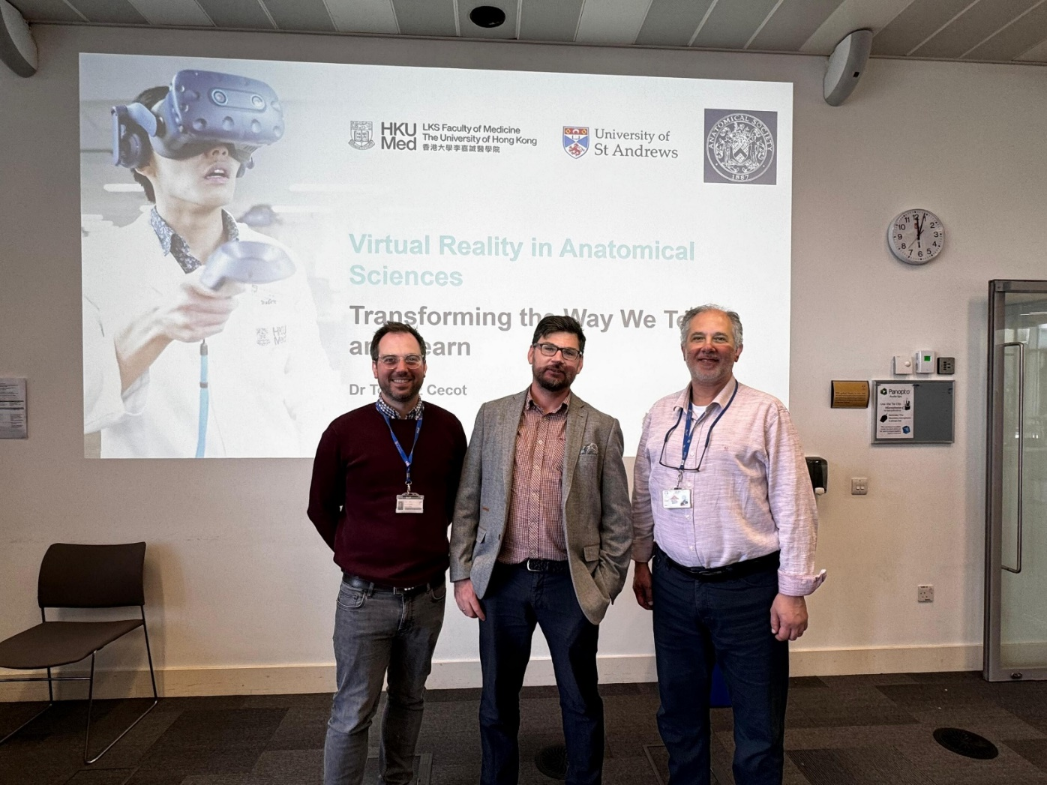
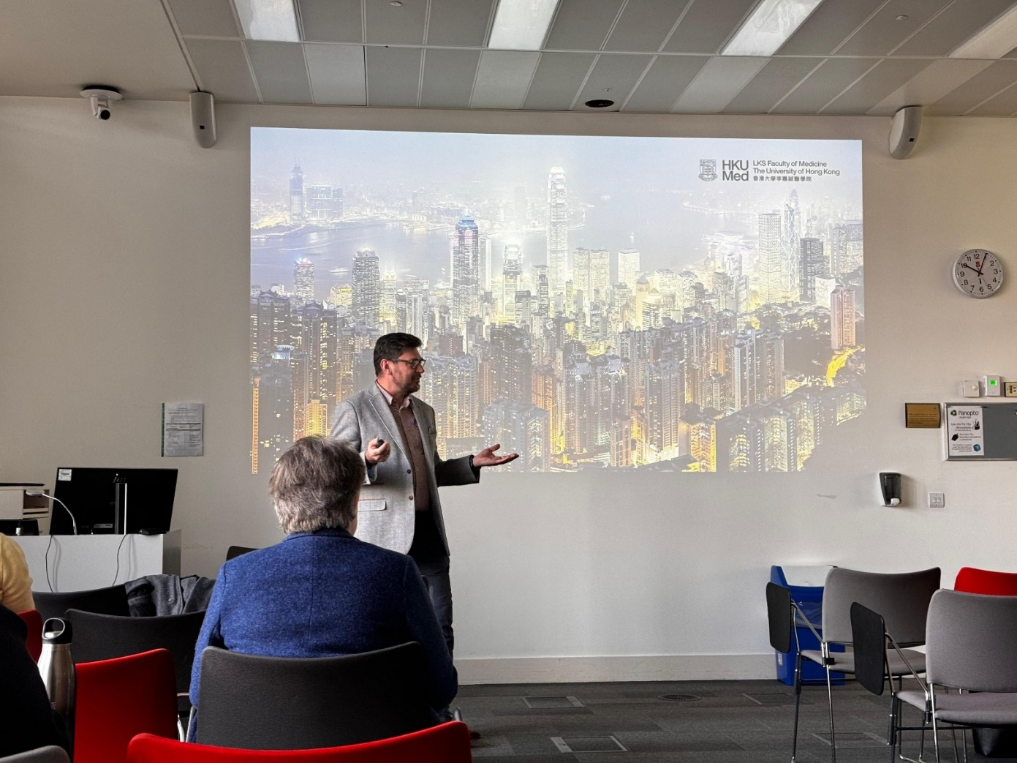
Dr Andrew O’Malley (left), Dr Tomasz Cecot (middle) Dr Enis Cezayirli (Right)

Copyright: If you submit images you must either own the copyright to the image or have gained the explicit permission of the copyright holder for the image to be submitted as part of the report for upload to the Society’s website, Newsletter, social media and so forth. A copyright statement must accompany each report if relevant. Answer N/A not applicable, YES or NO in the box below
Yes

SIGNATURE | ANDREW O’MALLEY |  | DATE | 24/05/2024
If submitted electronically, a type-written name is acceptable in place of a hand-written signature
File: AS-Award-Report-Form-171023

File: AOM Report Website version uploaded 020724

