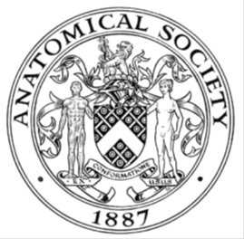
_______________________________________________________________________________________
AWARDEE REPORT FORM
_______________________________________________________________________________________

NAME |  | Elena Patera
TWITTER HANDLE* optional |  | @ArtedelCuerpoH1
UNIVERSITY |  | St George’s University of London
NAME OF AWARD |  | Barclay Smith Travel Fund
PURPOSE OF AWARD conference attended with city and dates.
Anatomical Society re-scheduled winter meeting
Dates: 17th-19th April 2023
Location: University of Nottingham, Nottingham, UK
REPORT: What were your anticipated benefits?
Before attending the conference, I was really looking forward to the invited talks and the oral presentations that were particularly focused on the use of ultrasound at different medical institutions. In addition, I was hoping to become more familiar with the concept of EDI and the different means I can use to incorporate EDI in my daily teaching practice as I was particularly familiar with one aspect of EDI that focuses on creating resources that are neurodivergence-friendly. I was anticipating that the conference would be a place where I could network with fellow anatomists and thankfully, I was able to make new connections with fellow anatomists (either early career or mid-career or senior) and engage with them in discussions regarding our teaching practice and identify potential possibilities for collaboration in the near future.
COMMENTS: Describe your experience at the conference / lab visit / course / seminar/ event.
Attending the conference was so enlightening; being able to learn about inclusive anatomy education has really made me aware of how important it is for anatomy educators to reflect on their teaching practice and ensure that their teaching material is accessible and inclusive as well. The oral presentations on the use of ultrasound and the challenges associated with its incorporation into the pre-clinical years of the medical curriculum have been very informative and has really helped me become aware of how much planning needs to be done prior planning the incorporation of ultrasound within a curriculum. One concept that resonated with me, was how important it is for non-clinical anatomy academics to receive proper training on how to use ultrasound (i.e., basics physics and knobology) prior expecting them to teach medical students via the use of ultrasound. I really liked how sonographer Dr Borsha Sarker and Prof. Debs Patten highlighted that with the incorporation of ultrasound within the pre-clinical years of the medical curriculum, we don’t aim to make medical students become sonographers but instead give them the opportunity to appreciate the anatomical structures they have been learning about, in cross sections and relate it to physiology and pathology; as well as comparing cadaveric anatomy to living anatomy. Furthermore, it was very interesting to hear about different evaluation methods and how important it is for research to be evaluated so that we can gain a proper understanding of the efficacy of a resource or a particular assessment method.

REPORT: In relation to skills, what were the most important things you gained? (does not apply to equipment grant. For public engagement/outreach awards what did your audience gain and how did you evaluate success?
I can certainly say that attending conferences and presenting my work helped me improve my oral presentation skills as sometimes you realize that something that makes sense to you does not always translate in the same manner to someone else, and it also helps you see things from someone else’s perspective and experience.
REPORT: How do you think you will put this learning experience into practice in the future? For public engagement/outreach awards how with the materials/knowledge generated by this activity be used in the future?
After listening to a wide range of talks regarding inclusive anatomy education, I aim to reflect on my teaching practice more often and ensure that my teaching practice does not indirectly exclude any individual or any of their protected characteristics.
Data Protection/GDPR: I consent to the data included in this submission being collected, processed and stored by the Anatomical Society. Answer YES or NO in the Box below
YES
Graphical Images: If you include graphical images you must obtain consent from people appearing in any photos and confirm that you have consent. A consent statement from you must accompany each report if relevant. A short narrative should accompany the image. Answer N/A not applicable, YES or NO in the box below-I have obtained consent from the individuals present on the image to use this particular image.
Image on the left shows a collage of the three poster presentations I had where I have been the first-author or second author and an image showing some of my previous colleagues and myself. The rest of the images show my poster presentations.
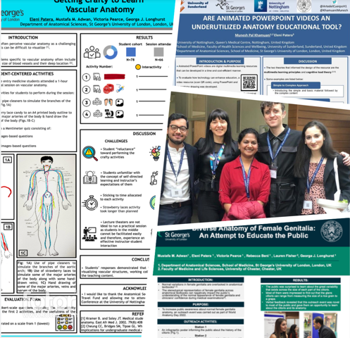
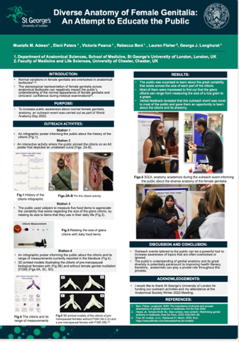
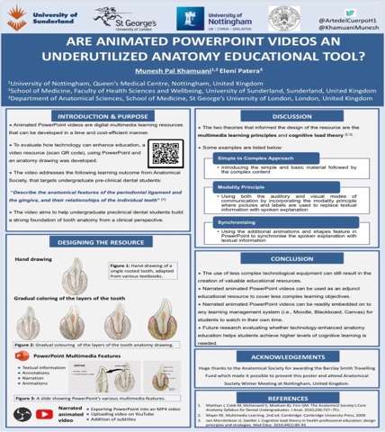
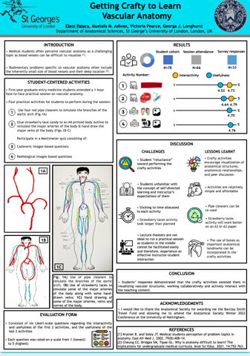

Copyright: If you submit images you must either own the copyright to the image or have gained the explicit permission of the copyright holder for the image to be submitted as part of the report for upload to the Society’s website, Newsletter, social media and so forth. A copyright statement must accompany each report if relevant. Answer N/A not applicable, YES or NO in the box below
I have obtained consent from all individuals shown on the image, to submit this image.
SIGNATURE | Elena Patera |  | DATE | 26/04/2023
If submitted electronically, a type-written name is acceptable in place of a hand-written signature

File: AS-Award-Report-Form-220922 – International Conference

