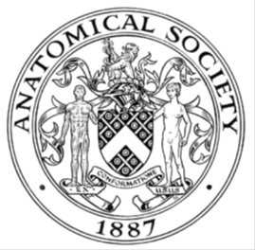
_______________________________________________________________________________________
AWARDEE REPORT FORM
_______________________________________________________________________________________

NAME |  | Leonard Shapiro
TWITTER HANDLE* optional |  | @leonard_shapiro @dr_keenan
UNIVERSITY |  | University of Cape Town
NAME OF AWARD |  | Anatomical Society Departmental Seminar Series Awards 2022/23 Round 5
PURPOSE OF AWARD conference/event attended/organised (full name) with city and dates.
For travel, accommodation and subsistence for Leonard Shapiro. Leonard travelled from South Africa to Newcastle University in England and presented an illustrated talk at Newcastle University on 16th October 2023. Leonard also ran two workshops at the Hatton Gallery on 14th October 2023 for a total of 45 participants (30 participants for workshop one and 15 participants for workshop two). The Hatton Gallery is a part of Newcastle University.

REPORT: What were your anticipated benefits?
For my talk on 16th October 2023: Imparting information about the collaborative work that Dr Iain Keenan and I are doing and the online course (Exploring 3D Anatomy) that we have created. Answering questions and engaging in discussion with attendees. Attendees were in the room as well as online via Zoom.

For the two workshops on 14th October 2023: giving Newcastle University medical and art students (and two GPs from the NHS) the opportunity to learn and practice a method of anatomy observation called Haptic Surface Painting (HSP) as well as a method of observation called haptico-visual observation and drawing (HVOD). The workshops lasted from 10.30am until 4.30pm.
COMMENTS: Describe your experience at the conference / lab visit / course / seminar/ event.
For my talk on 16th October: It was a real pleasure to present to members from both the medical as well as psychology faculties. I was glad that there was also online attendance. I was glad to engage in discussion with the attendees and answer questions. I detected real interest in the subject that I was speaking about,

Both of the workshops on 14th October were full. In fact, they were oversubscribed. The workshop room at Hatton Gallery was perfectly suited for the purpose, with work tables and chairs provided.

The planning for my talk and the workshops began months before, with Dr Iain Keenan booking the venue and advertising my talk.

Both Iain and I designed the advertising poster for the two workshops and Iain advertised the workshops through his networks, located the Hatton Gallery as a suitable venue and supported and assisted me. Iain contributed the anatomy component to the Haptic Surface Painting (HSP) workshop.
REPORT: In relation to skills, what were the most important things you gained? (does not apply to equipment grant. For public engagement/outreach awards what did your audience gain and how did you evaluate success?
I was able to evaluate the success of my oral presentation and learned how I can further refine it for future presentations. It is always beneficial to practice my oral presentations so that I can learn from it and improve it for the future.

The audience was able to see how art-based methods can contribute to anatomy education and clinical practice.

For the two workshops, I was able to share the two methods (HSP and HVOD) with students and week as two GPs.

The participants were able to gain practical, hands-on experience in practicing these two methods.
A lively discussion took place after the second (HVOD) workshop.
The participants expressed their enjoyment of these workshops and their benefit.

REPORT: How do you think you will put this learning experience into practice in the future? For public engagement/outreach awards how with the materials/knowledge generated by this activity be used in the future?
I will adjust my presentation to add an aspect of it near the beginning of my talk, rather than near the middle of it.

With regards to HSP, I will give more specific guidance while the students are practicing this method.

With regards to HVOD workshop, there is nothing further that I would adjust.
Data Protection/GDPR: I consent to the data included in this submission being collected, processed and stored by the Anatomical Society. Answer YES or NO in the Box below
YES
Graphical Images: If you include graphical images you must obtain consent from people appearing in any photos and confirm that you have consent. A consent statement from you must accompany each report if relevant. A short narrative should accompany the image. Answer N/A not applicable, YES or NO in the box below
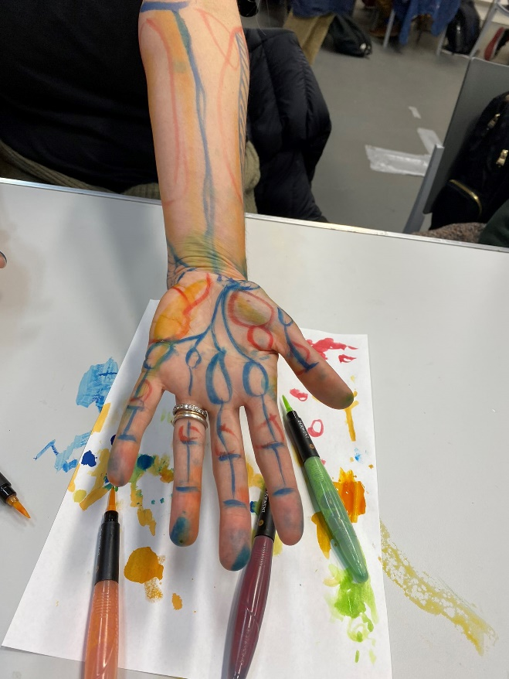 Haptic Surface Painting (HSP). Exploring the upper-limb through palpation and marking onto the skin using food colouring.
Image supplied by Dr Olivia Turner. Permission granted from Olivia to share. YES
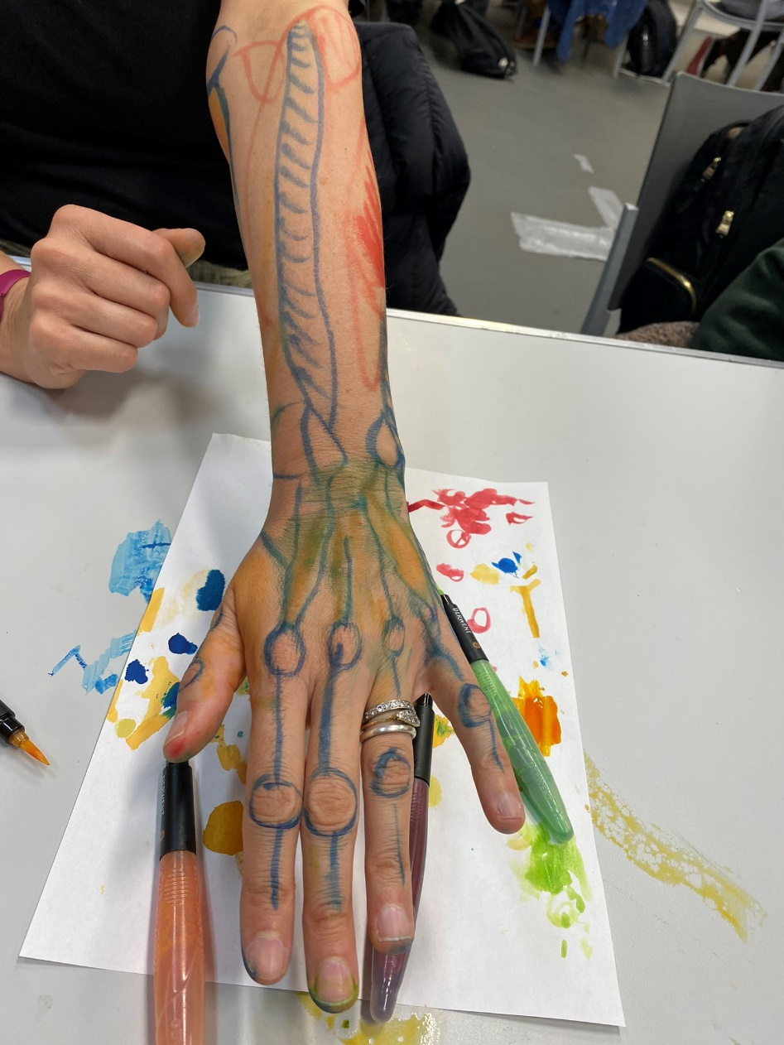 Haptic Surface Painting (HSP). Exploring the upper-limb through palpation and marking onto the skin using food colouring.
Image supplied by Dr Olivia Turner. Permission granted in writing from Olivia for Anatomical Society to share. YES
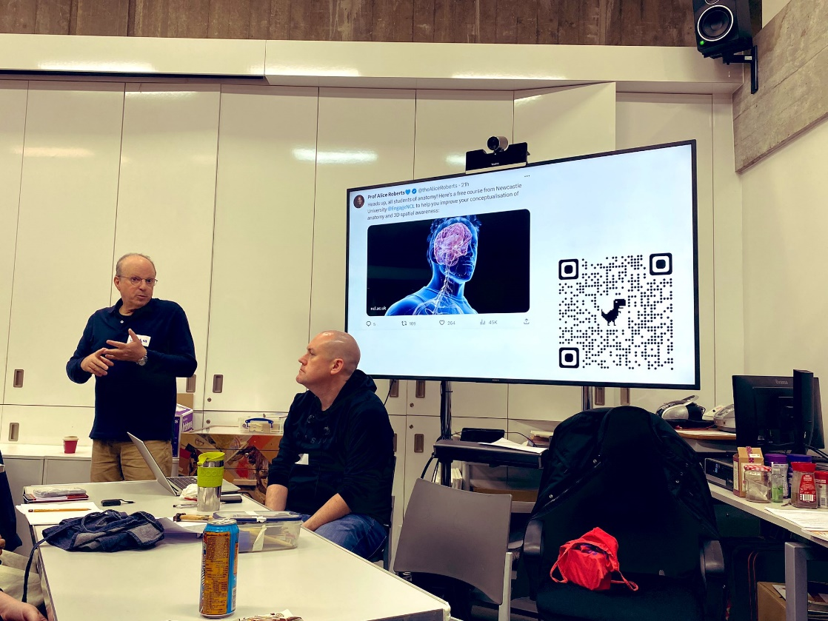
Leonard Shapiro and Dr Iain Keenan introducing the workshops. Image supplied by Dr Olivia Turner. Permission granted in writing from Dr Olivia Turner and Dr Keenan for Anatomical Society to share. I give my consent for the image of myself to be shared by the Anatomical Society. Note that we have paid the licence fee for use of the image on the screen behind us.
YES

Copyright: If you submit images you must either own the copyright to the image or have gained the explicit permission of the copyright holder for the image to be submitted as part of the report for upload to the Society’s website, Newsletter, social media and so forth. A copyright statement must accompany each report if relevant. Answer N/A not applicable, YES or NO in the box below
YES. Please see above under images for copyright permission for each photograph.

SIGNATURE | Leonard Shapiro 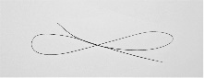 |  | DATE | 20 October 2023
If submitted electronically, a type-written name is acceptable in place of a hand-written signature

File: AS-Award-Report-Form-220922 – International Conference

