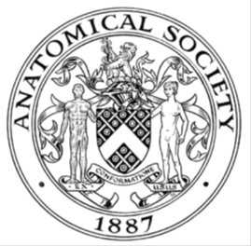
_______________________________________________________________________________________
AWARDEE REPORT FORM
_______________________________________________________________________________________

NAME |  | Ahmad Elmansouri
UNIVERSITY |  | University of Southampton
NAME OF AWARD |  | Barclay Smith award
PURPOSE OF AWARD conference/event attended/organised (full name) with city and dates.
IFAA London ExCel Center 9-11th August 2019 congress attendance and presentation

REPORT: What were your anticipated benefits?
- The opportunity to present research to senior colleagues and receive useful feedback about future directions in my work.
- An opportunity to showcase Southampton as a centre of excellence for using students as partners.
- An opportunity to gain new insights into innovative techniques in medical education – my chosen specialist field. Including the benefits and hazards of using techniques such as VR
COMMENTS: Describe your experience at the conference / lab visit / course / seminar/ event.
The IFAA represented an ideal opportunity to reflect on the last few years of work and to appreciate research from leading anatomists and clinicians.

It was an honour to hear from Emeritus Professor Susan Standring who described the history of the acquisition of anatomical knowledge with reference to the popular works of ‘Gray’s Anatomy’.

Supporting my colleagues Dr Scott Border, Sam Hall and Jonny Stephens I was able to reflect on the journey of the National Neuroanatomy Competition and brainstorm where we could go next to make it an even greater success. Followed by an interesting lecture on characteristic gaze patterns in learners and experts in Anatomy by Dr Zumwalt and colleagues which introduced me to a concept I had never even considered before.

Later, I was able to learn about the challenges we face when internationalising Anatomy Education. Anatomy often leads the way when it comes to medical education and steps to making more well-established international connections will further the development of the international medical community as well.

On Saturday morning, I listened to insightful discussions on Anatomy education in China and its differences from the UK system and was able to learn about different methods of embalming. I was given the opportunity to present my work and had some interesting discussions with senior academics about their experiences of Near-peer teaching. I also listened to an interesting lecture regarding transgender surgery and discussed the moral implications of hormone manipulation prior to surgery with the speaker after the session.

In the Free Oral Communications on Education, Deepika Anbu discussed the use of the Flipped classroom model in comparison to the classical lecture approach. Alistair Robson shared some insights into the world of video assisted learning in the context of histology education and Octavia Kurn spoke about the different traits of neurophobes vs neurophiles in the context of neuroanatomy knowledge acquisition.

Sunday concluded the congress with another array of useful lectures including ones by Dr Scott Border and Claudia Krebs in a Brave new e-world! The promises and pitfalls of digital learning resources for teaching the anatomical sciences. Overall a fantastic experience at an educational and entertaining congress. I am grateful for the society’s support in facilitating my learning and development as a clinician and educator.

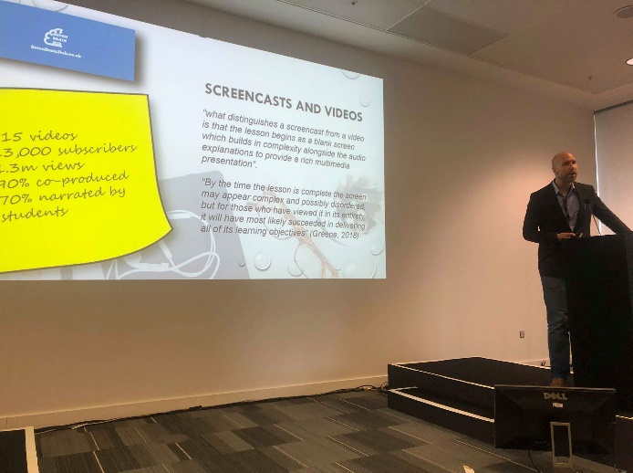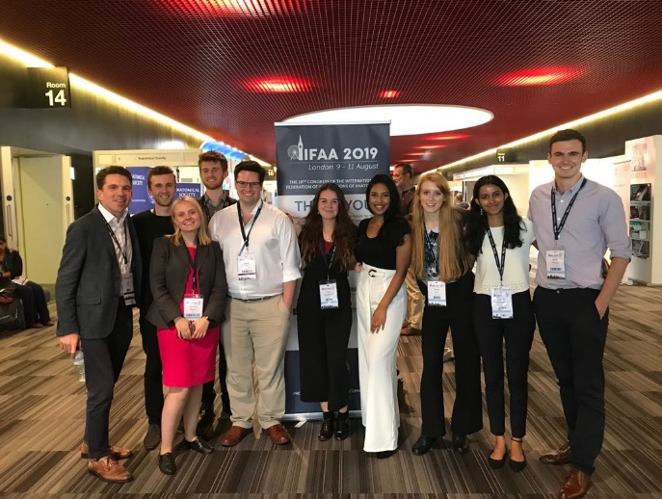

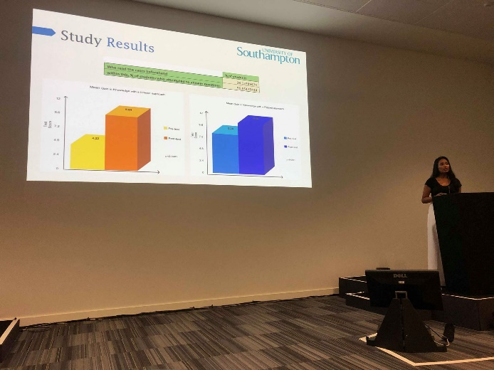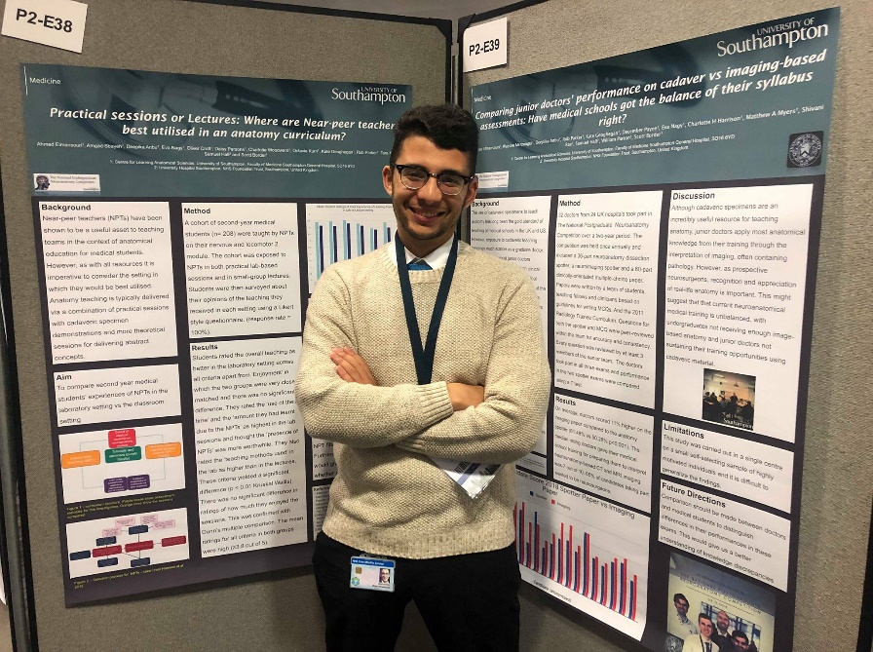

REPORT: In relation to skills, what were the most important things you gained? (does not apply to equipment grant. For public engagement/outreach awards what did your audience gain and how did you evaluate success?
- Able to observe excellent public speaking and take note of key parts that made talks better than others
- Able to take home messages from talks on educational innovation among others
- Able to discuss future employment and further higher education with several senior colleagues

REPORT: How do you think you will put this learning experience into practice in the future? For public engagement/outreach awards how with the materials/knowledge generated by this activity be used in the future?
- Employment of new teaching techniques
- Use of different presentation skills
- Consideration of how I can use novel approaches in anatomy to improve my own teaching and learning
Data Protection/GDPR: I consent to the data included in this submission being collected, processed and stored by the Anatomical Society.
YES
Graphical Images: If you include graphical images you must obtain consent from people appearing in any photos and confirm that you have consent. A consent statement from you must accompany each report if relevant. A short narrative should accompany the image.
YES

Copyright: If you submit images you must either own the copyright to the image or have gained the explicit permission of the copyright holder for the image to be submitted as part of the report for upload to the Society’s website, Newsletter, social media and so forth. A copyright statement must accompany each report if relevant.
YES

SIGNATURE | Ahmad Elmansouri |  | DATE | 26/08/2019
If submitted electronically, a type-written name is acceptable in place of a hand-written signature

File: AS-Award-Report-Form-BLANKCO-SEAL-date110216-Amended AT-070818

