_______________________________________________________________________________________
AWARDEE REPORT FORM
_______________________________________________________________________________________

NAME |  | Isabelle Poulson
UNIVERSITY |  | Liverpool
NAME OF AWARD |  | Barclay-Smith Award
PURPOSE OF AWARD conference attended (full name) with city and dates
Winter 2017 conference of the Anatomical Society, Dundee, Scotland, 18th-20th December

REPORT: What were your anticipated benefits?
I attended the conference with the hopes of presenting the outcomes of my summer research to the society. I hoped this opportunity would allow me to gain skills in presenting that could be further applied to the final year of my degree at the University of Liverpool.
COMMENTS: Describe your experience at the conference / lab visit / course / seminar.
I thoroughly enjoyed attending the Winter Anatomical Society conference this year. The opportunity to not only present to the society but also meet and speak with other members of the Society was a great experience for an undergraduate student such as myself. The experience also allowed me a better insight into possible future career paths I could pursue following graduation from my degree.

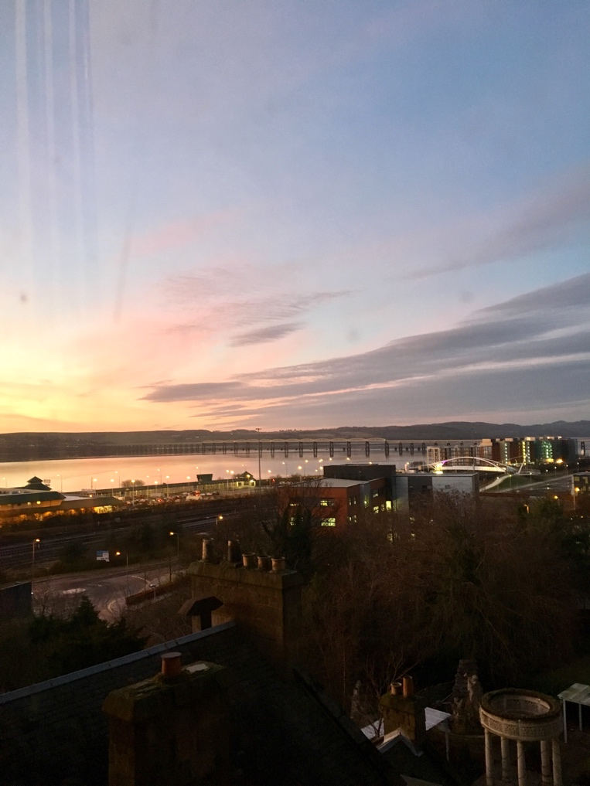

REPORT: In relation to skills, what were the most important things you gained? (does not apply to equipment grant)
From this experience I gained a huge amount of confidence in presenting to a large group of people. I am now better equipped to not only produce a presentation of my scientific research but also to inform others of my research through an oral presentation.

REPORT: How do you think you will put this learning experience into practice in the future?
I expect the skills I have learnt from this experience to be invaluable in my Anatomy and Human Biology degree. In upcoming months I will be presenting my Honours project and the oral presentation I completed at the conference has given me skills to present this in a relaxed and confident manner. This experience will no doubt also be applicable in my future scientific career, whether it be in research or further study.

SIGNATURE | Isabelle Poulson |  | DATE | 27/12/2017
If submitted electronically, a type-written name is acceptable in place of a hand-written signature

File: AS-Award-Report-Form-BLANKCO-SEAL-date110216

