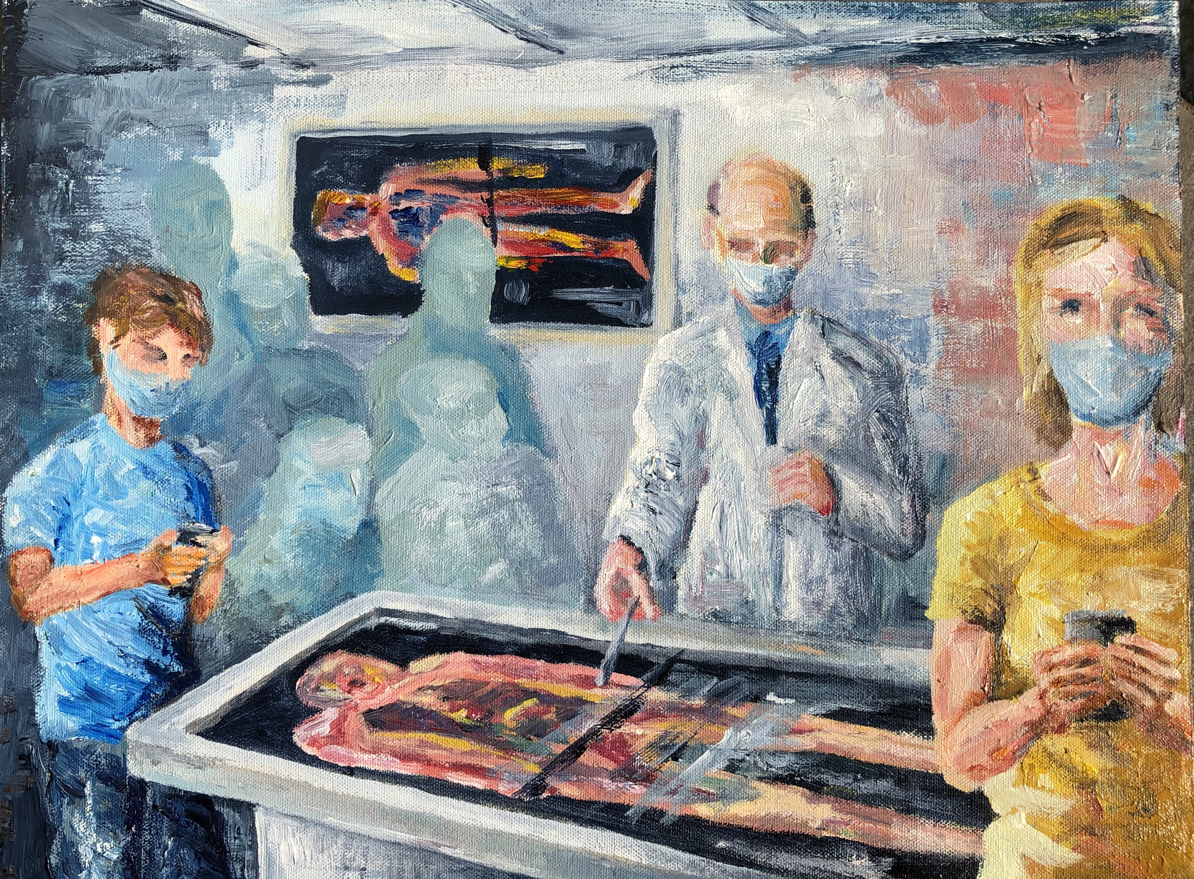

File: BI -RU 311021 The Covid Safe Anatomy Lesson – v1 -221121

