Title: The influence of island evolution on size-shape relationships in the anatomy of sheep, goats and their relatives

Primary supervisor: Dr Philip G. Cox, Centre for Integrative Anatomy, Department of Cell & Developmental Biology, University College London, UK

Secondary supervisor: Dr Jesse J. Hennekam, Faculty of Science and Engineering, Maastricht University, Netherlands

Project overview
Evolution via natural selection has produced an astounding diversity of anatomical form across mammals and other vertebrates. Within groups of closely related species, the morphology of different parts of the skeleton can often be predicted from size. Such strong size-shape (allometric) relationships are driven by the need to maintain functional performance. However, factors such as living on islands with limited resources and few predators can potentially disrupt these allometric relationships, leading to novel morphologies not predicted by size, with potentially impaired performance. The aim of this project is to test the hypothesis that life in an island environment disrupts standard size-shape trends, using the Caprinae, an ungulate subfamily comprising sheep, goats and their wild relatives, as a case study. There are three main objectives:

1: To determine the relationship between size, morphology, ecology, and habitat across the Caprinae. This will be investigated using geometric morphometric methods on the jaws and limbs of a wide sample of extant and extinct caprine genera.

2: To assess the degree to which the allometric relationships are disrupted by life in an island environment. This will be quantified using geometric morphometric techniques developed by the supervisors on the extinct dwarf goat Myotragus. This genus is known from Mallorca and Menorca from the Early Pliocene to around 4,500 years ago and is an example of island dwarfism.

3: To determine the functional consequences of morphological variation resulting from island dwarfism. This will be explored using virtual biomechanical simulation on Myotragus and some of its extant relatives.

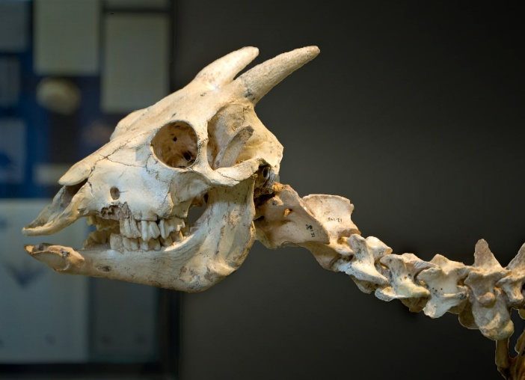
Figure 1: Mounted skeleton of Myotragus balearicus (Balearic Museum of Natural Sciences, Sóller, Mallorca)

