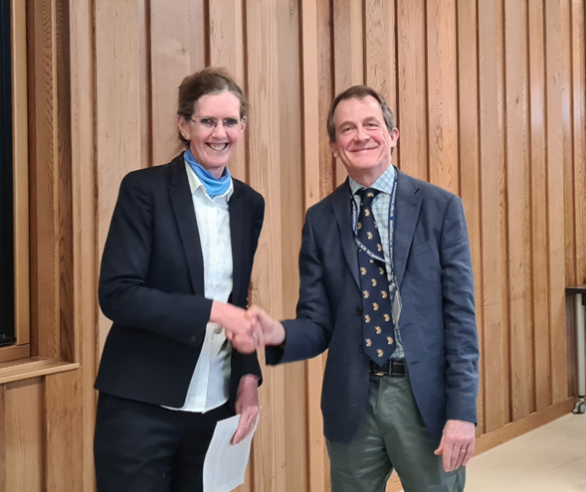

Dr Gavin Clowry, Honorary Research Officer, was awarded the 2022 Symington Memorial Prize by Professor Tracey Wilkinson, President, at the Anatomical Society in-person Winter Meeting, hosted by the University of Nottingham, 17th to 19th April 2023.

ENCOMIUM FOR GAVIN CLOWRY DELIVERED BY THE PRESIDENT OF THE ANATOMICAL SOCIETY, PROFESSOR TRACEY WILKINSON:

We, the Anatomical Society, would like to award one of our two most prestigious awards, the Symington Memorial Prize, this evening. This award is given every two years.

Originally established in 1920 by the Queen's University of Belfast in commemoration of Professor Johnson Symington, who was a former President of the Anatomical Society, the prize is awarded by the Academic Council of Queen's University on the recommendation of the Council of Anatomical Society, which sought the advice of its Education Committee. The award is made for contributions to the advancement of Anatomy, including education in Anatomy, by a Member of the Anatomical Society not of professorial status.

It is my pleasure to award the winner of the Symington Memorial Prize for 2023 to … Gavin Clowry from Newcastle University.

Gavin has over 30 years of experience of teaching anatomy and neuroanatomy. He taught neuroanatomy, first as demonstrator in UCL (1991-1993) and then in Newcastle from 2009 onwards to undergraduate physiology, pharmacology and psychology and postgraduate neuroscience students. Since taking up his lectureship at Newcastle, he taught for two years as a demonstrator teaching thorax, abdomen, upper and lower limbs, before leading the module on the upper and lower limbs from 1996 to 2004. Gavin’s research informs his teaching in this area. He also teaches developmental neurobiology to UG and PG developmental geneticists and to MRes stem cell biologists. Following reorganisation of the Newcastle MBBS curriculum in 2017, he continued to teach upper limb until 2019, incorporating innovations such as combining DR anatomy with clinical examination of the shoulder joint into one session.

Gavin’s research career began as a postgraduate student under the supervision of Margaret Matthews in the Department of Human Anatomy, Oxford. He studied the rules concerning axon/target recognition during synapse formation and the response of neurons to injury. This instilled in him an interest in development, plasticity and repair of the nervous system and trained him in neuroanatomical research skills such as tract tracing, immunohistochemistry and electron microscopy. Gavin’s first presentation at a scientific meeting was to the Anatomical Society at the 100th anniversary meeting in Oxford, and he attended the 125th anniversary meeting in Edinburgh when his research group received the prize for the best paper in the Journal of Anatomy 2010.

Gavin moved to the laboratory of Gerta Vrbova, Dept of Anatomy and Developmental Biology, University College London (1989-1994) where he studied models of motorneuron degeneration and replacement with embryonic motorneuron transplants in animal models. Skills and knowledge acquired there made him ideally suited to join Janet Eyre and Simon Miller’s multidisciplinary research group in Newcastle University studying all aspects of motor system development and cerebral palsy. The team won Wellcome Trust programme funding and he led on projects including validating animal models of cerebral palsy and studying the molecular neuroanatomy of the developing motor system in human postmortem tissue, as well as initiating a motor neuron disease research programme. Cerebral palsy related research has remained a major theme for him until today, generating many high impact publications, including a paper in Brain (2000) that combined neurophysiological and neuroanatomical data to show that corticospinal innervation occurs prenatally in humans, radically changing our way of thinking about how corticospinal tract lesions in development affect maturation of spinal cord circuitry.

In 2002 Janet Eyre, Susan Lindsay and Gavin renewed the Wellcome Trust funding and a second theme of studying development of the human cerebral cortex was initiated, which has continued to this day and has involved two successful Anatomical Society PhD studentships. It has also been featured in two Anatomical Society meeting symposia which he has co-organised. A series of publications, chiefly in Cerebral Cortex and the Journal of Anatomy, have provided the most detailed description of the molecular anatomical development of the early fetal human forebrain yet provided. This work also brought Gavin into close contact with the Human Developmental Biology Resource human fetal tissue bank.

In 2015, Gavin was elected to the Council of the Anatomical Society and in 2016 was elected as our Research Officer. During this time, he has promoted numerous opportunities for researchers provided by the Society, including improvements to the research web pages, refining of application procedures for scholarships and studentships, and providing more opportunities for early career researchers to apply for PhD studentships. The Society is greatly indebted to Gavin for his work and wish to congratulate him on winning this prestigious award, which he fully deserves.

File: Encomium TWGC210823

