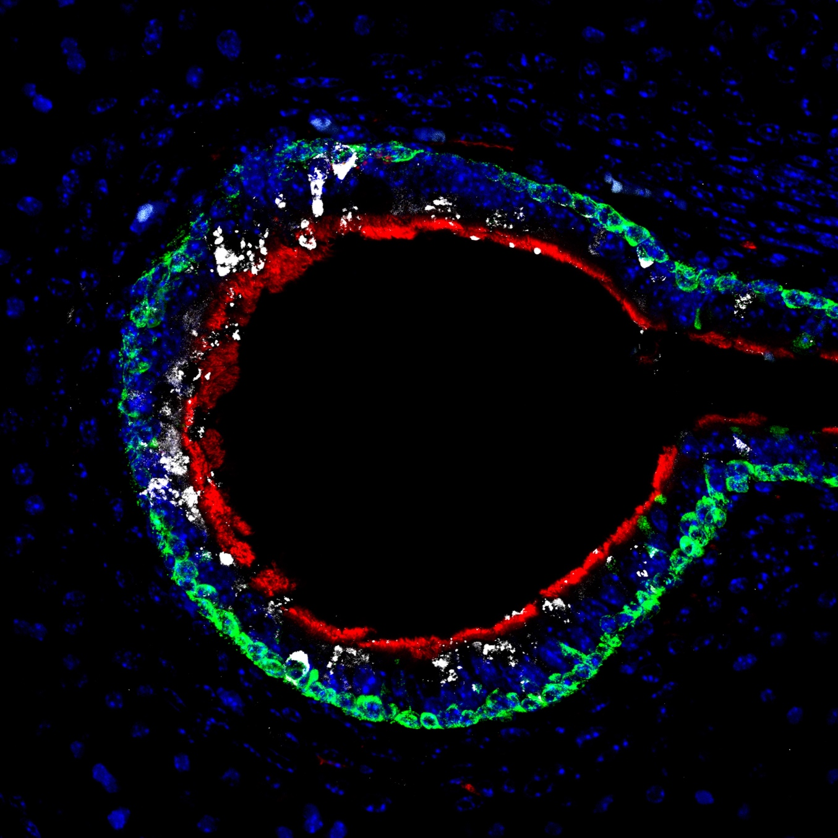

File: Joint Runner Up Best Image Award - Juan Fons Romero – v1 - 170722

