_______________________________________________________________________________________
AWARDEE REPORT FORM
_______________________________________________________________________________________

NAME |  | Dr Jennifer Paxton
TWITTER HANDLE* optional |  | @Dr_JZP
UNIVERSITY |  | University of Edinburgh
NAME OF AWARD |  | Departmental Seminar Award
PURPOSE OF AWARD conference/event attended/organised (full name) with city and dates.
Dr Shane Browne, Lecturer in Anatomy at the Royal College of Surgeons in Ireland, was invited to the University of Edinburgh to give a seminar in the Anatomy@Edinburgh Research Seminar Series, organised by Dr Jennifer Paxton.
This event took place on the 22nd April 2024

REPORT: What were your anticipated benefits?
Minimum number of words between 200-400. Please write in coherent paragraphs.
I met Dr Browne in September 2022, in Berlin, at the Anatomical Society symposium held at the Anatomische Gesellschaft of which I was a co-organiser. I was very impressed with his talk at this event and our shared interests in bioengineering and tissue repair led to further discussions. Following this, we discussed opportunities to collaborate on shared research topics, namely the implementation of material from Dr Browne’s research lab into ongoing work in my lab at the University of Edinburgh.
The seminar invitation was a fantastic opportunity for Dr Browne to visit Edinburgh and learn more about our work, as well as present his exciting work to a varied audience of anatomists, cell biologists, bioengineers, material scientists and tissue engineers.

The purpose of the Anatomy@Edinburgh Research Seminar Series is to provide a bi-monthly opportunity for research, closely aligned with anatomy, to be presented and to highlight the importance of anatomy and anatomical research across a varied and diverse field. In this respect, Dr Browne was a fantastic choice to showcase work from an excellent anatomist and bioengineer and how these fields can work so well together.

From the above points of views, I was anticipating an excellent, highly relevant seminar with additional opportunities for discussion about future collaborative plans.

COMMENTS: Describe your experience at the conference / lab visit / course / seminar/ event.
Minimum number of words between 200-400. Please write in coherent paragraphs.
As expected, Dr Browne gave an excellent seminar as part of the Anatomy@Edinburgh Research Seminar Series. The talk was well attended and the audience was composed of anatomists, bioengineers, cell biologists and tissue engineers, and ranged from undergraduate students to postgraduate students and several faculty members. There was an excellent Q & A session following the talk, where Dr Browne discussed his work further with other members of the audience and met several people who were interested in his work.

Dr Browne was also given a tour of the Anatomy department at the University of Edinburgh, including the Anatomical Museum (Including our newly-established ATLAS Facility for 3D scanning and printing), our Anatomy teaching laboratory, as well as our research facilities in nearby buildings. This gave Dr Browne the opportunity to see the facilities we have here at the University of Edinburgh and provide more opportunities for potential collaboration in several different areas, from tissue engineering research to anatomical educational materials.

Following his talk, Dr Browne had discussions with myself and members of my group around areas of collaboration. In particular this focused on how my lab could make use of the modular HyA hydrogels he described in his talk in our work. These discussions have continued since via email as my lab begin to use these HyA-based hydrogels.

REPORT: In relation to skills, what were the most important things you gained? (does not apply to equipment grant. For public engagement/outreach awards what did your audience gain and how did you evaluate success?
Minimum number of words between 200-400. Please write in coherent paragraphs.
I, personally, learned a lot about the use of Hyaluronic acid hydrogels and their potential for use in tissue repair and regeneration across multiple tissue types. I was very interested to hear of the previous work of Dr Browne and enjoyed the variety of work presented. In particular, the wide range of material properties that can be generated using the HyA biomaterials described in Dr Browne’s talk has great potential for the study of the bone-tendon interface which is a big focus of my group’s work. In addition, I can see the potential for his work and materials in my own laboratory, and hopefully this will be the beginning of a positive collaboration for us both.

In addition, many students attended this talk, both from my research laboratory and other labs in the University. This meant that they learned a lot about these new HyA hydrogels and the way that these novel biomaterials could be used in repair and regeneration. This was a fantastic opportunity for them to learn about another avenue of potential research, as well as the importance of anatomy and anatomical research in new and exciting healthcare-related applications. There was also the opportunity for the students to meet Dr Browne and discuss their own research topics, building their communication skills and scientific network.

REPORT: How do you think you will put this learning experience into practice in the future? For public engagement/outreach awards how with the materials/knowledge generated by this activity be used in the future?
Minimum number of words between 200-400. Please write in coherent paragraphs.
I believe that there were many points of scientific cross over between the work of Dr Browne and my own laboratory’s work. Specifically, we are looking for collaborate on the use of Dr Browne’s material as a biomaterial scaffold for bone cell growth, as a suitable niche for bone and enthesis tissue engineering studies. If successful, this may form the beginnings of longer-term collaboration and funding applications, hopefully resulting in continued work and publications in the future.

From my own perspective, it was also useful to form better connections with a fellow anatomist who is actively researching within the bioengineering, tissue engineering and repair field. This further highlighted the importance of anatomy in this multidisciplinary area and helps to raise the profile of anatomical and anatomically-related research to a wider audience.

We are very grateful to The Anatomical Society for the opportunity to host this seminar, as we think it will be the beginning of a very useful and exciting collaborative relationship between two anatomists working in the bioengineering field. The Anatomical Society was mentioned in all advertising of the event and they were thanked at the beginning and end of the seminar. Myself and Dr Browne would like to formally thank the Society for the generous support and the opportunity to make this event happen.

Data Protection/GDPR: I consent to the data included in this submission being collected, processed and stored by the Anatomical Society. Answer YES or NO in the Box below
YES
Graphical Images: If you include graphical images you must obtain consent from people appearing in any photos and confirm that you have consent. A consent statement from you must accompany each report if relevant. A short narrative should accompany the image. Answer N/A not applicable, YES or NO in the box below
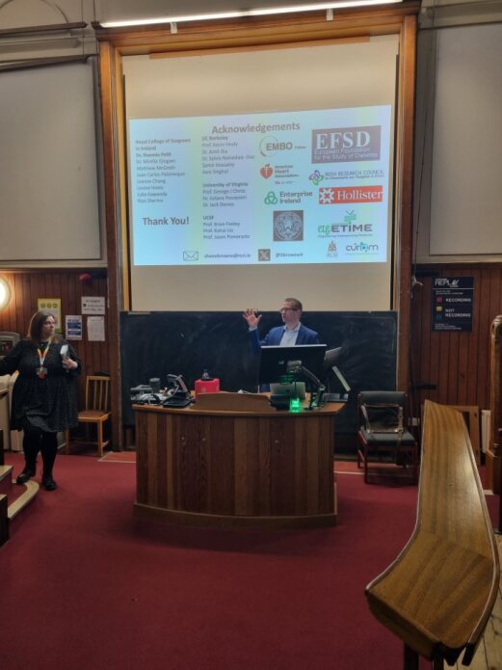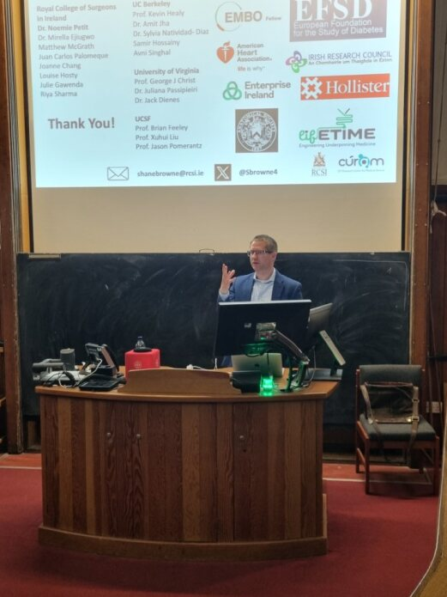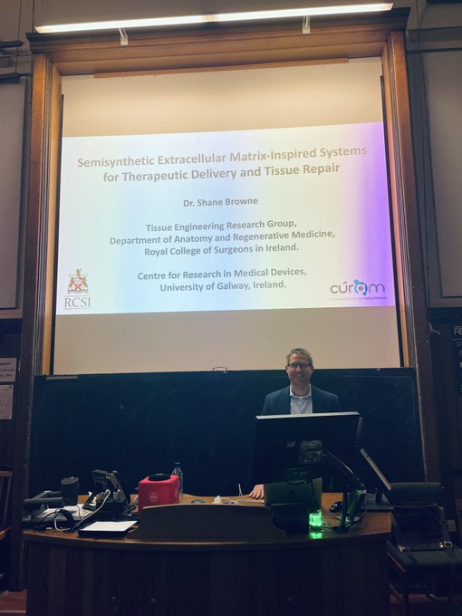
YES - Consent for images has been obtained.
Copyright: If you submit images you must either own the copyright to the image or have gained the explicit permission of the copyright holder for the image to be submitted as part of the report for upload to the Society’s website, Newsletter, social media and so forth. A copyright statement must accompany each report if relevant. Answer N/A not applicable, YES or NO in the box below
YES

SIGNATURE | Jennifer Paxton |  | DATE | 13/05/24
If submitted electronically, a type-written name is acceptable in place of a hand-written signature
File: AS-Award-Report-Form-171023 – International Conference

