Project title:
Using anatomical morphometrics to guide tissue-engineered design for improving treatment options for ankle ligament injury

Supervisors:
Dr Jennifer Z Paxton, Edinburgh Medical School: Biomedical Sciences, University of Edinburgh https://www.ed.ac.uk/biomedical-sciences/anatomy/staff/anatomyteachingstaff/jenniferpaxton
Professor Hamish Simpson, Head of Orthopaedics and Trauma, Edinburgh Orthopaedics, https://www.ed.ac.uk/inflammation-research/people/principal-investigators/professor-hamish-simpson

Project description:
Ankle ligament injuries are one of the most common musculoskeletal problems worldwide. Injury rates increase in younger populations and those engaging in sporting or military professions. While minor ankle sprains can be treated conservatively, there are high rates of re-injury and almost half of patients will complain of pain on ankle examination years later, highlighting that ankle ligament repair is poor. Notably, the enthesis, the hard-soft tissue connection, is postulated to account for some instances of ligament pain following injury.

This project is focussed on using anatomical morphometrics to design and develop tissue-engineered models for improving ankle repair strategies. It builds upon previous work in the host laboratory which examines the anatomical features of the enthesis in other anatomical areas [1] and the modification of existing tissue-engineered models [2,3] to provide a solid workflow for combining two complementary research areas [4].

Ultimately, we aim to combine anatomical morphometric analysis of cadaveric tissue with the design and development of tissue-engineered structures that possess anatomically and clinically relevant characteristics for ankle ligament repair.

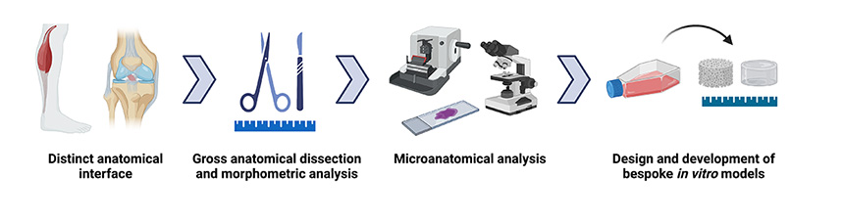
Figure 1. Overall aim of combining anatomical morphometrics with tissue-engineered design [Image is graphical abstract from 4].

References:

1. Mortimer JW, Alsaykhan H, Vadibeler S, Rust PA, Paxton JZ. Anatomy and histomorphology of the flexor digitorum profundus enthesis: functional implications for tissue engineering and surgery. BMC Musculoskelet Disord. 2021 Dec 10;22(1):1032. doi: 10.1186/s12891-021-04922-1. PMID: 34893040; PMCID: PMC8665545.

2. Paxton JZ, Grover LM, Baar K. Engineering an in vitro model of a functional ligament from bone to bone. Tissue Eng Part A. 2010 Nov;16(11):3515-25. doi: 10.1089/ten.TEA.2010.0039. Epub 2010 Aug 28. PMID: 20593972.

3. Paxton JZ, Wudebwe UN, Wang A, Woods D, Grover LM. Monitoring sinew contraction during formation of tissue-engineered fibrin-based ligament constructs. Tissue Eng Part A. 2012 Aug;18(15-16):1596-607. doi: 10.1089/ten.TEA.2011.0535. Epub 2012 May 21. PMID: 22439983.

4. Loukopoulou C, Mortimer JW, Paxton JZ. Making connections: using anatomy to guide tissue engineering approaches at the enthesis. Eur Cell Mater. 2022 May 5;43:162-178. doi: 10.22203/eCM.v043a14. PMID: 35510558.

