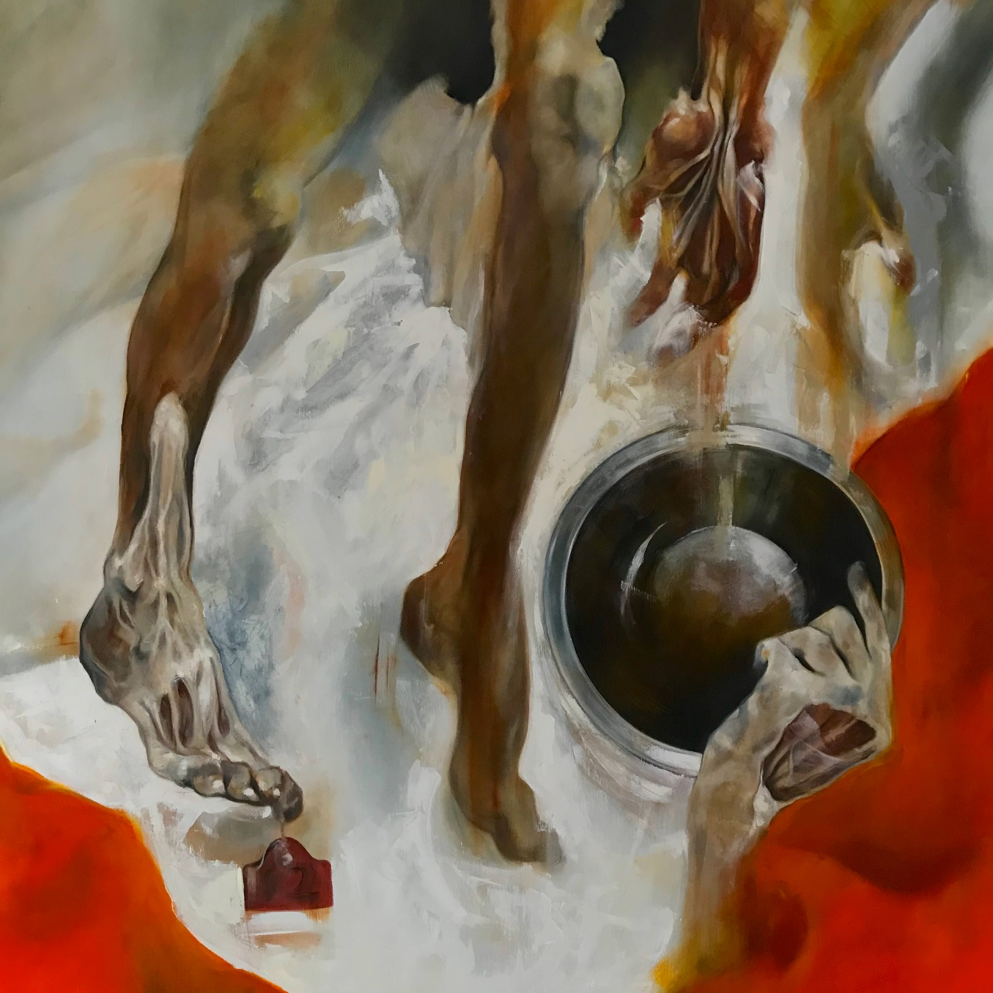

File: Saorsa Dissection of Experience

