Anatomical and molecular characterisation of vascular ingression in the embryonic vertebrate brain
Supervisor: Dr. Frank Schubert, University of Portsmouth
Student: Amanda Corla
The vascularisation of the neural tube is a critical step in the development of the vertebrate nervous system. The brain in particular has a high demand of oxygen and nutrients, and hence depends on an efficient blood supply. Ischemia, e.g. due to trauma or stroke, has devastating consequences for brain function. The close link between neural and vascular cells is further exemplified by the blood-brain barrier. This highly selective barrier regulates the transport of molecules between blood and brain, and is formed through the intimate interaction of endothelial cells, pericytes, astrocytes and neurones. Finally, neural and vascular precursors jointly form a stem cell niche, presumably allowing the coordinate differentiation of neurones and glia with the associated capillaries.
Considering the importance of the brain vasculature, surprisingly little is known about how during embryogenesis endothelial cells first enter the neural tube even at anatomical level, let alone about the molecular mechanisms of this process. Research into vascular and neural development over the past decades has, however, provided the necessary tools to investigate vascular ingression at structural and functional level. In this project, we are utilising the close link between biochemists and developmental biologists in Portsmouth and the existing collaboration with cell biologists in Rouen to analyse brain vascularisation in a multi-disciplinary approach.
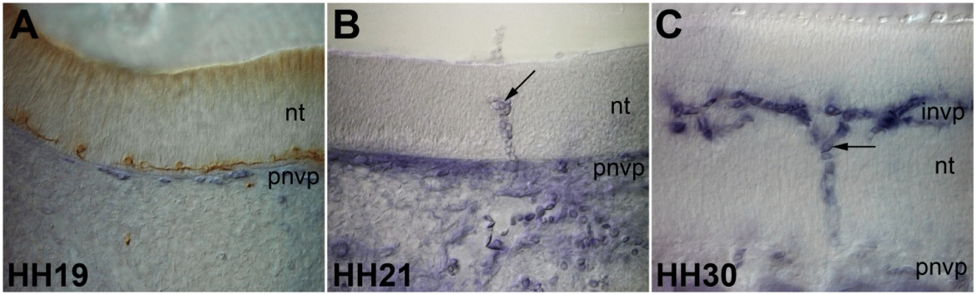
Endothelial cells initially assemble as the perineural vascular plexus (pnvp) adjacent to the neural tube (A) before eventually ingressing (B) and spreading inside the neuroepithelium to form the intraneural vascular plexus (C, invp).
Project aims:
- Deliver a comprehensive anatomical description of how endothelial cells invade the brain
- Provide insight into the molecular mechanism of ingression
- Contribute to our understanding of neural-vascular interactions during development
Beyond the immediate topic of brain vascularisation during embryogenesis, clarifying how the ingressing endothelial cells remodel the ECM will have wider implications for understanding invasion of the brain by cells in general. Inside the brain, the possibility of local signals regulating sprouting and fusion is relevant for processes like neo-vascularisation.

