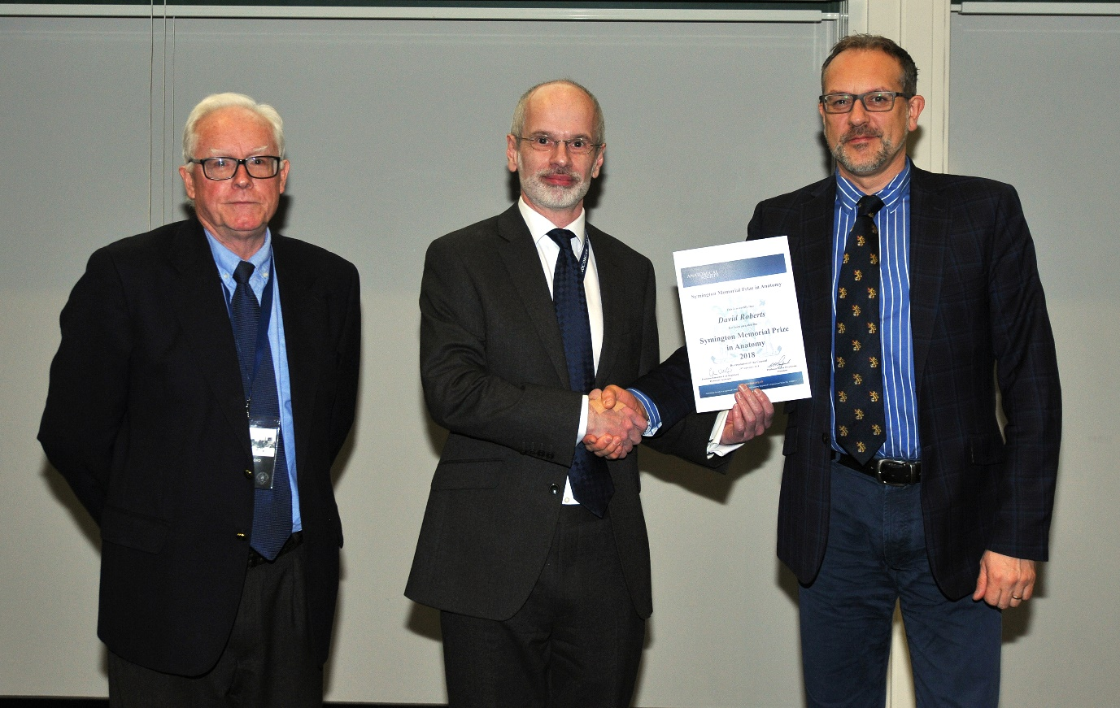

Dr David Roberts receiving his Symington Memorial Prize Certificate from the President, Professor Stefan Przyborski and Professor Emeritus Colin Ockleford, Honorary Secretary, at the Society’s AGM held on 12th December 2018, York.

File: Symington Memorial Prize 2018 Photo

