Updated Project Résumé

Role of Calcium Dependent Neurotransmission in selected populations of cortical projection neurons in the distribution of GABAergic interneurons

The precise ratio between inhibitory GABAergic interneurons and glutamatergic pyramidal neurons determines how well neural networks in the cerebral cortex function. Pyramidal cell dysfunction has been demonstrated to impact GABAergic cell numbers, which can result in the establishment of abnormal networks and disordered brain function. The mechanisms by which the pyramidal neurons control the number, survival, and distribution of interneurons are yet unknown at the cellular and molecular levels. The involvement of pyramidal neurons in the formation of inhibitory circuits has received relatively little attention, despite long-standing studies demonstrating how different subtypes of cortical pyramidal neurons affect the development and maturation of GABAergic cells. This is a crucial research question as defective interneurons may lead to the overexcitability of the cortex, and the lack of inhibitory control on the excitatory pyramidal neuron populations is both disruptive and destructive to brain functioning. All these perturbations occurring during development can have a devastating impact on the brain and moreover, it may lead to the emergence of various forms of neuropsychiatric and neurodevelopmental disorders such as autistic spectrum disorder, epilepsy, or schizophrenia.
Therefore, fundamental to my DPhil research is gaining an understanding of the mechanisms that control the delicate connections between the excitatory pyramidal neurons and the inhibitory interneurons. More specifically, to clarify the role of pyramidal neurons in the development and maintenance of GABAergic interneurons. By blocking or enhancing the communication between the pyramidal cells and the interneurons, I will be able to identify the role of excitatory pyramidal neurons in the survival of interneurons during and after development. To answer this question, I use several conditional knockout (cKO) lines and chemogenetic tools to manipulate the neuronal activity of glutamatergic deep-layer projection neurons both in a chronic (long-term) and acute (short-term) fashion. These deep-layer projection neurons in layer 5 and layer 6b of the cerebral cortex have been shown to have unique input and output connections that can orchestrate interneuron cell function and distribution either directly or indirectly. Investigating the excitatory-inhibitory neuron connections in a cell type- and layer-specific manner is essential to comprehend how these cortical circuits are formed and maintained before and after development.
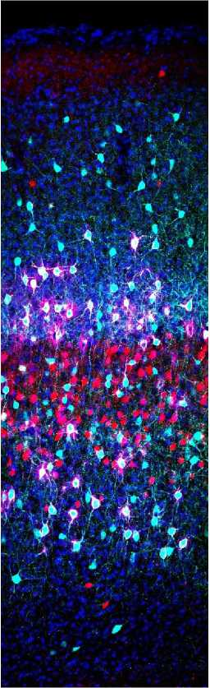

Confocal image of a mouse primary somatosensory cortex illustrating GABAergic parvalbumin interneurons in cyan and glutamatergic cortical layer 5 projection neurons in red. Synchronous synaptic vesicle release from layer 5 neurons was abolished by the conditional deletion of Snap25 from layer 5 neurons of the cerebral cortex. The perineuronal nets enwrapping the somata and processes of parvalbumin neurons are seen in magenta and the nuclei counterstain DAPI is in blue.
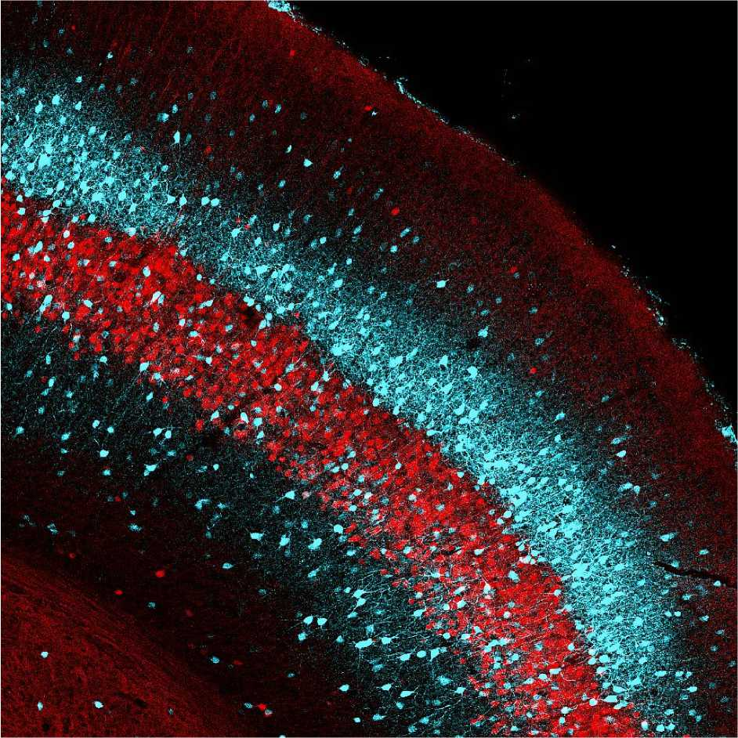

Confocal image of a mouse primary somatosensory cortex showing inhibitory (cyan) and excitatory neurons (red) in layer 5. The inhibitory cells are parvalbumin-positive interneurons, whereas the excitatory cells are Rbp4-Cre-positive projection neurons that are chronically ‘silenced’ from birth. The abolition of Ca²⁺- dependent neurotransmission selectively from layer 5 cortical neurons enables us to elucidate the role of excitatory deep-layer projection neurons in the development, distribution, and density of inhibitory interneurons.
File: Updated PR Molnar and Szabo - 190923

