File: Updated Project Resume 290922
In-vivo dissection of white matter pathways in Parkinson’s disease: tracking progressive degeneration and biomarkers of symptomatology

Supervisors: Professor Simon Keller
https://www.liverpool.ac.uk/translational-medicine/staff/simon-keller/
Dr Antonella Macerollo
https://www.liverpool.ac.uk/psychology/staff/antonella-macerollo/
Dr Thomas Butts
https://www.sunderland.ac.uk/about/staff/medicine/thomasbutts/
Mr Jibril Farah
https://www.thewaltoncentre.nhs.uk/Consultant/77/mr-j-o-farah.html

Institution: The University of Liverpool and the Walton Centre NHS Foundation Trust, Liverpool

Parkinson’s disease (PD) is characterised by heterogenous motor symptoms that cannot be explained by progressive basal ganglia degeneration and dysfunction alone; various subtypes of PD exist, some subtypes have a worse prognosis than others, and some symptoms are less responsive to therapy than others. It is likely that other structures outside the basal ganglia play a role in the pathophysiology of PD. Despite that grey matter pathology has been well-studied in this disorder, relatively little consideration has been given to white matter fasciculi and the impact of white matter degeneration on motor and cognitive function and treatment outcomes.

The student will conduct a comprehensive analysis of white matter fasciculi in patients with PD using magnetic resonance imaging. There are two major objectives of this programme of research:

1. To determine the relationship between progressive white matter tract deterioration and motor and cognitive deficits through analysis of serially acquired diffusion tensor imaging scans in patients with a new diagnosis of PD. For this objective, white matter fasciculi across the brain will be analysed.
2. To apply state-of-the-art experimental imaging approaches to improve segmentation of white matter fasciculi and explore whether patients with newly diagnosed PD show evidence of intra-axonal or extra-axonal water diffusion abnormalities.
3. Using a novel whole-brain MR spectroscopy approach, to determine the distribution of abnormal metabolite concentrations in patients with newly diagnosed PD.

This project will provide the student with unique insights into the relationship between neuroanatomy and clinical neuroscience in the UK’s second most common neurodegenerative disorder.

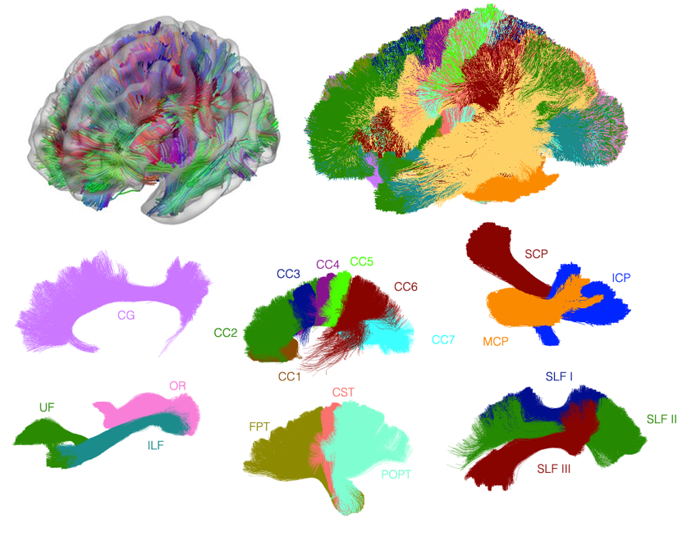
Figure 1. Segmentation of selected major white matter fasciculi in the human brain from diffusion tensor imaging data. The microscopic properties of these fasciculi will be examined in the early stages of PD and over time, with a special focus on the relationships with disease-related symptoms. CC, corpus callosum; CG, cingulum; CST, corticospinal tracts; FPT, frontopontine tracts; ICP, inferior cerebellar peduncle; ILF, inferior longitudinal fasciculus; MCP, middle cerebellar peduncle; OR, optic radiations; POPT, parieto-occipital pontine; SCP, superior cerebellar peduncle; SLF, superior longitudinal fasciculus; UF, uncinate fasciculus.

