Updated Résumé 01.09.21

Is the extensive non-neuronal pathology reported in mouse models of Spinal Muscular Atrophy seen in post-mortem tissue from patients? A detailed morphological assessment
Spinal muscular atrophy (SMA) is a debilitating motor neurone disease, primarily affecting the infant population. Characteristic neuromuscular pathology includes the degeneration and death of lower alpha motor neurones, leading to skeletal denervation, atrophy and progressive paralysis, however extensive non-neuronal pathologies are also reported. Evidence of universal vascular abnormalities are widespread. The vascular supply to the central nervous system is imperative in development and functionality, with vast populations cells throughout the brain and spinal cord requiring high metabolic turnover. Disrupted spinal cord microcirculation is reported in SMA mouse models and is associated with functional hypoxia throughout the CNS. To determine if similar defects are present in the spinal cord of human SMA patients we are undertaking a detailed morphological study to assess vascular supply of the spinal cord. Utilising stereological techniques, we report a significant reduction is vascular density in SMA patients throughout grey and white matter structures in the post-mortem spinal cord, most pronounced in the ventral horn, the site of motor neurone degeneration. In continuation, we will determine if and how a reduced vascular supply may impact the neuronal environment. Hypoxic conditions are a recognised risk factor for the trigger of motor neurone degeneration, therefore vascular deficits have the potential to influence or exacerbate SMA pathology.

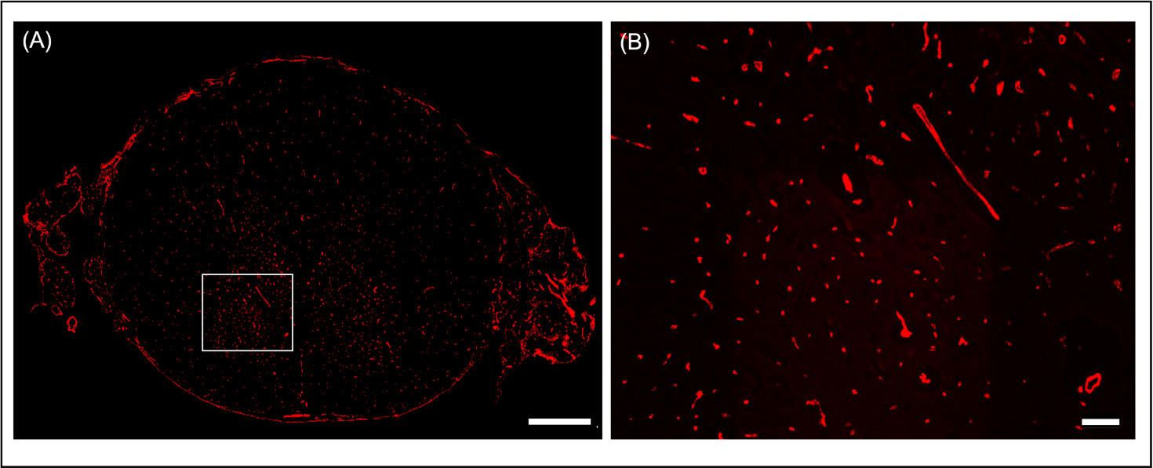

Human paediatric spinal cord (9 months of age) immunohistochemically stained using marker Von Willebrand Factor for visualisation of blood vessels. (A) Low power micrograph of entire transverse section of spinal cord, scale bar = 1000µm. (B) High power micrograph of ventral horn grey matter, scale bar = 100µm.

