**­­­­­­­­­­­­­­­­**

**UNDERGRADUATE SUMMER VACATION SCHOLARSHIP AWARDS – FINAL SUMMARY REPORT FORM 2018/19**

***NB: This whole report will be posted on the Society’s website therefore authors should NOT include sensitive material or data that they do not want disclosed at this time.***

**Name of student:**

Victoria Ward

**Name of supervisor(s):**

Helen Dodson

**Project Title: (no more than 220 characters)**

Characterisation of breast cancer cell lines grown as 3D spheroid cultures.

**Project aims: (no more than 700 words)**

The overall aim of this project was to establish growth conditions for several cell lines derived from luminal A and luminal B breast tumours as 3D spheroid cultures. These cell lines are being used in the lab to address aspects of the DNA damage response in breast cancer. Histone H2AX is a key component of the DNA damage response and the phosphorylated form of this protein, known as γH2AX, is a commonly used marker of DNA damage in both the laboratory and clinical setting. One copy of the *H2AFX* gene is commonly lost in breast cancer and the cell lines being used in this study model *H2AFX* in the haploid and diploid state in luminal A and B tumours.

The cell lines have been well characterised in 2D monolayer cultures in the lab and aspects of growth, migration, morphology and the expression of key markers of the epithelial to mesenchymal transition have been studied. During this project I aimed to advance this work by establishing conditions for these cells to grow as 3D spheroids, as this is will more accurately reflect how transformed epithelial cells grow in the context of a tumour mass.

3D culture techniques are advancing and specifically I aimed to test two culture methods, known as the ‘hanging drop’ method and ‘low-adhesion’ method. I aimed to compare 6 cell lines grown as spheroids with their respective 2D cultures and studied aspects of morphology and gene expression. Specific emphasis was placed on two subtypes of breast cancer, namely luminal A (as represented by cell lines BT483H2AFX+/+ and MDA-MB-134-VIH2AFX+/-) and luminal B (as represented by cell lines BT474H2AFX+/+ and CAMA-1H2AFX+/-). These 4 cell lines were purposely chosen due to the copy number status of the *H2AFX* gene. Additionally, two controls were used in the project, which included a well characterised breast cancer cell line MCF7, and a non-tumour breast cell line MCF10A. With each of the 6 cell lines, I proposed to count and manipulate the cells to form spheroids using the ‘hanging drop’ method and the ‘low-adhesion’ method. Both methods forced the cells to interact with each other in alternative ways as compared to 2D cultures grown in flasks or well plates. The ‘hanging drop’ method relied on natural gravitational settlement of cells when placed in small volumes of media and then upturned in a humid culture environment. The ‘low-adhesion’ methods required the treatment of 96-well tissue culture plates with agarose to prevent cells from sticking and then a centrifugation step to induce the cells to adhere to initiate the formation of a spheroid.

Initially, we aimed to characterise aspects of the DNA damage response using γH2AX as a marker in immunofluorescence experiments. It took rather longer than anticipated to optimise the culture conditions and then to establish the protocols for fixation, embedding, sectioning and staining. During the time frame of this project, we unfortunately did not manage to optimise this staining on the spheroid sections. However, we did manage to establish robust protocols for spheroid formation in 4 of the 6 cell lines. We spent the time optimising the techniques and characterising the spheroids using H&E staining and also established protocols for RNA extraction and performed some preliminary quantitative PCR reactions. The outcomes will be further elaborated in the later section of this report.

**Project Outcomes and Experience Gained by the Student (no more than 700 words)**

**Project Outcomes:**

My goal was to characterise each cell line grown as spheroids using the following methodology;

1. I kept a daily cell/spheroid diary to evaluate the growth of each cell line as spheroids. I used a variety of suspension densities and cultivation time periods to optimise their growth and recorded this by light microscopy (Figure 1).

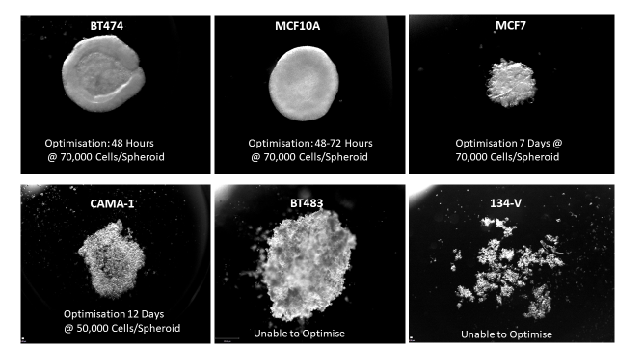

***Figure 1: Light microscopy images of spheroids.*** *Each cell line at its optimal starting cell density and cultivation time period.*

I was able to successfully culture 4 of the 6 cell lines as spheroids; the normal breast line, MCF10A, commonly used MCF7 cells and the luminal B-derived cells lines BT474 and CAMA-1. The other cell lines, BT483 and MDA-MB-134-VI did not form stable spheroid structures using either of the methods tested. When manipulating them, such as changing media or fixing or even slight movements, resulted in the spheroid structure being disrupted. The luminal A-derived cell lines appeared to lack the same cell-cell adhesion as those derived from luminal-B tumours.

2. I used Haematoxylin & Eosin staining to characterise the morphology of the spheroids. They were fixed in a 4% PFA and placed in a 2% agarose mould prior to processing, clearing and embedding in paraffin wax. Sectioned were stained with H&E and then imaged (Figure 2).

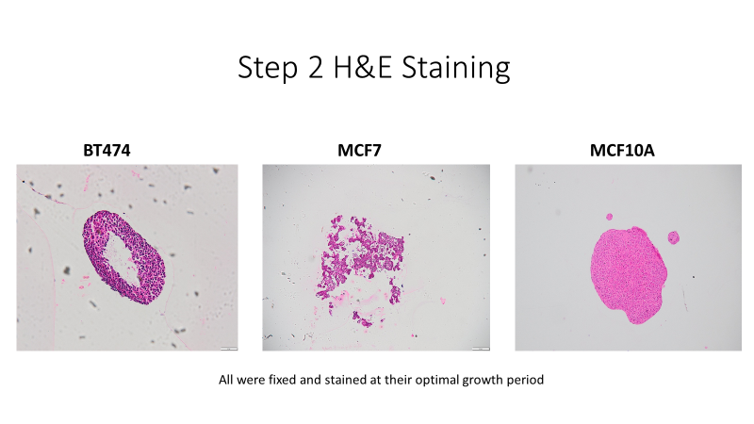

***Figure 2: H&E staining of optimised spheroids****.*

H&E staining was carried out on all 4 cell lines which were successfully cultured as spheroids. BT474 spheroids have a very characteristic donut morphology, which would be interesting to explore further, in contrast MCF10A spheroids where solid throughout.

3. I analysed gene expression using qPCR – I wanted to compare the level of H2AX mRNA to determine if cells grown as spheroids showed any changes in gene expression compared to 2D culture conditions. Additionally, I decided to quantify the levels of E-Cadherin and Zeb-1, which are genes involved in the epithelial to mesenchymal transition.

H2AX expression increased in the spheroids derived from cell lines BT474, BT483 and CAMA-1 compared to 2D cultures. The significance of this finding would require further research. E-cadherin expression also increased in spheroids from MCF10A, BT483 and CAMA-1 as compared to 2D cell cultures. E-cadherin expression changes as cells become more invasive and loose epithelial characteristics.

Experience gained:

During this 10 week research project I gained valuable experience of tissue culture and microscopy techniques, but I also developed more generic skills such as time management, data analysis and presentation skills. I enjoyed taking responsibility for my own project and making decisions about what parameters would be tested and implementing changes to protocols. I grew to appreciate that experimental research is challenging and results can be inconsistent at times and I learned to re-evaluate my findings under these circumstances. I embraced the academic environment and enjoyed engaging with other researchers. I believe that this experience will be very valuable to me both in the final year of my undergraduate degree and in my planned future research career.

Please state which Society Winter or Summer Meeting the student is intending to present his/her poster at:

Summer Meeting

**Proposed Poster Submission Details (within 12 months of the completion of the project) for an AS Winter/ Summer Meeting – (no more than 300 words)**

Breast cancer is the most common invasive cancer in women and a leading cause of cancer related death. The role of the DNA damage response protein, H2AX, in breast cancer progression is being investigated. The *H2AFX* gene is not mutated in breast cancer, however many primary breast tumour samples show heterozygous deletion. Patients with luminal B type-tumours have an overall lower survival rate and loss of one copy of *H2AFX* is very common. This project aimed to establish a methodology to grow several breast-derived cell lines as spheroids to further our understanding of H2AX in cancer biology. Cell lines were selected based on the classification of luminal A (BT483 and MDA-MB-134-VI) or B (BT474 and CAMA-1) and the genotype for *H2AFX,* also commonly used MCF7 cells and normal MCF10A cells were studied. Growth as spheroids was compared using two methods, known as ‘hanging drop’ and ‘low adhesion plates’ . Spheroids were stained with H&E to characterise the morphology, and RNA was extracted to allow comparison of gene expression for several genes with 2D cultures. Four of the six cell lines tested were established as spheroids. The CAMA-1 and MCF7 cells performed best in low adhesion plates, whereas the MCF10A and BT474 formed spheroids equally well using either protocol. H&E staining revealed differences in spheroid morphology and notably BT474 spheroids were donut-like, whereas MCF10A spheroids where solid throughout. Preliminary qPCR experiments revealed that H2AX expression increased in the spheroids derived from cell lines BT483, BT474 and CAMA-1 compared to 2D cultures and also E-cadherin expression increased in spheroids from MCF10A, BT483 and CAMA-1. The significance of this findings requires further research. Since spheroids provide a more realistic model of the 3D environment of the human breast this will allow further investigation of the role of H2AX in breast cancer progression.

**Brief Resume of your Project’s outcomes**: **(no more than 200-250 words)**.

*The title of your project and a brief 200-250 word description of the proposed/completed project. The description should include sufficient detail to be of general interest to a broad readership including scientists and non-specialists. Please also try to include 1-2 graphical images (minimum 75dpi). NB: Authors should NOT include sensitive material or data that they do not want disclosed at this time.*

**Title: Characterisation of breast cancer cell lines grown as 3D spheroid cultures.**

Breast cancer is the most common invasive cancer in women and a leading cause of cancer related death. Cell lines are commonly used models of disease and to complement our work investigating human tumour samples, we are exploring some of the basic biology of breast cancer in cell lines. Cell lines are typically grown as 2D flat cultures which are not at all like the 3D structure of breast tissue. In order to study breast cancer cells in the lab in a more realistic 3D form, cell culture spheroids were established. Breast cancer is categorised into several sub-types, with luminal tumours being the most common, accounting for approximately 60% of all diagnosis. In this project we tried to establish conditions for spheroids with 6 breast-derived cell lines (one control and 5 derived from luminal disease). I optimised conditions using two methods, where cells are either grown in a hanging drop of media or by using agarose to create a low adhesion environment for the cells. I was able to establish conditions for 4 of the 6 cell lines to grow as spheroids and characterised these using H&E staining. In order to analyse differences in gene expression of some key molecules involved in tumour invasiveness between 2D cultures and 3D spheroids, RNA was extracted and gene expression investigated by quantitative PCR. Establishing these conditions for 3D cultures will allow further investigation of key factors involved in breast cancer progression and invasion in the future.

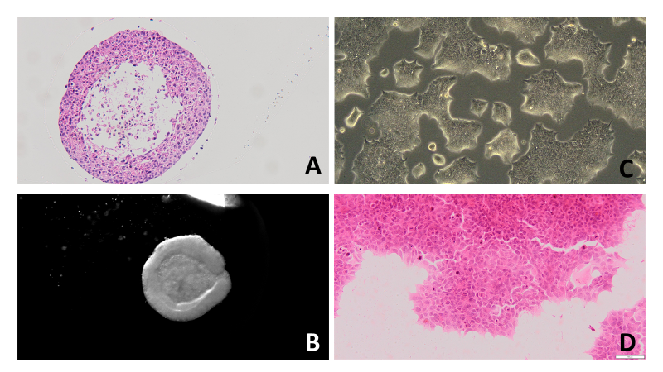  
***Figure 3: Comparison between BT474 cell line grown as a spheroid compared to a 2D culture.*** *(A) H&E stained spheroid, (B) spheroid imaged prior to fixation, (C) 2D culture imaged in flask, (D) H&E stained 2D culture.*



**Other comments: (no more than 300 words)**

*Signature of student...Victoria Ward............Date… .11th Sept 2019*

*Signature of supervisor…*Helen Dodson*…......... Date…11th Sept 2019……….…*

END OF FORM

----------------------------------------------------------------------------------------------------------------------------------------

*File: USVRS-AwardandBursaryTemplateLetter 2019-v2 GDPR-220519 – Dr Helen Dodson*

*File: USVRS 201819 Report DodsonWard no sigs*