**UNDERGRADUATE SUMMER VACATION SCHOLARSHIP AWARDS – FINAL SUMMARY REPORT FORM 2023/24 *NB: This whole report will be posted on the Society’s website therefore authors should NOT include sensitive material or data that they do not want disclosed at this time.***

**Name of student:**

Diyya Ameen

Twitter Handle*:

*(*optional)*

**Name of supervisor(s):**

Malcolm Logan

**Project Title: (no more than 220 characters)**

Comparative analysis of embryonic limb muscle bundle formation in chick, mouse, and human development

**Project aims: (no more than 700 words)**

The aim of this project was to gain insight into the process of laying out the anatomy of limb musculature in different sized vertebrates, (chick, mouse, and human). Despite the research available on the process of how myogenesis occurs, muscle tissue regeneration, and culturing muscle cells from stem cells, not much is known about the fundamental architectural steps in forming limb musculature. One key question we chose to focus on was the dimensions of muscle bundles in early development. Namely, we were interested in determining whether a small and large animal both start off with the same sized muscle bundles that become larger or smaller respective to the length of their gestational period. To address these aims, 3D modelling, imaging and immunohistochemistry techniques were used on chick and mouse limbs of various stages in embryonic development (chick: day 9 to day 11; mouse: E14.5 data generated, E.16.5 existing imaging data used). Furthermore, preliminary human data was extracted from imaging data from the lab’s work investigating limb development in humans.

**Project Outcomes and Experience Gained by the Student (no more than 700 words)**

Through this project we have produced quantitative data describing the volume of different vertebrates’ forelimb muscle bundles when they are first morphologically evident, focusing on those muscles of the forearm common between mice, humans and chickens. In addition to volumetric data, fibre number and approximate diameter was extracted through ‘digital dissection’ of muscle bundles.

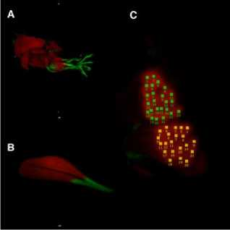**Figure 1: Digital Dissection of Murine Muscle Bundles at E14.5**

Panel A displays muscle bundles of the mouse forelimb at embryonic day 14.5 (E14.5), red indicates myosin staining and green indicates expression of Scleraxis, a tendon marker. Panel B demonstrates digital dissection of the Abductor Pollicis Longus (APL) and Extensor Pollicis Brevis (EPB), revealing the fibres composing the bundle. APL and EPB fibres were counted using the ‘Count Helper’ application, Panel C (green corresponds to APL and yellow corresponds to EPB), the APL had 23 identifiable fibres and the EPB 21 fibres. Video of the digital dissection can be seen here:

<https://www.youtube.com/shorts/6r2PYgYjACk>

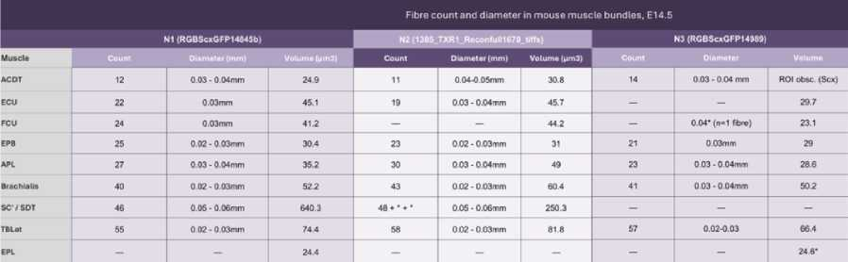

**Table 1: Volume, fibre count, and approximate fibre diameter of mouse muscle bundles at E14.5.**

Data extracted from 3 Optical Projection Tomography (OPT) imaging datasets performed on mice limbs stained for  
myosin using wholemount immunohistochemisty. ACDT: Acromiodeltoid; ECU: Extensor Carpi Ulnaris; FCU: Flexor  
Carpi Ulnaris; EPB: Extensor Pollicis Brevis; APL: Abductor Pollicis Longus; SDT: Spinodeltoid; TBLat: Triceps Brachi  
Lateralis; EPL: Extensor Pollicis Longus; *: denotes parts of dissected muscle bundles in imaging datasets that were of  
low resolution and thus have estimated muscle fibre counts based of their dissected surface area and the known  
values of nearby fibres with measurable diameter (as seen in Fig 1).

Although n1 and n2 datasets yielded relatively similar volumetric values, there is inconsistency when compared to n3. This indicates the need for more iterations to obtain a precise range of volumetric values.

In generating this data, I learnt how to process imaging datasets in Dicom/tiff formats using 3D modelling software (Horos/Osirix). Furthermore, I developed a reliable method of rendering volumetric data from imaging datasets, inspired by the use of the ‘region of interest’ (ROI) tool in computing tumour volume used by clinicians/radiologists. Having done this, I also contributed to updating the lab’s Horos manual and had the opportunity to work with the Gordon Museum at King’s College London using skills obtained from this project (link:<https://www.kcl.ac.uk/alfred-poland-1>)

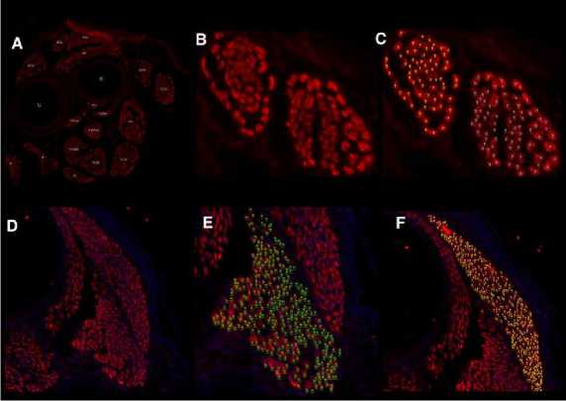

**Figure 2: Comparison of equivalent muscle bundle between mouse (E14.5) and chick forelimb (Day 11) cryosections**

Comparing the Extensor Carpi Radialis of the E14.5 mouse to the equivalent chick muscle, Extensor Metacarpi Radialis (EMR) at Day 11. 147 fibres were counted in the mouse ECR (panels A-C), whilst the chick EMR was shown to have 716 total fibres (panels D-F). **Note:** the mouse fibre data is not conclusive as fibre resolution was poor due to the sectioning angle; *i.e.,* each counted fibre may actually be more than a single fibre. More mouse slides are being processed to obtain clearer images of each fibre. Green, yellow, and blue dots represent counted fibres.

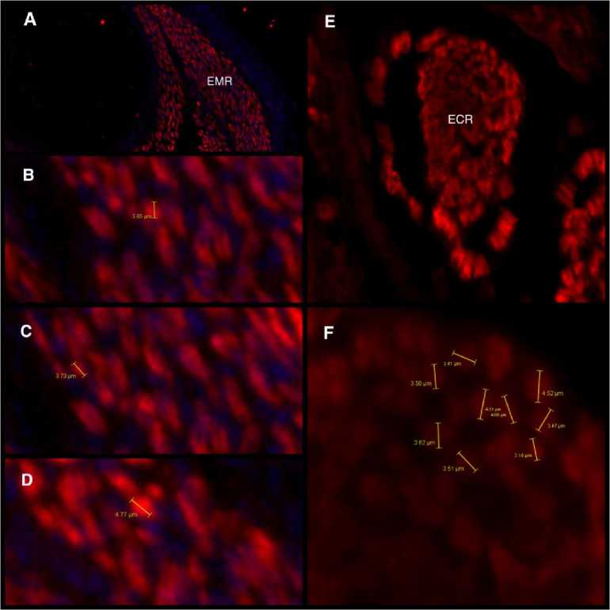

**Figure 3: Comparing the ECR of E14.5 mouse to the chick EMR at Day 11.**

Chick fibre diameter range: 3.73µm-4.77µm, mouse fibre diameter range: 3.16µm-4.52µm

We are also generating chick whole-mounts to provide volumetric data, however we have yet to image these as they are not yet ready due to tissue processing difficulties we are troubleshooting. Instead, we focused on fibre dimensions in chick muscle bundles. We observed fibre size between fibres in the Extensor Metacarpi Radialis (EMR, in chick) and Extensor Carpi Radialis (ECR, in mice) is relatively similar (Fig.3), however the number of fibres making up the bundle differs (Fig.2), explaining the difference in overall muscle size. This indicates that large and small animals may be restricted to the same size fibres but grow larger by bundling more of these fibres to form larger muscles during gestation. That said, this is speculation based off the modest data collected thus far—we will need to process more samples to support this theory.

To conclude our work serves as a starting point. We provide novel describing the dimensions of muscle bundles in early development of different vertebrates. In due time, we shall be working to give a deeper description of how the architecture is laid out between different sized vertebrates.

**Please state which Society Winter or Summer Meeting the student is intending to present his/her poster at:**

**Summer Meeting 2025**

**Proposed Poster Submission Details (within 12 months of the completion of the project) for an AS Winter/ Summer Meeting – (no more than 300 words)**

**Brief Resume of your Project’s outcomes**: **(no more than 200-250 words)**.

*The title of your project and a brief 200-250 word description of the proposed/completed project. The description should include sufficient detail to be of general interest to a broad readership including scientists and non-specialists. Please also try to include 1-2 graphical images (minimum 75dpi). NB: Authors should NOT include sensitive material or data that they do not want disclosed at this time.*

This project aimed to explore how limb musculature is laid out during embryonic development across vertebrates of different sizes—specifically in chick, mouse, and humans. While significant research exists on myogenesis, muscle regeneration, and stem-cell-derived muscle culture, the quantitative dimensions of these developing muscles has not been previously described. A key focus of this study was to examine the dimensions of muscle bundles in vertebrates to determine whether small and large animals share similarly sized initial muscle bundles, which later scale in size relative to their gestational periods.

To address these questions, we used 3D modelling, imaging, and immunohistochemistry techniques. Data was collected from chick and mouse at specific developmental stages (chick: days 9–11; mouse: E14.5 and E16.5), and preliminary human data was extracted from existing imaging datasets related to limb development.

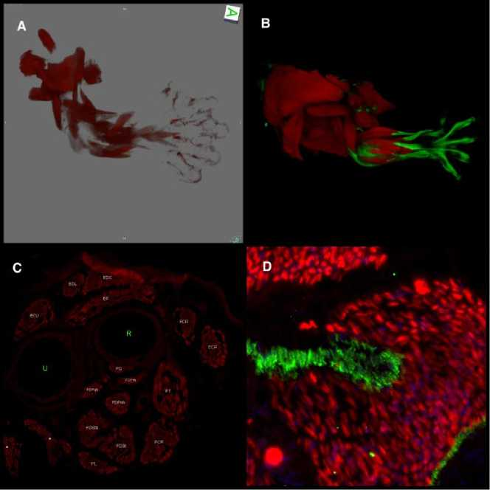

**An Overview: Comparative analysis of chick, mouse, and human muscle bundle development.**

Panel A displays a 3D rendering of the muscles of the human forelimb at Carnegie stage 20 (CS20), stained for myosin (red). Panel B depicts the mouse forelimb at E14.5, showing myosin labelled in red and Scleraxis (a tendon marker) expression in green. An overview of the muscle bundles of the mouse is shown in panel C, this was obtained through cryosectioning mouse limbs and staining them for myosin (red). Panel D shows a cryosection through the chick limb at day 11, with muscle fibres labelled for myosin (red) and collagen 6 labelled in green.

**Other comments: (no more than 300 words)**

I would like to express my gratitude to the Anatomical Society for funding this project and allowing me to gain an extensive number of skills which will no doubt support me in pursuing a career in research. In addition to the Anatomical Society, I would also like to thank the members of the Logan Lab for creating a supportive and productive environment to facilitate my growth as a (***very*** early career) scientist. The lab fosters a very collaborative manner of working that invites growth and learning. Special thank you to: Malcolm Logan (PI) and Eleanor Feneck (Post-Doc) who provided support all through the ups and downs of this project, and Ana Alex (PhD student) who provided invaluable insight into what to expect as an early career researcher.

**Data Protection/GDPR**: I consent to the data included in this submission being collected, processed and stored by the Anatomical Society. Answer YES or NO in the Box below

YES

**Graphical Images**: If you include graphical images you must obtain consent from people appearing in any photos and confirm that you have consent. A consent statement from you must accompany each report if relevant. A short narrative should accompany the image. Answer N/A not applicable, YES or NO in the box below

N/A

**Copyright**: If you submit images you must either own the copyright to the image or have gained the explicit permission of the copyright holder for the image to be submitted as part of the report for upload to the Society’s website, Newsletter, social media and so forth. A copyright statement must accompany each report if relevant. Answer N/A not applicable, YES or NO in the box below

YES

Signatures D.B Ameen and M. LOGAN Date: 21.11.24

*File: USVRS 2324 Logan Ameen Report Website*