UNDERGRADUATE SUMMER VACATION SCHOLARSHIP AWARDS – FINAL SUMMARY REPORT FORM 2020/21
NB: This whole report will be posted on the Society’s website therefore authors should NOT include sensitive material or data that they do not want disclosed at this time.

Name of student:
Nathan Shields
Name of supervisor(s):
Claire Conway
Project Title: (no more than 220 characters)
Development of Finite Element Models of the Rodent Patella
Project aims: (no more than 700 words)
AIM 1 Reconstruct microCT data creating 3D digital models of rodent patellae

AIM 2 Predict internal stresses in patellae, generated by our bioreactor, using finite element analysis techniques

METHODS

We proposed developing a digital framework that will enable predictions of internal stress experienced by bone and cartilage in patellae, representative of mechanical loading in a bioreactor environment. This digital methodology includes 3D reconstructions of existing microCT data sets of rodent patellae. The imaging data has been digitally reconstructed into 3D geometries and then discretised into finite element meshes. Material properties were assigned based on available literature, and mechanical loading conditions, informed by our bioreactor parameters, were then applied to the finite element meshes. Future work in the digital workflow created will be to analyse the calculated internal stresses developed within each tissue of the patellae. These predictive calculations will then be compared with the literature for initial validation of our model. Once validated, this model will allow quantification of stress levels generated in cartilage tissue by mechanical changes in bone.

Samples: Datasets for this study consisted of microCT images of 16-week-old rodent patellae (n=12, left & right knee) which are in use for a related project in our laboratory (fully licensed and approved). Thus 24 samples were available for this work.

Groups: Two groups were defined (n=12 each) and analysed. Group 1 served as control and Group 2 was modelled as ‘damaged’ by altering subchondral bone parameters.

Reconstruction: Using the 3D Slicer software system, DICOM files were reconstructed to create 3D digital patella geometries. These digital patella models were discretized into finite element meshes using the Meshmixer software system.

Finite Element Analysis: Finite element meshes were imported into the FEBio software package for material property assignment and mechanical loadings. Predicted internal stresses of patellar tissues under mechanical load were calculated. Future work will be automation of the workflow to enable comparison between the predicted cartilage stress states in the two groups performed and quantified automatically using python post-processing.

Project Outcomes and Experience Gained by the Student (no more than 700 words)
I gained experience and new skills in the following techniques as part of the primary project goal:
MicroCT image manipulation
Research investigating the patella bone and its surrounding cartilage is an important area in the study of osteoarthritis, in particular in relation to its use as an osteochondral model to study bone-cartilage crosstalk. Micro-computed tomography (microCT) dataset of 6 rodent patella samples was converted to a TIFF stack, rather than a DICOM file set as originally planned, since we found this file format worked better with our proposed software (3D Slicer software), to facilitate our further analysis. The microCT data set consists of a series of x-ray images taken from different angles around the patella samples, which are then reconstructed using advanced computational algorithms to create cross-sectional images. These images are presented in greyscale, which is based on a materials’ ability to attenuate x-rays, and in which bone is bright (attenuates many x-rays) and cartilage is darker(attenuates fewer x-rays) and air is black, since it attenuates none. Thus our different tissues can be clearly defined.
MicroCT image reconstruction and 3D rendering
We initially tested and compared two different software packages, called ‘ITK-Snap’ and ‘3D Slicer’ for image analysis and segmentation, and it was determined that 3D Slicer was more suited to our application. The TIFF stack was then uploaded to 3D Slicer, and a feature called “Image Spacing” for all views (i.e., Axial, Sagittal and Coronal) was set to 0.021167mm and the views were centred. The Region of Interest (ROI) was set under the “Volume Rendering” Module and the volume was cropped accordingly. To isolate the bone tissue, a new “bone” segment was added in the “Segment Editor” and the correct threshold was selected. To isolate the cartilage tissue, a “cartilage” segment was then added and the extra tissue surrounding the bone was cut to show only the cartilage on the posterior medial and lateral aspects of the unit. To prevent any inequalities in the mesh occurring during later FEA, a feature called “grow from seeds” was used to avoid ‘negative Jacobian’ and ‘self-Intersections’ being detected within the mesh. The segmentation was then smoothed to reduce noise in the image.
Finite element model development and meshing
The resulting STL file that was generated was then imported to ‘Mesh Mixer’ where the entire model was selected to reduce the mesh percentage under a feature called “Shape Preserving”. This was an important step in the process as having too many vertices and triangles in the mesh meant that the file was too large for analysis. However, having too few vertices and triangles distorted the mesh and did not give a clear representation of the patella. A “Shape Preserving” percentage range of 60-90% gave a sufficient mesh result.
Biomechanical finite element analysis
The resulting “Binary STL” mesh file was then imported to the ‘FEBio’ software package where the default “Mesh Parameters” were used, and the “Material” was chosen as “Neo-Hookean” to represent bone. The Young’s Modulus and Poisson’s Ratio were also set to 350 MPa and 0.25 , respectively, based on literature reviewed. “Boundary Conditions” and the “Fixed Displacement” in the X, Y, and Z planes for the patella sample were selected. The surface traction load was applied before analysis began. The parameters chosen broadly represent the loading conditions that can be applied experimentally in our laboratory-based bioreactor system.
FEBio then completed multiple calculation iterations and produced a contour map of the patella sample showing the displacement, stress, strain, pressure, position, and initial position. While a full prediction and quantification of bone damage generated in this system was not carried our due to time constraints, we now have an operational system that will allow us to do this in the future.
Summary
This project allowed me to interpret CT images and generate 3D volumes. I became skilled using reconstruction software (3D Slicer) and in creating 3D geometries from the 2D image data-sets. Based on data generated in 3D Slicer, I gained experience using the finite element analysis software (FEBio) for numerical simulation.
Overall, this was a hugely beneficial experience for me, and I am very grateful to the Anatomical Society for providing me with the resources necessary to complete it.

Please state which Society Winter or Summer Meeting the student is intending to present his/her poster at:
Summer Meeting Bangor, Wales 2022

Proposed Poster Submission Details (within 12 months of the completion of the project) for an AS Winter/ Summer Meeting – (no more than 300 words)
Development of Finite Element Models of the Rodent Patella

Brief Resume of your Project’s outcomes: (no more than 200-250 words).
The title of your project and a brief 200-250 word description of the proposed/completed project. The description should include sufficient detail to be of general interest to a broad readership including scientists and non-specialists. Please also try to include 1-2 graphical images (minimum 75dpi). NB: Authors should NOT include sensitive material or data that they do not want disclosed at this time.

Sesamoid bones are unique osteochondral structures that form within developing tendons. Their development and function have been the subject of a recent resurgence of interest in the anatomical literature for a variety of reasons. The patella is the largest sesamoid bone in the body and is a crucial component of healthy knee biomechanics. A common patellar pathology includes osteoarthritis (OA).
This project fused advanced imaging technology with mechanical stress prediction to advance our understanding of bone cartilage crosstalk in OA. This project allowed me to learn the process of reading microCT images to interpret and generate 3D anatomical volumes. It also allowed me to become skilled using reconstruction software (3D Slicer) and also in creating 3D geometries from the 2D image data-sets. Furthermore, based on data generated in 3D Slicer, I gained experience using the finite element analysis software (FEBio) for numerical simulation to predict each tissue component’s biomechanical response to loading.

Other comments: (no more than 300 words)

Data Protection/GDPR: I consent to the data included in this submission being collected, processed and stored by the Anatomical Society. Answer YES or NO in the Box below
YES
Graphical Images: If you include graphical images you must obtain consent from people appearing in any photos and confirm that you have consent. A consent statement from you must accompany each report if relevant. A short narrative should accompany the image. Answer N/A not applicable, YES or NO in the box below
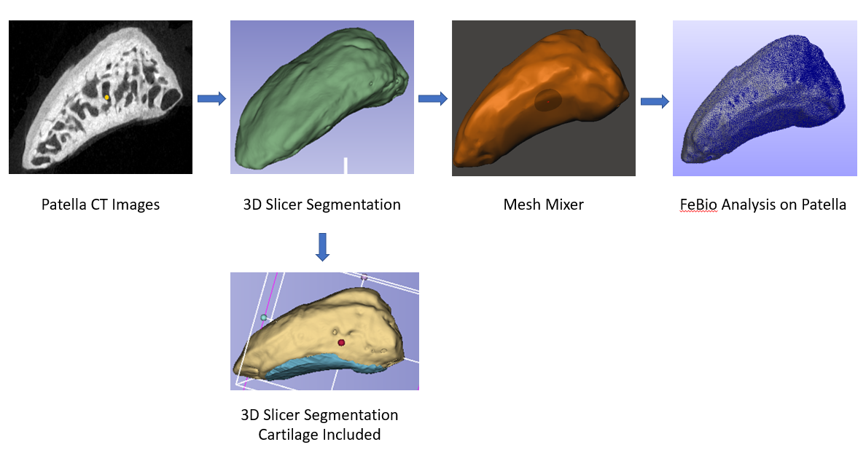
Figure 1 Digital workflow
n/a
Copyright: If you submit images you must either own the copyright to the image or have gained the explicit permission of the copyright holder for the image to be submitted as part of the report for upload to the Society’s website, Newsletter, social media and so forth. A copyright statement must accompany each report if relevant. Answer N/A not applicable, YES or NO in the box below
YES

Signature of student.....................Date…19 – Nov – 2021

Signature of supervisor……........... Date 19 – Nov – 2021

END OF FORM
----------------------------------------------------------------------------------------------------------------------------------------
File: USVRS-AwardandBursaryTemplateLetter 2021 – v2FINALappAMT – 120521-Dr Claire Conway

File: USVRS Report 2020-21 Conway no sigs upload website - 021221

