UNDERGRADUATE SUMMER VACATION SCHOLARSHIP AWARDS – FINAL SUMMARY REPORT FORM 2023/24
NB: This whole report will be posted on the Society’s website therefore authors should NOT include sensitive material or data that they do not want disclosed at this time.

Name of student:
Roisin Ryan

Name of supervisor(s):
Supervisor: Professor Niamh Nowlan
Co-supervisor: Professor Connor Green

Project Title: (no more than 220 characters)
How does hip joint size and morphology influence the risk of avascular necrosis in the paediatric hip?

Project aims: (no more than 700 words)
Legg-Calvé-Perthes disease (LCPD) is a paediatric idiopathic hip disorder that leads to either unilateral of bilateral necrosis of the femoral head.¹ LCPD has a low incidence rate and effects 3–12-year-old males mostly.² While LCPD is not a life-threatening condition, it is life-limiting and the lack of knowledge surrounding the cause of the disease makes diagnosis and treatment difficult. While there are multiple ways to classify the disease, treatment is decided on a case-by-case basis due to the lack of prognostic factors. Treatment methods include rest, medication and surgery and are aimed at maintaining the sphere shape of the femoral head, preventing femoral head collapse and preventing secondary arthritis.² LCPD negatively impacts range of hip-motion causing severe pain and hip deformities. Long-term outcomes of the disease pre-dispose patients to premature osteoarthritis and the requirement for hip arthroplasties.³ As Perry et al. explain, ‘There are few diseases in childhood with such a profound effect on quality of life over such a prolonged period’.^{3(p. 515)}

This retrospective chart review study consisted of patients who underwent a magnetic resonance image (MRI) at Children’s Health Ireland since 2018. While research to date has primarily focused on looking at the affected Perthes’ hip, the main objective of this study was to look at the unaffected contralateral Perthes’ hip of children with unilateral LCPD and compare it with ‘normal’ control hips of children who underwent an MRI for various reasons but whose MRIs were normal. It was hypothesised that there would be some difference(s) in the hip joint size and/or shape between the contralateral Perthes’ hip and an age-matched control normal hip. This difference may show that the contralateral Perthes’ hip is not completely normal and shows signs that may predispose a child to LCPD. Understanding these signs could lead to better diagnosis and treatment outcomes. The main aims defined to complete this study included:

1) Developing an image segmentation protocol to analyse hip MR scans
The first step in carrying out this project was to develop a segmentation process for hip MR scans using two different scan types - both coronal T1 spin echo and coronal T1 spin-echo fat saturated. Synopsys Simpleware, a 3D image processing and segmentation software tool, was used to achieve this aim. Medical images can be uploaded, co-registered and analysed with the goal to divide medical images into a set of meaningful regions with similar qualities like intensity and colour.⁴ Multiple inter-observer tests of segmentation were carried out and the final segmentation protocol included both semi-automated and manual techniques. Methods and defined parameters were developed to segment seven different anatomical regions in the hip. The segmentation method developed throughout this study can be used for further studies in both LCPD and other hip disorders.

2) Generating data through segmentations of two groups of patients – Normal control patients and unilateral Perthes’ patients
Previously collected MRI scans were divided into two separate groups for segmentation. One hip from the normal control patient MRIs and the unaffected contralateral Perthes’ hip from the unilateral Perthes’ patient MRIs were segmented at a time following the segmentation protocol developed above. 16 MRIs were age (3-13-year-olds) and sex matched, as much as the sample would allow. 2D slices were segmented, and the software layered and interpolated these slices, creating patient specific 3D anatomical models.

3) Analysing the volumetric data obtained
From the 3D anatomical models created, numerical and categorical data was used to carry out volumetric analysis to determine the hip joint size differences in the contralateral Perthes’ hip versus the normal control hip. Analysis was done using graphical representations, trendlines, t-tests and Fisher’s r to z transformation to measure significance. Conclusions were made about how hip joint size influences the risk of LCPD in the paediatric hip from this volumetric analysis.

Overall, combining these three project aims meant the overarching aim of gaining a better understanding of what makes some children more susceptible to LCPD could be addressed.

Project Outcomes and Experience Gained by the Student (no more than 700 words)
Firstly, we developed a segmentation which can be used for further studies in both LCPD and other hip disorders. Secondly, we conducted volumetric analysis as this is a vital step in understanding more of what makes some children more susceptible to LCPD. The results obtained from the volumetric analysis in this study are described below;

Volumetric data for all seven regions was generated through segmentation in Synopsys Simpleware. Volumetric data for an eighth region labelled ‘Total Femoral Head’ was calculated by adding four regions’ (E.Bone+E.Cartilage+P.Cartilage+Tissue1) data. This region was excluded for three patients due to mal-alignment of scans (n=13).

When data was graphed, visual trends could be seen indicating differences between contralateral Perthes’ hips and normal control ‘healthy’ hips. From the box and whisker plots (figure 1), it initially appeared that the volumes of the regions in the normal control ‘healthy’ hips tended to be greater than in the age-matched contralateral Perthes’ hips. A two-tailed t-test (table 1) was then conducted to assess this trend and found that there was no statistically significant difference in the volumes between groups in any of the regions.

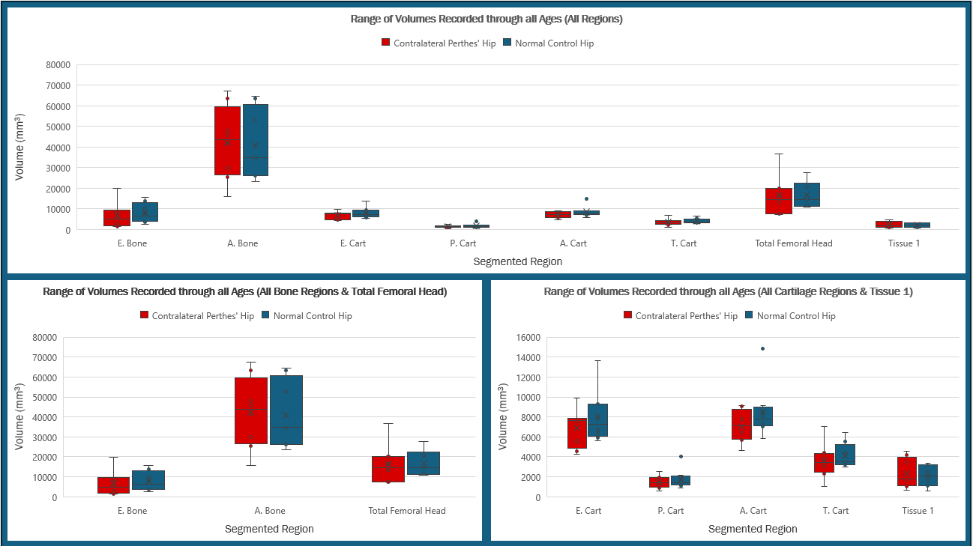
Figure 1: Box and whisker plots showing range of volumetric data obtained through all ages for each segmented region (upper: all regions, bottom (left): all bone regions & total femoral head, bottom (right): all cartilage regions & tissue 1). x = Mean values o = Data points TFH: Total Femoral Head CP: Contralateral Perthes’ Hip N: Normal Control Hip

Table 1: Relevant statistical measurements for all eight regions displayed in figure 1. Null hypothesis: µ_{D}=0 Alternative hypothesis: µ_{D}≠0 CP: Contralateral Perthes’ Hip N: Normal Control Hip

Four regions were extracted for further analysis (figure 2) based on their mean, median and p-values. Fisher’s r to z transformation (table 2) was used to assess the correlation coefficients of the trends in (figure 2) and from this, it was deemed there is no significant difference in the correlation coefficients of all four regions. Finally, it seemed apparent from the trendlines that in each of the four regions volumetric data of the normal control hips was greater than that of the contralateral Perthes’ hips and we decided to refine our t-test to an upper one-tailed t-test (table 2). From this test, it was determined that there is not enough evidence to suggest volumetric data of the normal control hips is greater than that of the contralateral Perthes’ hips.

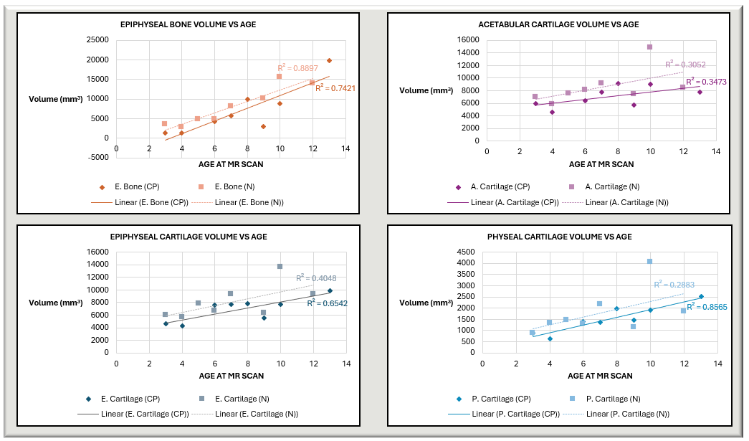
Figure 2: Scatter plots of the four determined most crucial regions. Linear trendlines and corresponding correlation coefficients have been inputted for statistical analysis. CP: Contralateral Perthes’ Hip N: Normal Control Hip

Table 2: Relevant statistical measurements for all four regions displayed in figure 2. Statistical measurements relevant to a one tailed t-test (null hypothesis: µ_{D}=0 and alternative hypothesis: µ_{D}>0) and Fisher’s r to z transformation are displayed (null hypothesis: no significant difference in the correlation coefficients and alternative hypothesis: significant difference in the correlation coefficients). CP: Contralateral Perthes’ Hip N: Normal Control Hip
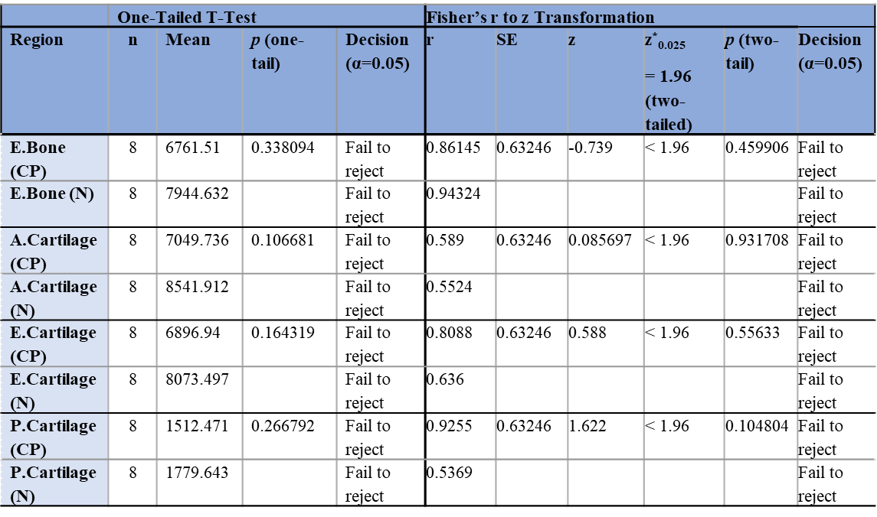

The results presented in this study indicate that there is no statistically significant difference between the main anatomical regions (in terms of volume) between contralateral Perthes’ hips and normal control ‘healthy’ hips. However, it is important to note that the small sample size may have been inadequate to accurately conduct these statistical tests.

Conclusion
The data generated from the two groups – unilateral Perthes’ patients and normal control patients – provides an immense amount of information that can be further analysed to gain a more comprehensive understanding of LCPD. The groups analysed in this study provide a basis for future studies in relation to understanding what makes children more susceptible to LCPD. Overall, more studies like this one should be conducted in the future to gain a better understanding of LCPD so that this life-limiting condition can be better understood and therefore, better tackled so that Perthes’ affected children can live a full childhood.

Experience gained
The experience I have had this Summer has given me a multitude of skills that I will be able to use in the future. Some of these include:
-Learning how to use the segmentation software, Synopsys Simpleware
-Developing detailed protocols
-Understanding how segmentation can be used to address research questions
-Statistically analysing numerical data and presenting findings through graphs
-Communicating research to others in a clear and concise manner
-Working in team settings and communicating knowledge

Please state which Society Winter or Summer Meeting the student is intending to present his/her poster at:
Winter meeting (Depending on dates which are not yet confirmed)

Proposed Poster Submission Details (within 12 months of the completion of the project) for an AS Winter/ Summer Meeting – (no more than 300 words)
INTRODUCTION: Legg-Calvé-Perthes disease (LCPD) is a paediatric idiopathic hip disorder, mainly affecting 3-12-year-old-males, leading to unilateral or bilateral necrosis of the femoral head.¹ At present, there is no known cause of the disease making diagnosis and treatment difficult. While the condition is not life-threatening, it is life-limiting and has many painful implications for the affected child.³
The focus of this study was to compare contralateral Perthes’ hips of children with unilateral LCPD with normal control ‘healthy’ hips. In this study, it was hypothesised that there would be a difference in the hip joint size and/or shape between the contralateral Perthes’ hips and healthy hips of children without LCPD. These differences may predispose children to LCPD and understanding these differences may help in disease prevention, diagnosis and treatment.

METHODS: 16 MRIs, age (between 3-13 years) and sex-matched, as much as the sample would allow, were segmented using a 3D image processing tool called Synopsys Simpleware. Image segmentation is used to divide medical images into a set of meaningful regions with similar qualities like intensity and colour.⁴ Semi-automated and manual segmentation methods of the separate 2D slices were used. The software then created a patient specific 3D anatomical model which was used in the volumetric analysis. (Step-by-step images of the segmentation protocol will be displayed)

RESULTS: Final segmentations, graphs and statistical tables will be displayed to present all findings.

CONCLUSION: Studies like this one which focus on control hips and unaffected Perthes’ hips are vital in determining what makes children more susceptible to LCPD. This may eventually lead to earlier intervention of LCPD and better treatment outcomes. Additionally, the segmentation protocol developed throughout this study can be used in further studies of LCPD.

Brief Resume of your Project’s outcomes: (no more than 200-250 words).
The title of your project and a brief 200-250 word description of the proposed/completed project. The description should include sufficient detail to be of general interest to a broad readership including scientists and non-specialists. Please also try to include 1-2 graphical images (minimum 75dpi). NB: Authors should NOT include sensitive material or data that they do not want disclosed at this time.

HOW DOES HIP JOINT SIZE AND MORPHOLOGY INFLUENCE THE RISK OF AVASCULAR NECROSIS IN THE PAEDIATRIC HIP?

Legg-Calvé-Perthes disease (LCPD) is a paediatric idiopathic hip disorder, mainly affecting 3-12-year-old-males, leading to unilateral or bilateral necrosis of the femoral head.¹ The main objective of this study was to look at the unaffected contralateral Perthes’ hip of children with unilateral LCPD and compare it with ‘normal’ control hips. It was hypothesised that there would be some difference(s) in the hip joint size and/or shape between the contralateral Perthes’ hips and age-matched control normal hips causing some children to be more susceptible to LCPD.

This retrospective chart review study consisted of patients who underwent a magnetic resonance image (MRI) at Children’s Health Ireland since 2018. A segmentation protocol for hip MRIs was developed and 16 MRIs, age (between 3-13 years) and sex-matched, as much as the sample would allow, were segmented using Synopsys Simpleware. Numerical and categorical data was generated from these segmentations.

Volumetric analysis was then carried out on this data. Initially, graphical trends (figure 1) could be seen indicating the volumes of some regions in the normal control hips tended to be greater than in the age-matched contralateral Perthes’ hips. However, through further analysis using t-tests and Fisher’s r to z transformation, no statistically significant differences were found in relation to volume amongst all the anatomical regions between the two groups.

The data and results generated in this study are a vital step towards understanding what makes some children more susceptible to developing LCPD so that disease prevention, diagnosis and treatment can improve.

Figure 1: Box and whisker plots showing range of volumetric data obtained through all ages for each segmented region (upper: all regions, bottom (left): all bone regions & total femoral head, bottom (right): all cartilage regions & tissue 1). x = Mean values o = Data points TFH: Total Femoral Head CP: Contralateral Perthes’ Hip N: Normal Control Hip

Other comments: (no more than 300 words)
Acknowledgements:
I would like to thank Professor Niamh Nowlan for the opportunity to conduct this research and for her support. I would also like to thank Professor Connor Green and Dr Siobhan Hoare for their expert contributions throughout the segmentation process. Finally, I want to thank Hannah Kane and the Perthes’ team for their invaluable help and support during the summer.

References:
1.Kim HKW. Legg-Calvé-Perthes Disease. American Academy of Orthopaedic Surgeon. 2010 Nov;18(11):676–86.

2.Pavone V, Chisari E, Vescio A, Lizzio C, Sessa G, Testa G. Aetiology of Legg-Calvé-Perthes disease: A systematic review. World Journal of Orthopedics [Internet]. 2019 Mar 18 [cited 2024 Jun 11];10(3):145–65. Available from: https://www.ncbi.nlm.nih.gov/pmc/articles/PMC6429000/

3.Perry DC, Arch B, Appelbe D, Francis P, Craven J, Monsell FP, et al. The British Orthopaedic Surgery Surveillance study: Perthes’ disease. The Bone & Joint Journal. 2022 Apr 1;104-B(4):510–8.

4.Despotović I, Goossens B, Philips W. MRI Segmentation of the Human Brain: Challenges, Methods, and Applications. Computational and Mathematical Methods in Medicine [Internet]. 2015 Mar 1 [cited 2024 Jul 31];2015(1):1–23. Available from: https://www.hindawi.com/journals/cmmm/2015/450341/

Data Protection/GDPR: I consent to the data included in this submission being collected, processed and stored by the Anatomical Society. Answer YES or NO in the Box below
YES
Graphical Images: If you include graphical images you must obtain consent from people appearing in any photos and confirm that you have consent. A consent statement from you must accompany each report if relevant. A short narrative should accompany the image. Answer N/A not applicable, YES or NO in the box below
N/A
Copyright: If you submit images you must either own the copyright to the image or have gained the explicit permission of the copyright holder for the image to be submitted as part of the report for upload to the Society’s website, Newsletter, social media and so forth. A copyright statement must accompany each report if relevant. Answer N/A not applicable, YES or NO in the box below
N/A

Signature of student Roisin Ryan Date: 04-Sep-2024

Signature of supervisor Niamh Nowlan Date: 04-Sep-2024

END OF FORM
----------------------------------------------------------------------------------------------------------------------------------------
File: USVRS-Award Letter 2024_ v1-170524_Template_ Professor Niamh Nowlan _200524

File: USVRS Report 2024 Nowlan Ryan website version no sig – uploaded 170924

