UNDERGRADUATE SUMMER VACATION SCHOLARSHIP AWARDS – FINAL SUMMARY REPORT FORM 2022/23
NB: This whole report will be posted on the Society’s website therefore authors should NOT include sensitive material or data that they do not want disclosed at this time.

Name of student:
Anne Thomas

Twitter Handle*:
(*optional)
Name of supervisor(s):
Gavin Clowry
Project Title: (no more than 220 characters)
Investigating the links between neuroinflammation and cortical hyperexcitability
Project aims: (no more than 700 words)
There is a growing body of research showing links between cortical hyperexcitability and increased neuroinflammation in Alzheimer’s disease. In Dementia with Lewy Bodies (DLB) there is evidence that increased network activity is present in the cortex. This may similarly be linked to increased neuroinflammation, as in Alzheimer’s. Investigation of this link is important in understanding more about the causes and progression of the under-researched neurodegenerative condition DLB. The prefrontal cortex is a higher cognitive brain area involved in temporal processing, planning, working memory, flexibility and goal-directed behaviour in both rodents and humans and will be investigated in this project.
The project aims to investigate cortical hyperexcitability and neuroinflammation in a mouse model of DLB. The mouse overexpresses mutant human SNCA gene (encoding human α-synuclein) where the alanine in position 30 is mutated to proline to model the development of α-syn oligomers and aggregates. The mouse model is hyperexcitable from a young age, with cognitive symptoms appearing at 10-12 months first, prior to the motor symptoms which appear at 14 months. The project aims to investigate potential links between hyperexcitability and neuroinflammation in this model within the PFC.
Cortical hyperexcitability is studied by recording local field potentials in the anterior cingulate cortex (a subdivision of the PFC). This will be induced in the sectioned cortical tissue using 4-Aminopyridine (4AP), which blocks potassium channels. This process has been trialled by a previous summer student who optimised the concentration of 4AP to be used. Slices will be taken from young, WT animals between 2 to 4 months old. There will be recording for 3 hours consistently, from deep layer 6 of the ACC to study the frequency and duration of seizures in the tissue.
The fixed sections from the electrophysiology experiments will then be subjected to staining for markers of activation and neuroinflammation. This aims to draw correlations between the 4AP treatment inducing the hyperexcitability and the inflammatory state of the cortex. Staining for GFAP and Iba-1 will indicate the prevalence of reactive astrocytes and microglia in the tissue. This aims to demonstrate the effect of stressing the tissue on neuroinflammation. Staining for c-Fos, parvalbumin and WFA will indicate the activation state of neurons and parvalbumin interneurons in the tissue, as well as the structure of the extracellular matrix structures, perineuronal nets, in the tissue. This is interesting because, in animal models of Alzheimer’s disease, microglia break down the PNNs and expose neurons to oxidative stress. Therefore, if the PNNs are broken down under these conditions, they may be more vulnerable and show changes in their activity. The staining, therefore, builds a bigger picture of the factors affecting hyperexcitability in cortical tissue.
Studying this in both the wild-type and the A30P mouse model system aims to show the effect of the DLB pathology on the cortical hyperexcitability and neuroinflammation. This could suggest reasons for the DLB symptoms that link to the cellular state of the neural tissue.

Project Outcomes and Experience Gained by the Student (no more than 700 words)
During the project, due to the need to refresh the the A30P transgenic mouse line, we were unable to study any of these mice. This means that we were unable to compare the differences in cortical hyperexcitability or the neuroinflammation in the transgenic line with the wild type mice. However, it was possible to build a strong base of control data. This involved comparing the hyperexcitability and the neuroinflammation of wild-type brains under stressed conditions (750 micromolar 4AP treatment for 3hrs) with sections that had only been treated with artificial cerebral-spinal fluid (aCSF). This allowed the effect of the stress of the neuroinflammatory and activity markers to be studied in the wild-type mice to show the effect of the 4AP on the cortical tissue. The experiments can be repeated in, and compared with the A30P mice at a later date so that the difference in the DLB model can be studied.
Electrophysiology:
Previous electrophysiology studies with incremental 4AP concentrations had demonstrated that at 750 micromolar there were some seizures in both the wild-type and the A30P mice, indicating a greater prevalence in the A30P mice. For this reason, the 750 micromolar concentration was chosen. Over the course of the project, 6 mice were sectioned and studied. Under the control condition of aCSF, no seizures were seen (defined as activity reaching 3x over baseline and lasting 5s or above from the point of initial diversion from the baseline) (Figure 1b). In the 4AP treated mice, seizures were seen in all but one of the samples (Figure 1a), with an overall mean duration of 10.29s (±2.09). This showed that the 4AP reliably induces seizures in the cortical tissue.
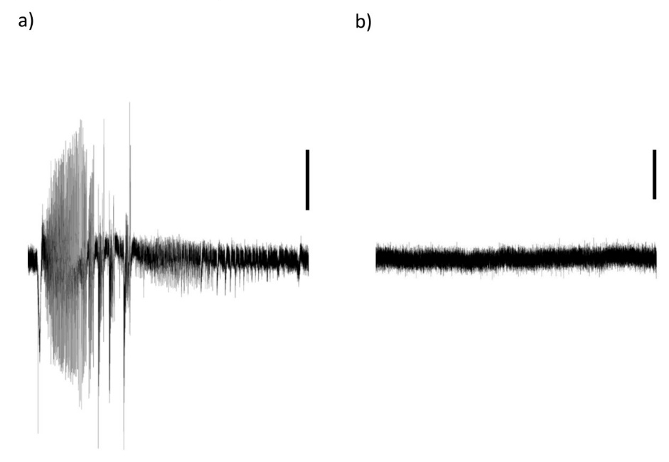
Figure 1: Comparison of continuous recording traces from the 4AP treated and the control tissue taken from the same mouse on the same day. a) Trace from 70-71 mins in 4AP treatment, scale bar = 100mV b) Trace from 71-72 mins in control aCSF treatment, scale bar = 100mV
Immunohistochemistry:
The stained 40μm tissue slices sectioned from 450μm was imaged using confocal microscopy, taking four three dimensional images of each slice at consistent positions on the anterior cingulate cortex of the mouse PFC. Fiji analysis of the GFAP and Iba-1 staining showed that in the wild-type tissue there was no significant difference between the area of staining in the 4AP treated and the aCSF control tissue (Figure 2). This was unexpected, as it was hypothesized that the stress of the 3hr 4AP treatment would increase the presence of neuroinflammatory markers in the tissue. However, there is the potential that the sectioning and the placement of the tissue on the rig during the electrophysiology for 3hrs is increasing the background neuroinflammation so that any change induced by the 4AP treatment on the microglia and astrocytes is disguised. This could be tested by comparing to a section that is immediately fixed after sectioning.
In the c-FOS, WFA for PNN and PV-stained sections it was demonstrated that there was a trend of increased number of c-FOS activated cells in the 4AP treated tissue (mean = 50.3 cells) than the control tissue (mean = 27.2 cells). It was also demonstrated that there was a significant increase PV staining in the 4AP treated tissue (mean = 12.7%) compared to the controls (mean = 2.17%) (p = 0.0395) (Figure 3). In the 4AP treated slices , the c-FOS activation positively correlated with the %Area of PV staining, however this was not the case in control slices (Figure 4). Together this demonstrates that 4AP treatment affects the activation of the cells within the PFC and changes the interneuron activation of the tissue.
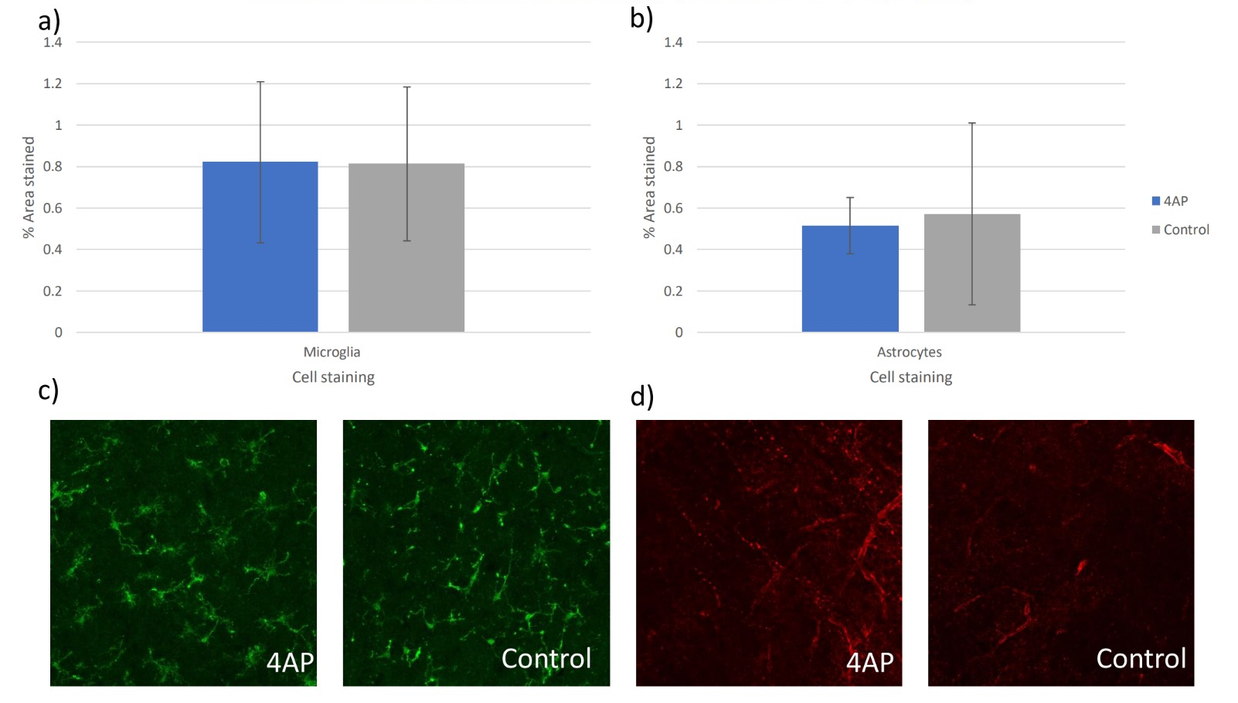
Figure 2: Comparison and quantification of neuroinflammatory staining under conditions of 4AP treatment and control aCSF treatment. a) Graph comparing the %Area of microglia staining in each image from tissue treated with 4AP for 3hours (blue) with aCSF control treatment (grey). b) Graph comparing the %Area of astrocyte staining in each image from tissue treated with 4AP with aCSF control treatment. c) Representative images from the 4AP treated (left) and control treated (right) conditions of the microglia staining. d) Representative images at 40x magnification from the 4AP treated (left) and control treated (right) conditions of the astrocyte staining. ​

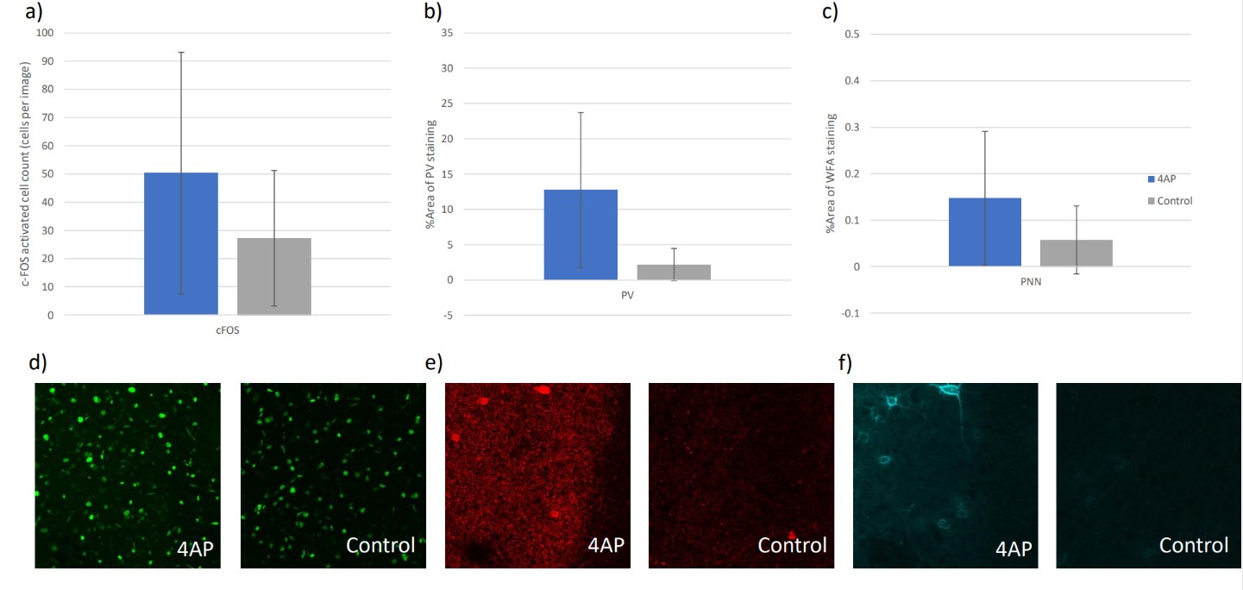
Figure 3: Comparison and quantification of neuron activation and Perineuronal net structure under conditions of 4AP treatment and control aCSF treatment. a) Graph comparing the cFOS activated cell counts per image from tissue treated with 4AP (blue) for 3hours compared to that treated with aCSF (grey) (p = 0.260). b) Graph comparing the %Area of PV staining in each image from tissue treated with 4AP for 3hours to that treated with aCSF (p = 0.0395). c) Graph comparing the %Area of PNN staining in each image from tissue treated with 4AP for 3hours to that treated with aCSF (p = 0.186). d) Representative images from the 4AP treated (left) and control (right) conditions of the cFOS staining. e) Representative images from the 4AP treated (left) and control (right) conditions of the PV staining. g) representative images at 40x magnification from the 4AP treated (right) and the control (left) conditions of the PNN staining. ​
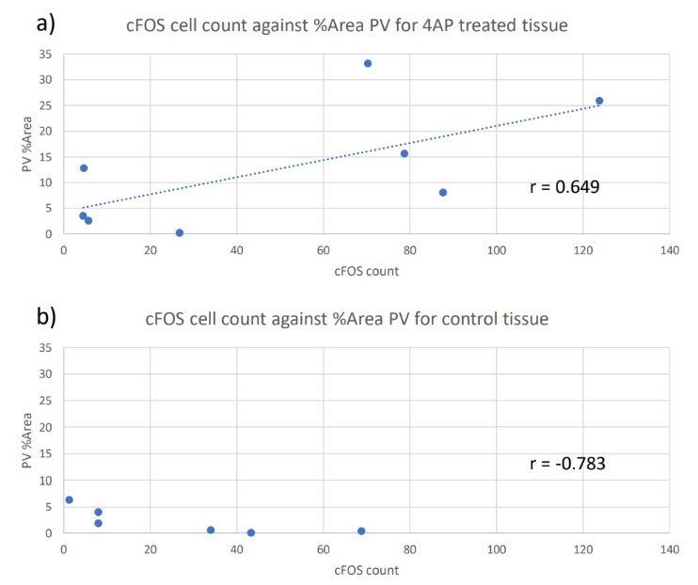
Figure 4: Comparison of correlation between cFOS and PV staining in 4AP treated tissue compared to in aCSF treated tissue. a) Graph showing correlation between the cFOS activated cell count against the %Area PV staining under 4AP treated conditions. b) Graph showing correlation between the cFOS activated cell count against the %Area PV under control conditions. ​

Experience:
The project has been a fantastic opportunity to expand my understanding of neuroscience, to grow my practical and analytical skills, and to immerse myself in the culture of academic, experimental study. I learned to independently carry out electrophysiology studies and analyse the resulting data. Discussion of the data, and the complexities of the factors affecting it demonstrated the challenges and excitement of biological research. Although I was unable to independently use the confocal microscope, I learned to develop analysis protocols for the resulting images. This is an important skill, and showed the importance of trying to reduce bias in the analysis and ensure accurate quantification.

Please state which Society Winter or Summer Meeting the student is intending to present his/her poster at:
Summer meeting

Proposed Poster Submission Details (within 12 months of the completion of the project) for an AS Winter/ Summer Meeting – (no more than 300 words)
Investigating the links between neuroinflammation and cortical hyperexcitability

Brief Resume of your Project’s outcomes: (no more than 200-250 words).
The title of your project and a brief 200-250 word description of the proposed/completed project. The description should include sufficient detail to be of general interest to a broad readership including scientists and non-specialists. Please also try to include 1-2 graphical images (minimum 75dpi). NB: Authors should NOT include sensitive material or data that they do not want disclosed at this time.

Investigating the links between neuroinflammation and cortical hyperexcitability
Neurodegenerative diseases, including Alzheimer’s disease, Parkinson’s disease, and Dementia with Lewy Bodies, show complicated pathologies, with changes in neuroinflammation and network excitability. The interplay of these features and their involvement in disease progression is a key area of investigation. There has been demonstration that in a transgenic mouse model of Dementia with Lewy Bodies there is a correlated increase in network hyperexcitability and the neuroinflammatory markers of astrocytes and microglia. The study investigates the link between these pathologies in the anterior cingulate cortex (ACC) of wild-type mice.
Here we show that there is a significant increase in parvalbumin activation in ACC neurons where the tissue had been treated with the potassium channel blocker 4-aminopyridine (4AP) to induce hyperexcitability. This is correlated with an increase in neuronal activation indicated by an increase in c-FOS expression in the neuronal tissue. The results did not show any change in the activation of microglia or astrocytes in the ACC. These results show that inducing hyperexcitability in wild-type cortical tissue changes the activity profile of the tissue within the interneurons, this fits with the changing activation of the neurons as seen in their electrical activity. The lack of difference in the neuroinflammation of the wild-type mice after the 4AP treatment is unexpected. Future comparison to the transgenic mouse model will demonstrate if this differs in the disease model. This will indicate involvement of these pathologies in the disease progression.

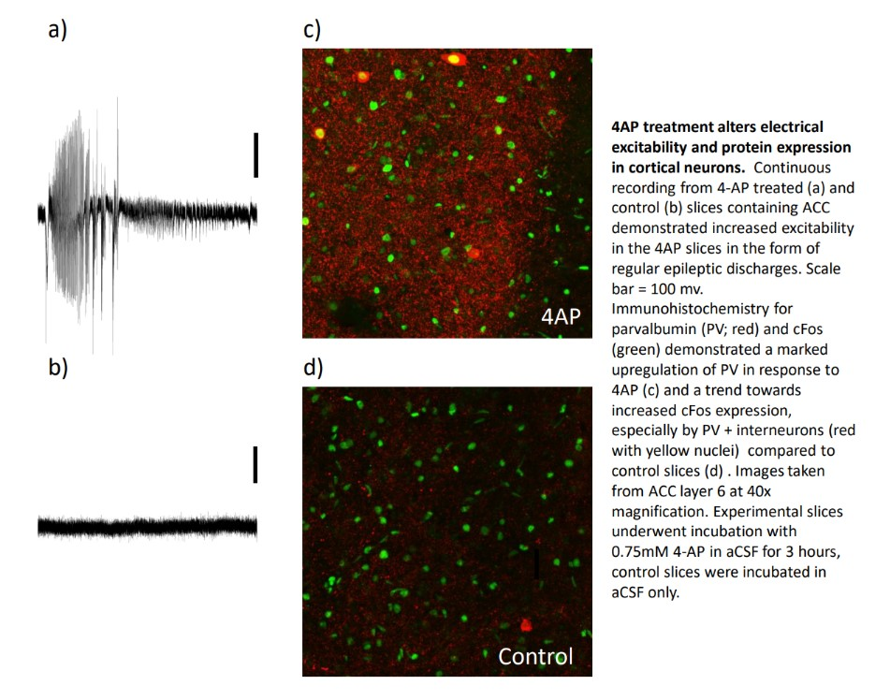

Other comments: (no more than 300 words)

Data Protection/GDPR: I consent to the data included in this submission being collected, processed and stored by the Anatomical Society. Answer YES or NO in the Box below
Yes
Graphical Images: If you include graphical images you must obtain consent from people appearing in any photos and confirm that you have consent. A consent statement from you must accompany each report if relevant. A short narrative should accompany the image. Answer N/A not applicable, YES or NO in the box below
N/a
Copyright: If you submit images you must either own the copyright to the image or have gained the explicit permission of the copyright holder for the image to be submitted as part of the report for upload to the Society’s website, Newsletter, social media and so forth. A copyright statement must accompany each report if relevant. Answer N/A not applicable, YES or NO in the box below
Yes

Signature of student..............A.THOMAS............Date…04/10/2023

Signature of supervisor……………G. CLOWRY...... Date…5th October 2023……….…

END OF FORM
----------------------------------------------------------------------------------------------------------------------------------------
File: USVRS Report 22-23 Clowry Thomas – No sig website version 111023

