**­­­­­­­­­­­­­­­­**

**UNDERGRADUATE SUMMER VACATION SCHOLARSHIP AWARDS – FINAL SUMMARY REPORT FORM 2023/24**

***NB: This whole report will be posted on the Society’s website therefore authors should NOT include sensitive material or data that they do not want disclosed at this time.***

**Name of student:**

Isabel Leighton

Twitter Handle*:

*(*optional)*

**Name of supervisor(s):**

Dr Craig Molloy-Humphreys

**Project Title: (no more than 220 characters)**

Evaluating the use of Lugol’s solution as a topical stain for the gross dissection of facial muscles in Rhesus Macaque (Macaca mulatta).

**Project aims: (no more than 700 words)**

The overall aim of this project was to explore the use of Lugol’s stain (LS) and validate its use as a tool within gross dissection of the facial musculature of rhesus macaque *(Macaca mulatta) and* to develop a method for doing so. To effectively establish this technique, four smaller project aims were established. They are as follows:

1.  Validate the use of LS as a topical stain for use on facial muscles.

2.  Compare the use of the stain as a topical stain versus submersion perfusion.

3.  Test the efficacy of different concentrations of LS.

4.  Apply topical staining to previously published specimens to evaluate the elucidation of new data.

From these aims, we will be able to understand the different variables that create an effective staining technique and how to adapt them to the studied model, rhesus macaques. Comparing the methods of perfusion and topical staining will give us a greater insight into how the solution works and the differences between the two techniques. As this method of staining has not been previously studied upon rhesus macaques, our understanding of the concentrations necessary to increase the visibility of the facial musculature is limited. Therefore, it is essential to test the efficacy of different concentrations to develop the most effective method to achieve greater definition of the muscle fibres studied. Comparing our findings with previous research will validate the use of LS, and specifically the method developed within this research.

Developing a cost effective, reproducible and adaptable method for visualising musculature, in this case facial musculature is of interest to the Anatomical community. The current common method to increase the visibility of structures for study are imaging techniques such as DiceCT. Submersion in an iodine-based solution, such as LS is an essential step for DiceCT scanning, however this submersion requires an extensive amount of time as well as technology that is not readily available to those wishing to explore and visualise muscle fibres in this way. Therefore, developing an effective way to visualise musculature without the time and financial constraints of DiceCT is vital. The possibility of using LS, an iodine and potassium iodine-based stain, to improve the visualisation of muscle fibres within gross dissection was presented by Bock and Shear in 1972. The investigation performed by Bock and Shear (1972) examined the jaw and tongue muscles of small Passerine birds, with aid of the staining process they experienced ‘uniformly excellent results. Additionally, this technique allowed for identification of muscle fibres not previously visible to them. The findings, however, have not been further explored in current research until this study.

This study focuses on mimetic musculature which is present in all mammalian species and provides the foundation for non-verbal communication. Work surrounding the facial musculature of non-human primates is limited, impacting our understanding of the variation which exists within facial musculature. Despite being the most commonly used non-human primate model species for modern humans in biological and medical studies, Rhesus macaques are not exempt from a lack of understanding around the variation present within the species facial musculature.  Studies which explore the facial musculature of rhesus macaques are often limited for several reasons which include difficulties in acquiring tissue, and difficulties distinguishing the muscle fibres from the surrounding fascia and other structures.

Overall, by exploring the method created by Bock and Shear (1972) we will gain a greater insight into the variation and muscles present within the mimetic musculature of rhesus macaques and established an accessible method to study indeterminable muscles.

References

**Bock WJ, Shear CR** (1972) A staining method for gross dissection of vertebrate muscles. *Anat Anz* **130**, 222–227.

**Project Outcomes and Experience Gained by the Student (no more than 700 words)**

The development of this method began by investigating 4 smaller aims listed above. Each aim was thoroughly explored to create an effective procedure capable of increasing the visibility and definition of muscle fibres.

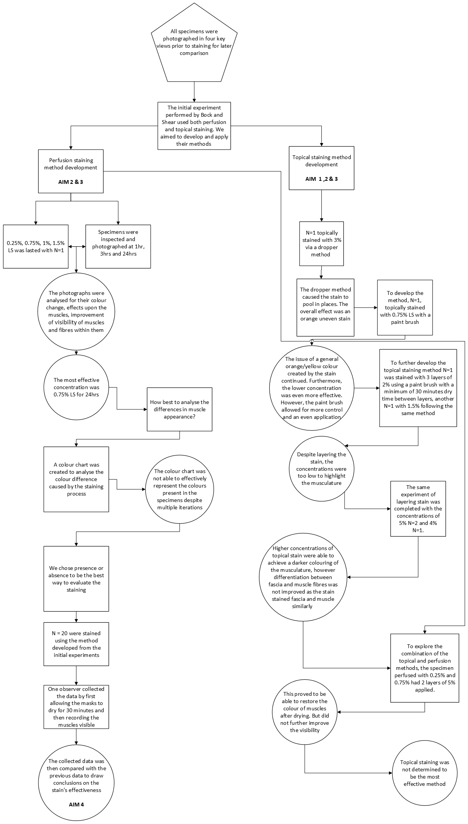Figure one: A flow chart summarising diagrammatically the experimental designed process followed. Two pathways branching from the initial experimental design performed by Bock and Shear demonstrates the experiments performed to explore the four aims of the study.

From the initial experiments, an effective method for staining the facial musculature of rhesus macaques has been developed.

1. First specimens should be removed from their preservative fluid, in this case a 50/50 solution of methanol and water, and have the excess fluid removed by first being patted dry and then air dry for a minimum of 10 minutes.
2. Then masks of the specimens should be carefully rolled into a shape suitable for placement within an amber glass container filled with 950ml of 0.75% LS. Before placement within the receptacle excess fluid must first be removed and returned after the specimen has been put into a position that allows for all surfaces of the specimen to be exposed to the solution. Failure to properly expose all surfaces to the stain will result in the areas unexposed remaining their original colour disrupting the overall view of the mask.
3. Specimens should then be stored safely for 24hrs out of direct sunlight.

Perfusion for 24hrs yields a uniform orange - brick red colour within the facial muscles and the surrounding fascia a paler beige. The colour difference between the two structures allows for easy differentiation and a greater ease when examining the fibres within muscle slips. Post perfusion one may easily identify the different muscles present and their origins and insertions within the specimen. Variation present across individual specimens is also easier to identify and analyse with the presence of staining.When this technique of using LS was first performed by Bock and Shear the pair reported removal of the stain could be completed with ease, however we found this to be false. Effective removal of the stain requires multiple periods of submersion within 50/50 to leach out LS. Each leeching period can be seen to remove areas of the stain with the edges of muscles such as the platysma being the most difficult to remove. However, leeching specimens can be used to create a more even stain across the musculature, as well as lighten the overall appearance of the mask which in instances of over saturation can be useful.

The data obtained was then compared to a previous study that demonstrated the presence of Frontalis, Corrugator supercilii, Orbicularis oculi, Orbitoauricularis, Levator labii superioris, Levator anguli oris, Buccinator, Platysma, Mentalis, Depressor anguli oris, Orbicularis oris, Zygomaticus major and minor and Zygomatico-orbital muscle mass. However definitive identification of these muscles is difficult due to a lack of colour difference between muscles.  The presence of these muscles was easily confirmed after the specimens were stained.   Levator labii superioris alaeque nasi and Procerus were recorded as present within the previous study, but we could not clearly identify these muscles in this study due to over/under dissection within the nasal area of the specimens. Despite this a colour change was still evident in this area; to confirm the presence of these muscles the staining technique would be best implemented within the dissection process.

Prior to this project I had no experience within active research or the protocols necessary to fund research, a vital skill for my future career progression. With this studentship I have gained the valuable experience of:

- Successfully developing a research application.

-  Progressing and integrating ideas to effectively develop a reproducible methodology for a technique I had no previous experience in requiring me to use skills in adaptation and problem solving.

- Learning new laboratory techniques such as: creating stock solutions and dilutions, imaging specimens as well as data and laboratory management.

**Please state which Society Winter or Summer Meeting the student is intending to present his/her poster at:**

**Winter 2024/5: 6-8th January, 2025. University of Central Lancashire (UCLAN), Preston**

**Proposed Poster Submission Details (within 12 months of the completion of the project) for an AS Winter/ Summer Meeting – (no more than 300 words)**

Title:

**Investigating the effectiveness of different concentrations of Lugol’s solution on visualising the facial musculature of the Rhesus Macaque using topical and perfusion staining.**

Introduction:

Facial musculature in non-human primates, particularly rhesus macaques, remains understudied due to challenges in tissue acquisition and distinguishing muscle fibres from surrounding structures. DiceCT scanning, which enhances soft tissue visibility using iodine-based stains like Lugol’s solution, is limited by time and technological constraints. This study explores the practicality of using Lugol’s stain in gross dissection to visualise muscle fibres, building on Bock and Shear’s 1972 work, which yielded excellent results in visualising previously hidden jaw and tongue muscles in small birds. However, their findings have not been further investigated in recent research.

Methods:

20 rhesus macaques were photographed in four key positions for later comparisons. An initial experiment replicating the topical method used by Bock and Shear (1972) was completed and then was further developed. Despite the adaptations completed, the visibility of facial musculature of rhesus macaques did not improve with topical method of staining as expected. However, perfusion experiments demonstrated that perfusing 0.75% LS for 24hrs was the most effective way of increasing the visibility of the facial musculature. The method developed was then applied to N = 20 specimens. One observer recorded the muscles visible to them after staining and this data was then compared to previously published data.

Results:

Photographic evidence illustrated the clear and positive effects of perfusing specimens with 0.75% LS for 24hrs, and the variability of success achieved with different methods. Comparison of data confirming the presence of different 15 muscles within rhesus macaque facial musculature.

Conclusion:

This study demonstrates the effective use of LS as a tool within gross dissection of the facial musculature. This may lead to more researchers being able to study indiscriminate muscle fibres by using the developed method.

**Brief Resume of your Project’s outcomes**: **(no more than 200-250 words)**.

*The title of your project and a brief 200-250 word description of the proposed/completed project. The description should include sufficient detail to be of general interest to a broad readership including scientists and non-specialists. Please also try to include 1-2 graphical images (minimum 75dpi). NB: Authors should NOT include sensitive material or data that they do not want disclosed at this time.*

 Evaluating the use of Lugol’s solution as a topical stain for the gross dissection of facial muscles in Rhesus Macaque (Macaca mulatta).

The overall aim of this project was to explore the use of Lugol’s stain (LS) and validate its use as a tool within gross dissection of the facial musculature of rhesus macaque (Macaca mulatta) and to develop a method for doing so. Creating an accessible, time and cost-effective method to effectively visualise muscle fibres will allow anatomists an opportunity to explore understudied areas within anatomy, such as the facial musculature of rhesus macaques.

Through experimentation of different concentrations of LS and methods of staining, a procedure to increase the visibility and definition of facial musculature that was previously unclear to the naked eye was curated. Musculature perfused with 0.75% LS for 24 hours yields a brick red colour that is discriminative against the paler fascia surrounding it.  The success of the procedure was confirmed by a comparison of muscles found after staining by one observer to the muscles visible in a previous study. 15 muscles were confirmed as present, and their variation recorded. Development of this method also demonstrated that removal of the stain was not as easily completed as the previous literature stated but instead could be used as a tool to control the saturation of the musculature.

The results gained from this study cumulated in an accessible method of increasing the visibility of muscle fibres.

**Other comments: (no more than 300 words)**

I would like to thank my supervisor Craig Molloy-Humphreys for all for the support and care that has gone into this project. I would also Charlie Ritchie for his ingenuity and for all the advice given over this summer. Their combined assistance in this project has been invaluable. I wish to extend my thanks to those working on the FACEDIFF project for providing the foundation of this project. I would also like to the Anatomical Society of Great Britain and Ireland for this fantastic opportunity.

**Ethics statement:**

The specimens were collected and previously dissected as part of the European Research Council (ERC) funded FACEDIFF project (Grant Agreement No. 864694). Both the previous dissection, and the current work falls, under the AWCO245 ethical approval from the University of Liverpool Animal Welfare and Ethics Committee.

|  |
| --- |
| **Data Protection/GDPR**: I consent to the data included in this submission being collected, processed and stored by the Anatomical Society. Answer YES or NO in the Box below |
| YES |
| **Graphical Images**: If you include graphical images you must obtain consent from people appearing in any photos and confirm that you have consent. A consent statement from you must accompany each report if relevant. A short narrative should accompany the image. Answer N/A not applicable, YES or NO in the box below |
| N/A |
| **Copyright**: If you submit images you must either own the copyright to the image or have gained the explicit permission of the copyright holder for the image to be submitted as part of the report for upload to the Society’s website, Newsletter, social media and so forth. A copyright statement must accompany each report if relevant. Answer N/A not applicable, YES or NO in the box below |
| N/A |

*Signature of student............Isabel Hope Leighton.......Date…23/09/2024………..*

*Signature of supervisor……Craig Molloy-Humphreys...... Date……23/09/2024…….…*

END OF FORM

----------------------------------------------------------------------------------------------------------------------------------------

*File: USVRS-Award Letter 2024_ v1-170524_Template_ Mr Molloy-Humphreys _200524*

*File: USVRS Report 2324 MH IHL no sig website version uploaded 250924*