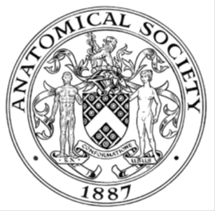
_______________________________________________________________________________________
AWARDEE REPORT FORM
_______________________________________________________________________________________

NAME |  | Amy Wilkinson
UNIVERSITY |  | University of Cambridge
NAME OF AWARD |  | Barclay Smith Award
PURPOSE OF AWARD conference/event attended/organised (full name) with city and dates.
Attendance of the Anatomical Society Winter Meeting in Lancaster between 18th-20th December 2019

REPORT: What were your anticipated benefits?
I anticipated to gain experience of presenting findings to the wider scientific community in the form of a poster. Also, to learn about different areas currently being researched in the area of anatomy.
COMMENTS: Describe your experience at the conference / lab visit / course / seminar/ event.
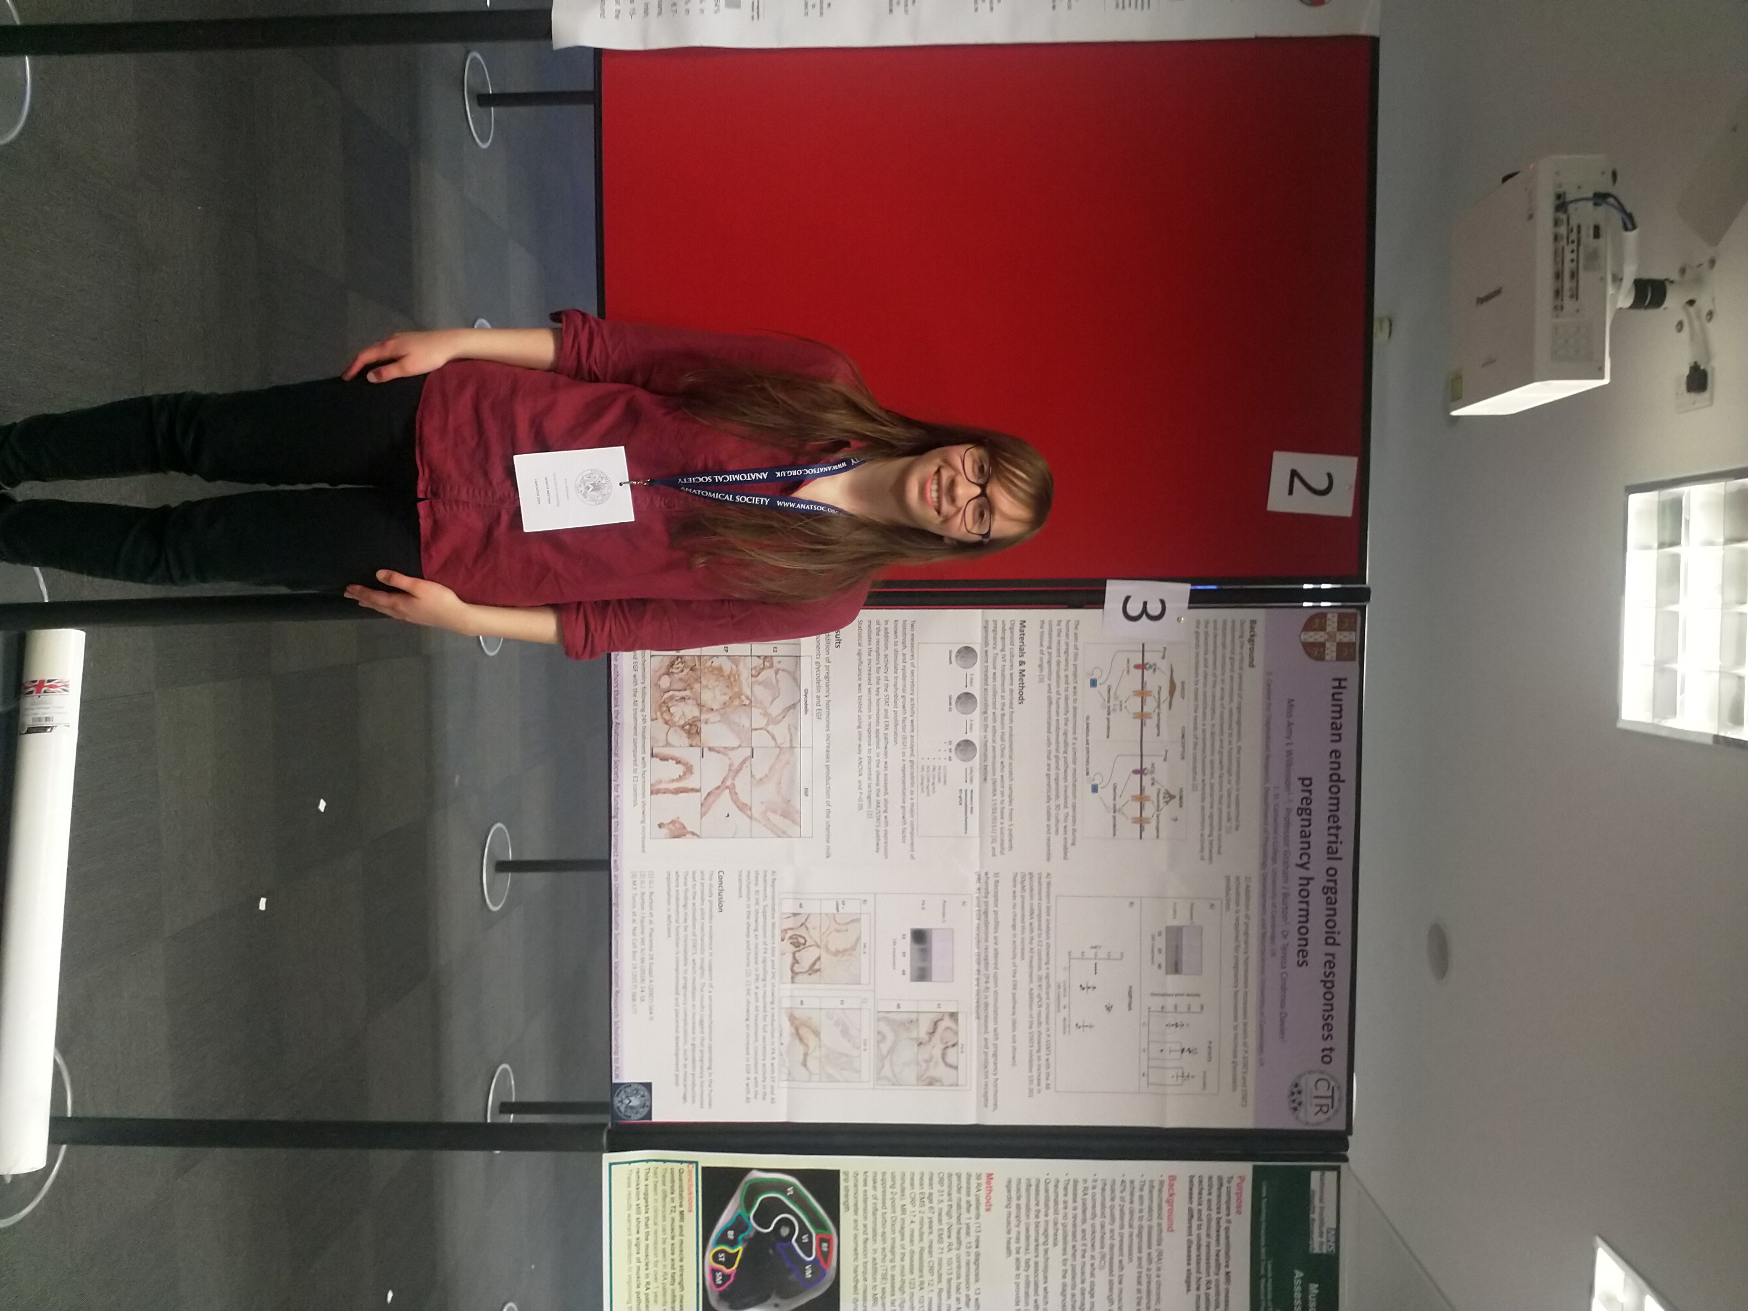
I really enjoyed having the opportunity to attend this conference. There was a wide range of topics covered in the talks, some of which I found surprisingly intriguing. I presented my poster on the first day which allowed me to chat to other people about the work I had done – something I had not previously had the chance to do. I also met some of the other students awarded the USVRS, and it was good to compare experiences.

REPORT: In relation to skills, what were the most important things you gained? (does not apply to equipment grant. For public engagement/outreach awards what did your audience gain and how did you evaluate success?
Most importantly I gained experience in presenting my work to people who were not familiar with my field. This was challenging, but I feel I improved throughout. I was also able to identify skills simply from watching people deliver talks, in terms of good communication.
REPORT: How do you think you will put this learning experience into practice in the future? For public engagement/outreach awards how with the materials/knowledge generated by this activity be used in the future?
I will definitely put this learning experience into practice as part of the final year of my degree, where I will have to present another poster and participate in a viva voce examination to answer questions about my research project. These skills will also be valuable further in the future regardless of what career I have, as they are generally transferable skills.
Data Protection/GDPR: I consent to the data included in this submission being collected, processed and stored by the Anatomical Society. Answer YES or NO in the Box below
Yes

Graphical Images: If you include graphical images you must obtain consent from people appearing in any photos and confirm that you have consent. A consent statement from you must accompany each report if relevant. A short narrative should accompany the image. Answer N/A not applicable, YES or NO in the box below
Yes

Copyright: If you submit images you must either own the copyright to the image or have gained the explicit permission of the copyright holder for the image to be submitted as part of the report for upload to the Society’s website, Newsletter, social media and so forth. A copyright statement must accompany each report if relevant. Answer N/A not applicable, YES or NO in the box below
Yes

SIGNATURE | Amy Wilkinson |  | DATE | 20/12/19
If submitted electronically, a type-written name is acceptable in place of a hand-written signature

File: Wilkinson Amy – BSR11920-No sig app upload

