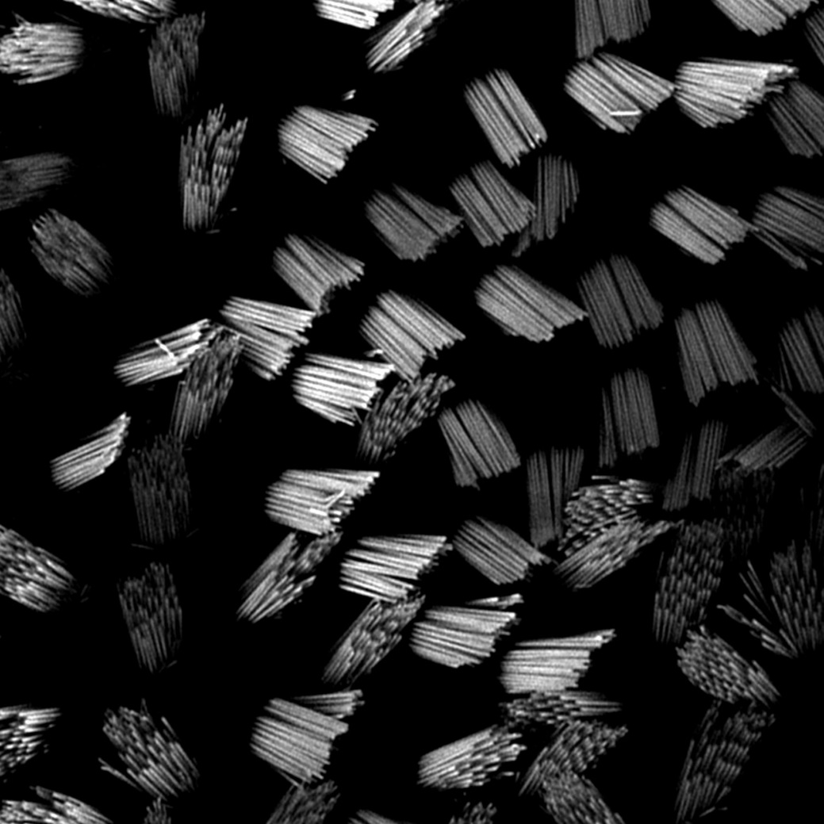

File: Zoe Mann – Hair Cell stereocilia – v1 - 251122

