Title: Development of an iPSC loaded biomimetic scaffold for spinal cord applications

Following spinal cord injury, a lesion cavity forms preventing axonal regrowth and despite the ongoing development of cell-replacement therapies, repair remains a challenge. Therapeutic biomaterial scaffold implants that mimic the properties of the spinal cord and can bridge the cavity with a supportive environment while delivering cells to support axons may have potential. Therefore, this PhD aimed to identify growth-promoting extracellular-matrix proteins and incorporate them into scaffold implants with cord-matched physicochemical properties. By optimizing scaffold stiffness and matrix-composition, it was hypothesized that a scaffold platform that could support neurons, astrocytes, and trophic induced pluripotent stem cell (iPSC) derived-progenitors could be developed to promote cord repair. Extensive screening of cord native extracellular-matrix proteins revealed a combination of collagen-IV (CIV) and fibronectin (FN) best enhanced neuronal and astrocyte outgrowth. Next, hyaluronic acid scaffolds functionalized with Coll-IV/FN were manufactured with differing stiffness’s from soft/biomimetic to stiff/supra-physiological (0.8-3.5kPa). Astrocytes cultured in soft but not stiffer CIV/FN scaffolds exhibited stellate morphologies and upregulated the anti-inflammatory cytokine, IL-10. Furthermore, soft Coll-IV/FN scaffolds also promoted iPSC-progenitor cell growth into large cellular spheroids. Media taken from soft CIV/FN scaffold-containing iPSC-progenitors and applied to spinal cord neurons, significantly enhanced neurite outgrowth. Finally, when dorsal root ganglia (DRG) explants were cultured on CIV/FN iPSC-loaded scaffolds up to 21 days, only soft scaffolds directed axonal outgrowth between DRG and iPSC-spheroids (Figure 1). Overall, this work shows the successful development of a novel biomimetic scaffold that when combined with iPSC-progenitors has significant therapeutic potential for spinal cord repair.

This work also received funding from the IRFU Charitable Trust and the SFI-AMBER Centre and has been published in Advanced Healthcare Materials https://doi.org/10.1002/adhm.202101663

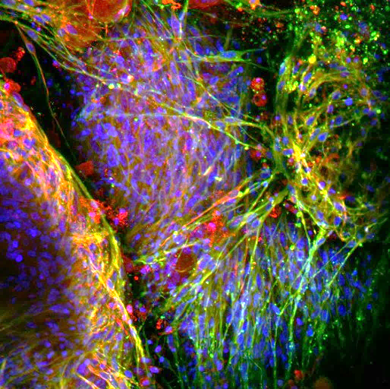

Figure 1. Biomaterial implants mimicking the structure of the spinal cord allow patient derived stem cell spheres (top-right) to connect with damaged nerves (bottom-left), replacing lost neural tissue. The biomaterial that these cells reside within supports the formation of neurites (green) across a bridge of supportive cells (red) offering new hope as a cell replacement strategy for spinal cord repair.
File: O’Brien and O’Connor Updated PR_ Uploaded 190923

