Title of the project: ROLE OF CALCIUM DEPENDENT NEUROTRANSMISSION IN SELECTED POPULATIONS OF CORTICAL PROJECTION NEURONS IN CORTICAL DEVELOPMENT

Early development of the brain depends on neuronal activity. The developing nervous system displays distinct spontaneous and sensory-driven neuronal activity patterns (Katz and Shatz, 1996). Such activity can influence other neurons through multiple routes, with varying consequences. Decreased pyramidal cell activity through chemogenetic inactivation of a large group of cortical neurons promoted PV+ interneuron death (Wong et al. 2018; Denaxa et al., 2018). These original studies were not designed to test whether the interaction between pyramidal cells and interneurons is trophic or entirely based on synaptically transmitted activity levels, although the latter is strongly supported by the observation that prior activity levels predict an interneuron’s likelihood of survival (Wong et al. 2018).
We wish to understand these mechanisms and link findings in mouse to human pathology.

We hypothesize:

1. Early interactions between glutamatergic projection neurons and GABAergic neurons determine the number and distribution of GABAergic interneurons. We can distinguish between trophic versus synaptic communication in our SNAP25 cKO mouse, in which regulated vesicular release is absent in selected populations of cortical projection neurons (layer 5,6 or 6b), but spontaneous vesicular release and constitutive neurotransmitter release is still present.

2. We shall observe Snap25 polymorphisms and reduced levels of SNAP25 protein in the very same human post-mortem specimen of patients with schizophrenia or autism where reductions in GABAergic CR+ interneurons in the human caudate putamen have been reported (Adorján et al., 2017, 2018; n=24 specimen for autism and schizophrenia each).

3. We shall find changes of CR+ or PV+ interneurons in well-established mouse models of schizophrenia such as the neuregulin-1 overexpressing mouse (Deakin et al., 2009), since the synaptic release mechanisms have been implicated in schizophrenia and there is a change in the GABAergic interneuron numbers and distribution in human basal ganglia and cortex.

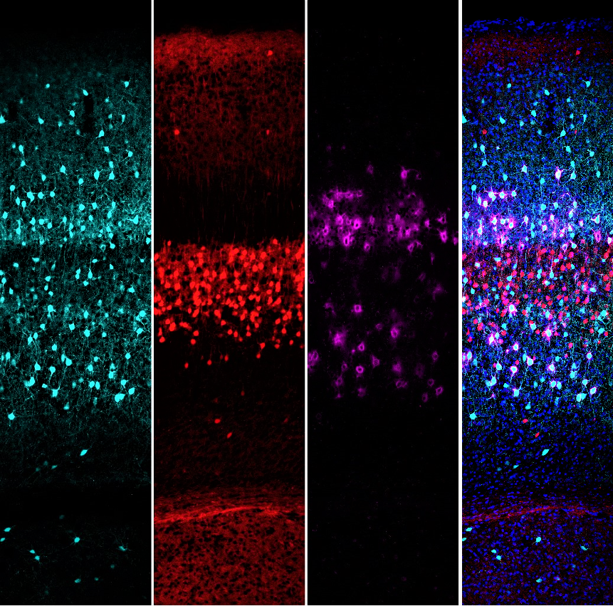

Confocal image of a SNAP25 conditional knockout mouse primary somatosensory cortex showing ‘silenced’ layer 5 glutamatergic pyramidal neurons (red), parvalbumin GABAergic interneurons (cyan), and the perineural net surrounding parvalbumin interneurons (magenta). Calcium-dependent neurotransmission is abolished in layer 5 pyramidal neurons to investigate its effect on cortical interneurons.

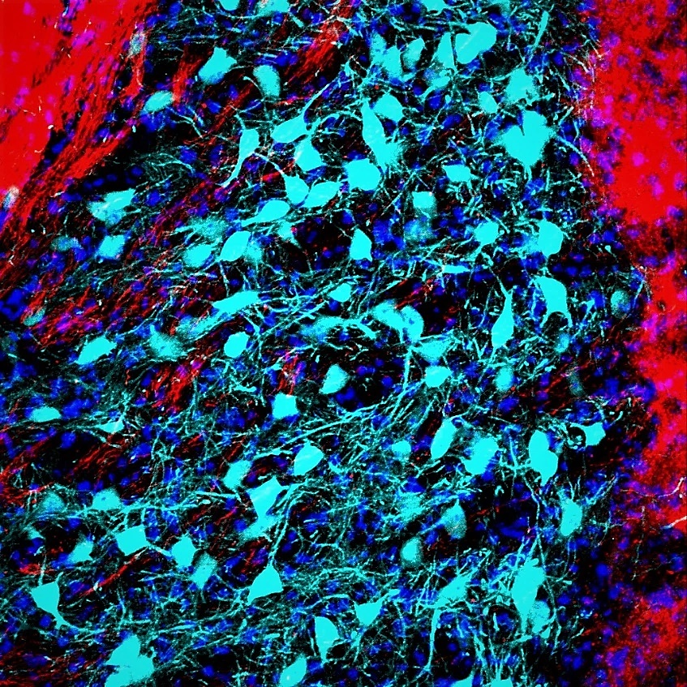

Confocal image of the nucleus of the globus pallidus external segment showing axonal fibres of ‘silenced’ layer 5 glutamatergic pyramidal neurons (red) and parvalbumin GABAergic interneurons (cyan). Calcium-dependent neurotransmission was abolished in layer 5 pyramidal neurons to investigate its effect on the density of parvalbumin interneurons.

File: Project Resume updated 190821-Molnar

