Updated Project Résumé August 2019
Project Title: Dynamics of cell behaviour during somite formation
Supervisor: Professor Claudio Stern
Student: Mr Adam Moverley

Somites are transient structures that form in a regular manner along the body axis of vertebrate embryos, which give rise to the characteristic segmental body pattern of vertebrae, skeletal muscles, dermal elements; they also direct the segmentation of adjacent tissues including motor nerves, sensory and autonomic ganglia and blood vessels. They form in head-to-tail sequence (90 min apart in the case of the chick), while new tissue is added from the primitive streak in the tail bud. Considerable work has been done on understanding the mechanisms responsible for controlling somite size and number and the rhythm of somitogenesis. Most effort has been devoted to studying the “segmentation clock”, a molecular oscillator that is thought to be responsible for this regulation. However, we know remarkably little about the cell behaviours controlled by these molecular events and how they generate the correct segmental pattern. Without this knowledge, it is impossible to understand the precise role of the “segmentation clock” in somitogenesis. This project aims to describe, in detail, the dynamics of cell and tissue changes that take place during somitogenesis, from a cell’s entry into the pre-somitic mesoderm at the tail to its emergence as a somite. The project is multidisciplinary and uses cutting edge techniques including super-resolution live microscopy to study a key morphogenetic process in vivo, and should reveal important information not only about somite formation but also about the general process of mesenchyme-epithelial transitions. The student will also be trained on computer programming (Python) and modelling.

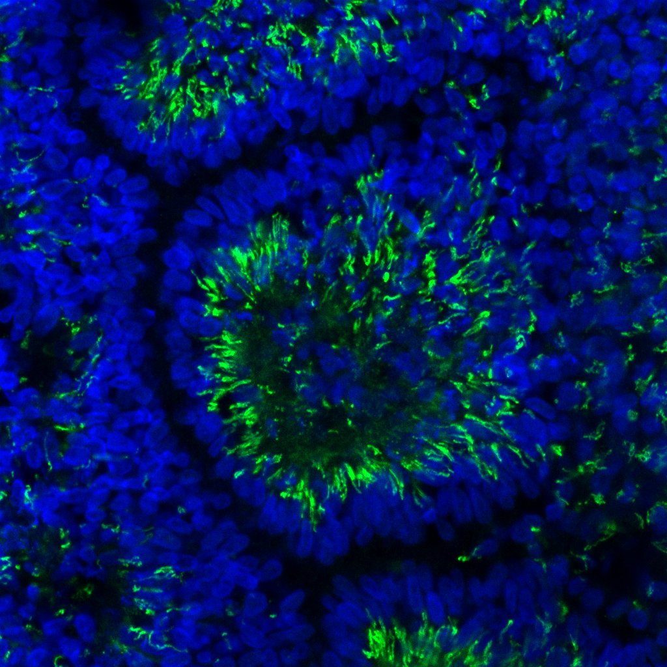

File: Project Resume updated August 2019 – Stern and Moverley

