UNDERGRADUATE SUMMER VACATION SCHOLARSHIP AWARDS – FINAL SUMMARY REPORT FORM 2017/18
NB: This whole report will be posted on the Society’s website therefore authors should NOT include sensitive material or data that they do not want disclosed at this time.

Name of student:
Kirsten Raphael
Name of supervisor(s):
Mrs Barbara Webb, Dr Ian Thompson
Project Title: (no more than 220 characters)
Engineering of an anatomically exact knee meniscus
Project aims: (no more than 700 words)
In Europe alone, more than 400.000 surgeries per year involve the knee meniscus, fibrocartilaginous structures composed of water (72%), collagens (22%) and glycosaminoglycans (0.8%). The lack of success in materials replacing meniscus tissue is possibly due to the inability of current materials to mimic the complex native meniscus anatomy.
The project aimed to fill the clinical need for new synthetic meniscal allograft materials. It intended to build a material that encourages biocompatibility, tissue integration and mechanical stability.
The objectives were:
  - Use 3D scans of a sample meniscus to create a negative mold from a 3D printer.
  - Produce a specialized, crosslinked material, consisting of hyaluronic acid with additives such as bioactive glass, collagen and silk fibroin.
  - Use the negative mold and the material to create an anatomically exact meniscus.
  - Perform mechanical testing (e.g. fatigue, compression, tensile) on the material.
  - Perform cell toxicity testing on the material.
Later in the project, the following objectives were added:
  - Use 3D scans of a sample meniscus to create a printable 3D model.
  - 3D print an artificial meniscus with flexible materials using the BCN Sigmax 3D printer.
  - Perform tensile testing on the 3D printed material.
  - Perform cell toxicity testing on the 3D printed material.
Project Outcomes and Experience Gained by the Student (no more than 700 words)
The initial idea was to develop a biocompatible material that was mechanically strong enough to endure the same forces as native meniscus tissue. Various materials such as hyaluronic acid and silk fibroin were to be chemically modified to create a strong and durable material, but the desired consistency was not achieved. It was therefore decided to use a 3D printer to print a meniscus shaped scaffold that could be backfilled with a material that would support the viability and proliferation of appropriate cells. The scaffolds were printed with a flexible material and would act as a support structure.

I became competent in cell culture methods, including cell resuscitation, cryopreservation and subculturing of adherent cells. For the first generation of the project, in which I tried to find mechanically strong biocompatible materials, I learnt various crosslinking and other chemically modifying techniques. I prepared and tested different materials and techniques, including methanol induced gelation of silk fibroin solution, carbodiimide crosslinking of hyaluronic acid, the mixing of bioactive glass and cellulose with silk and hyaluronic acid and calcium chloride crosslinking of gelatin-alginate blend films.

When the aforementioned materials failed to be sufficiently strong for our application, I moved to the 3D printing of a scaffold. I learnt about the theory of 3D printers and became competent in using the BCN3D Sigmax printer and Cura software. I initially used Ninjatek Cheetah flexible filament for the meniscus scaffold and tweaked the software and printer settings to optimise printing quality; I used soluble PVA filament to create support structures where needed.

In order to acquire the 3D printed native knee meniscus shape, we worked together with the King’s College London anatomy and dissection department. I dissected a freshly frozen knee, which taught me an incredible amount about knee anatomy and dissection techniques, and took out both the lateral and medial menisci. We used a Shining Einscan-Pro 3D scanner to scan the menisci and convert the images into G-code in Cura. I printed the menisci with varying infill and shell thickness to acquire a range of mechanical properties.

I printed ASTM tensile test specimens s of the Ninjatek Cheetah filament to test its mechanical properties; I used PLA filament as a control. I became competent in using the Instron machine and corresponding software and carried out tensile testing which showed that the Ninjatek Cheetah has favourable mechanical properties over PLA.

Finally, I filled the 3D printed menisci with a 7% alginate 8% gelatin solution which I crosslinked with a calcium chloride solution to achieve optimal mechanical and biocompatibility properties. I carried out cell proliferation experiments using Alamar Blue technique on the Ninjatek Cheetah, PLA and crosslinked and uncrosslinked gelatin alginate solution, which showed promising results for the Ninjatek Cheetah material as a biocompatible material.

Overall, the data I gathered over the course of this project showed that the 3D filament material used in this study was relatively biocompatible and had good mechanical stability, as well as the gelatin-alginate solution. The combination of these materials and others could be useful in the engineering of meniscus

Please state which Society Winter or Summer Meeting the student is intending to present his/her poster at:
Summer Meeting 2019

Proposed Poster Submission Details (within 12 months of the completion of the project) for an AS Winter/ Summer Meeting – (no more than 300 words)
Complex 3D printed knee meniscus implants with controllable degradability

It is proposed to test different flexible 3D filaments on mechanical properties and biocompatibility and print knee meniscus shaped implants. These implants can be designed according to the native meniscus anatomy, i.e. containing two different zones, and filled with materials that degrade at a different rate. This will ensure synchronous meniscus tissue integration and regeneration in vivo by allowing the control of cell migration. Using Live/Dead staining and Alamar Blue, the viability and proliferation of human chondrocytes and human dermal fibroblasts will be tested on the 3D filament materials and hydrogel materials with which the 3D printed meniscus scaffolds will be filled. The degradation rate of materials will be measured, as well as mechanical properties and toxicity.

Brief Resume of your Project’s outcomes: (no more than 200-250 words).
The title of your project and a brief 200-250 word description of the proposed/completed project. The description should include sufficient detail to be of general interest to a broad readership including scientists and non-specialists. Please also try to include 1-2 graphical images (minimum 75dpi). NB: Authors should NOT include sensitive material or data that they do not want disclosed at this time.
Engineering of an anatomically exact knee meniscus
The medial and lateral knee menisci are fibrocartilaginous structures that act as shock absorbers and load distributors. Injury to these structures can be debilitating to the patient and is incredibly common, with over 400.000 knee meniscus related surgical procedures being performed yearly in Europe alone. The treatment options are limited, and patients are often not able to return to full function again. The 3D printing sector is developing rapidly and is offering innovative solutions to medical problems. We proposed that a thorough understanding of the meniscus anatomy, an appreciation of nuances in individual patients’ shape of the meniscus, and the newest techniques in 3D printing can offer a line of medical devices that enhance clinical outcomes.
A Shining Einscan-Pro 3D scanner was used in combination with the Cura software and BCN3D Sigmax 3D printer to scan native meniscus tissue and print porous structures. Flexible Ninjatek Cheetah 3D printing filament was used and compared to polylactic acid (PLA) filament. Preliminary results showed that the flexible filament supported human dermal fibroblast (HDF) proliferation more than the PLA, as well as having favourable tensile properties, tested with an Instron machine. As a potential gel matrix to fill the porous 3D printed meniscus a 7% alginate 8% gelatin blend was prepared, which showed promising results with regards to biocompatibility. This project is being continued more in-depth and more results are being gathered.
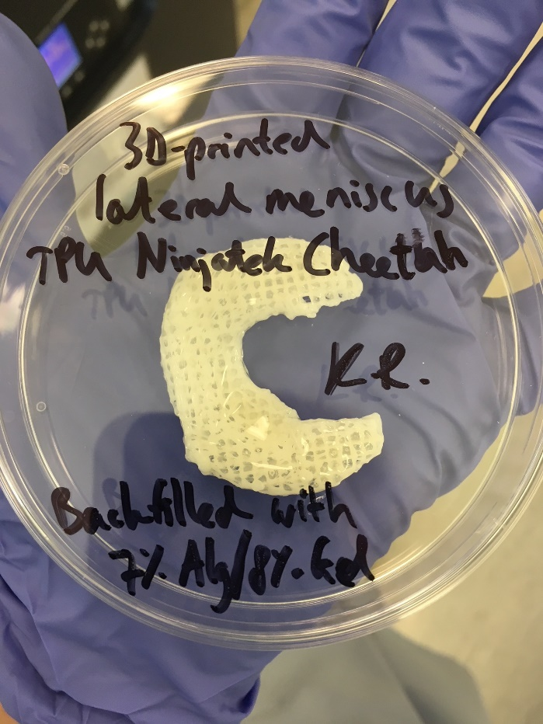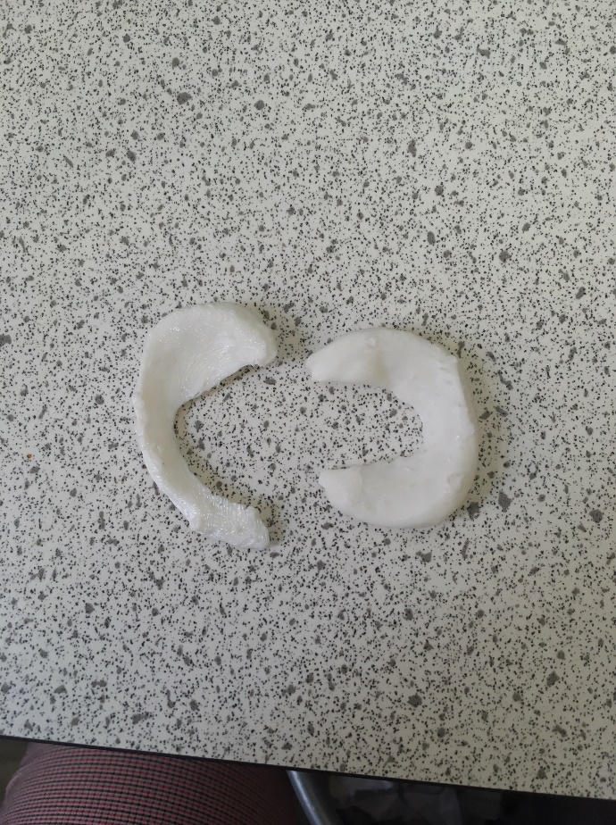

Figure 1: Porous 3D Printed meniscus with gel matrix Figure 2: Solid 3D printed meniscus

Other comments: (no more than 300 words)
I would like to highly commend Kirsten for her efforts during this 9-week project. The data obtained will allow this project to move forward into a more formal grant application mode. Additionally, Kirsten demonstrated a highly professional attitude during the first phases of this project when all experiments resulted in negative data. Many other students would have become disheartened and drift away from the challenge. However, Kirsten showed dogged determination and perseverance in pushing the development into positive results, which hopefully will move onto a clinically applicable device.
Dr Ian Thompson

Signature of student.... Ms Kirsten Raphael………… Date ………4th October 2018………….

Signature of supervisor…… Mrs Barbara Webb and Dr Ian Thompson…….............. Date……3rd October 2018…….…

END OF FORM
----------------------------------------------------------------------------------------------------------------------------------------
File: USVRS-AwardandBursaryTemplateLetter 2018-v3FINALGDPR-210518 – Mrs Barbara Webb

File: USVRS: 201718 – Report – WebbThompsonRaphael – nosigs- v1-151018

