UNDERGRADUATE SUMMER VACATION SCHOLARSHIP AWARDS – FINAL SUMMARY REPORT FORM 2021/22
NB: This whole report will be posted on the Society’s website therefore authors should NOT include sensitive material or data that they do not want disclosed at this time.

Name of student:
Diana (Dasha) Vezeleva
Name of supervisor(s):
Andrew A Pitsillides, Lucinda AE Evans
Project Title: (no more than 220 characters)
Dawning of a New ‘Phase’ in Contrast Imaging: Visualising Soft and Hard Joint Tissues
Project aims: (no more than 700 words)

High-resolution synchrotron phase-contrast X-ray (sCT) imaging has made it possible to view soft and hard murine knee joint tissues simultaneously. These images capture the whole, intact joint in ultra-thin slices which are stacked to form a 3D image, and thus also the position in 3D of individual cells within the joint tissues. While other forms of imaging (e.g. histology) are inherently destructive, or fail to show soft and hard tissues simultaneously without staining (e.g. microCT), phase-contrast sCT offers a modern solution to the former issues faced when attempting to view these contrasting tissue types.

A consequence of this new technique, allowing both hyaline and mineralized layers of cartilage to be clearly viewed in 3D (even down to cellular detail), has been the recent and surprising observation of chondrocytes which exist ‘half-in-half-out’ (HIHO) of the calcified and non-calcified cartilage layers. HIHO chondrocytes are unique in having their superficial half in hyaline articular cartilage (HAC), while the deep half is encased in articular calcified cartilage (ACC). Their existence challenges prior assumptions about chondrocytes, which have hitherto been thought of belonging discretely to one or another specific cartilage zone, rather than partially occupying different portions of each layer at the same time (Evans and Pitsillides, 2022).

The discovery of these HIHO chondrocytes has profound implications for osteoarthritis research, proving as it does that the vast majority of cartilage research has ignored an entire chondrocyte population. The unique location and complete dearth of prior research into these HIHO chondrocytes makes them an interesting group to explore – as does the fact that they are the most likely population to control the mineral/HAC interface, which becomes disrupted during the development and advance of osteoarthritis.

A greater understanding of the standard and pathological anatomy of the knee joint at the microscopic level will hopefully lead to greater appreciation of differences in healthy vs diseased joints as a whole, with the hope that the earliest detectable shift in joint pathophysiology will provide a meaningful target for therapy.

The primary aims of this project exploiting high-resolution sCT images were to:
1) use ‘gold standard’ methods of manual image segmentation to quantitatively measure the volume and prevalence of HAC, ACC and HIHO chondrocytes in intact knee joints;
2) to undertake statistical analyses to compare and contrast HAC, ACC and HIHO chondrocytes in intact knee joints in male mice of three different strains: CBA (healthy parental control), STR/Ort (with age-related osteoarthritis) and BLK-6 (a common research model with intermediate osteoarthritis predisposition); and
3) to compare and contrast findings between three different age groups, namely skeletally-immature (8-10 weeks), young adult (18-20 weeks) and aged mice (40+ weeks).

Project Outcomes and Experience Gained by the Student (no more than 700 words)

Project Outcomes
✓ This project has gathered the first quantitative data on HIHO chondrocytes, which have been previously unexplored, allowing researchers to begin to infer their potential role in the initiation and/or progression of osteoarthritis. This may have significant implications for novel treatments of osteoarthritis.
✓ These methods and models allowed quantitative comparisons of both volume and prevalence of HIHO chondrocytes in both young versus aged, as well as healthy versus osteoarthritic joints.
✓ Greater understanding of the advancements in imaging provided by High-Resolution sCT scanning and the new potential for more accurate analysis as a result.
✓ New, 3D data on HAC and ACC chondrocyte morphology in situ, unfixed and unstained, compared to previous research which has studied them in cell culture or 2D histology
✓ New, 3D data on HIHO chondrocyte morphology, which have been previously unexplored as a distinct cell type, and how they compare to cells in HAC and ACC layers.
✓ Knowledge of future research possibilities using sCT images and ideas for new avenues of exploration

Results which suggest:
✓ HIHO cells have a significantly smaller volume compared to strictly HAC or ACC cells
✓ Volume of cells decreases from HAC layer to HIHO, then increases from HIHO to ACC layer, with ACC cell volume larger on average than HAC cells
✓ Chondrocyte volume in STR-Ort (OA) is larger on average than in CBA mouse (healthy), supporting extensive previous research on the pattern of excessive chondrocyte hypertrophy in OA (Rim et. al., 2020)
✓ All conclusions are currently conditional on obtaining greater sample sizes of both OA and healthy mouse models with usable images

Personal Experience [gained]:
✓ Learned how to read CT images and identify different aspects of knee joint anatomy at the microscopic scale, including layers of cartilage and individual cells within the joint tissues
✓ Learned how to do manual segmentation and image analysis using CTAn software (Skyscan, Belgium)
✓ Learned how to perform statistical analyses in SPSS software, interpreting the output tables provided and making graphs of data
✓ Understand how to interpret results in data to broaden understanding of joint mechanics
✓ Learn how to work successfully as an individual, as well as within a team setting
✓ Broaden my understanding of bone and joint tissues and open the door to new ideas and possibilities
✓Public presentation of data at a Royal Veterinary College Skeletal Biology Group meeting

Please state which Society Winter or Summer Meeting the student is intending to present her poster at
Winter Meeting - January 2023

Proposed Poster Submission Details (within 12 months of the completion of the project) for an AS Winter/ Summer Meeting – (no more than 300 words)
Poster will include:
✓ Images produced by Synchrotron scanning along with descriptions of what is seen in the images and how they are quantitatively analysed in CTAn.
✓ Methods of image analysis, including a general description of the process of manual segmentation of individual chondrocytes (proper vs improper technique, possible issues, etc) including images which show examples of how cells look in each layer of cartilage.
✓ Brief description of output of “task list” run in CTAn and what the statistical values produced by task list indicate (individual 3-D analysis data vs. compiled 3-D analysis).
✓ Description of statistical analysis run in SPSS and why the specific test type was chosen.
✓ Conclusions of project overall, graphical representations of interactions between factors in data, and the potential future avenues of research highlighted by this project.
✓ Description of similarities and differences in chondrocyte morphology in different layers of cartilage as well as different strains of mouse, to show trends and possible outcomes of analysis.
Brief Resume of your Project’s outcomes: (no more than 200-250 words).
The title of your project and a brief 200-250 word description of the proposed/completed project. The description should include sufficient detail to be of general interest to a broad readership including scientists and non-specialists. Please also try to include 1-2 graphical images (minimum 75dpi). NB: Authors should NOT include sensitive material or data that they do not want disclosed at this time.

Dawning of a New Phase in Contrast Imaging: Visualising Soft and Hard Joint Tissues

High-resolution synchrotron phase-contrast X-ray imaging has made it possible to view soft and hard joint tissues simultaneously. This imaging technique allows individual cells to be visualised, and has illuminated the presence of chondrocytes existing ‘half-in-half-out’ (HIHO) of these two layers. HIHO chondrocytes are half located in a hyaline articular cartilage (HAC) environment, with the other half encased in the articular calcified cartilage (ACC). This makes them unique, and their location is at a critical tissue interface with possible roles in osteoarthritis pathophysiology. Despite this, very little is known about their formation, relationships and functions due to a prior dearth of non-destructive 3D imaging techniques.

This project has focused on quantifying the 3D morphology of HAC, HAC and HIHO chondrocytes, comparing data between healthy and OA mouse models. It has thus resulted in the collection and analysis of the first data on these unique HIHO cells, allowing researchers to begin to infer their potential role in the initiation and/or progression of osteoarthritis. This may have significant implications for future tissue-engineering based and novel targeted treatments of osteoarthritis.

Additionally, the comparison of HIHO chondrocytes to cells in neighbouring HAC and ACC layers has resulted in a greater understanding of how chondrocyte morphology changes as the cells travel from being progenitor cells at the superficial cartilage layer through hyaline cartilage toward the underlying ACC, in which they simultaneously undergo hypertrophy. Data from this project suggests that HIHO chondrocytes are significantly smaller in volume than those in neighbouring HAC or ACC layers, which was highly unexpected, challenging scientific dogma about chondrocyte biology and lifecycle.

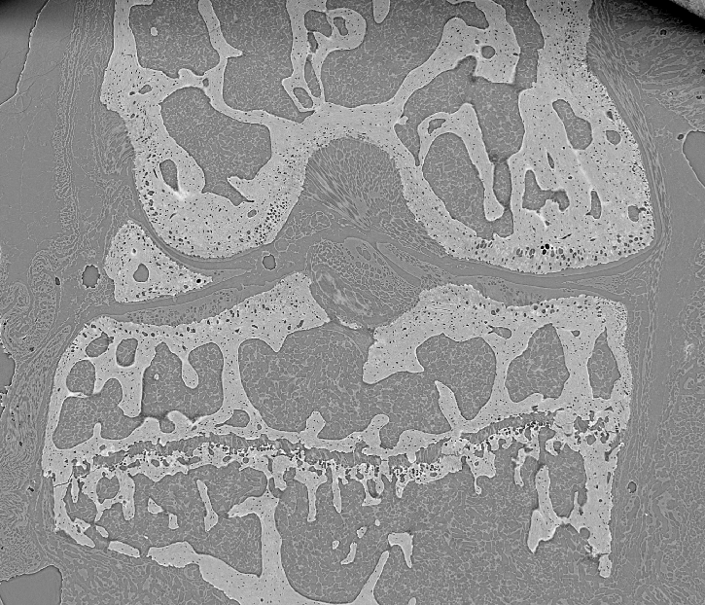
Synchrotron CT image of stifle joint in STR-Ort mouse taken at Diamond Light Source (Didcot).

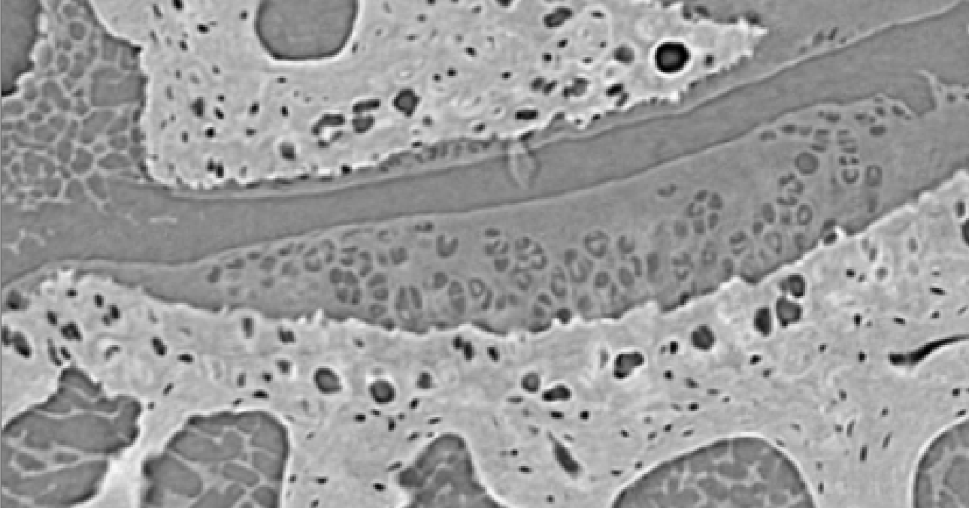
Same image zoomed in to show HAC, ACC and HIHO chondrocytes (top to bottom)

Other comments: (no more than 300 words)
Evans, L. A. E., Pitsillides, A. A. (2022). Structural clues to articular calcified cartilage function: a descriptive review of this crucial interface tissue.

Madi, K., Staines, K., Bay, B., Javaheri, B., Geng, H., Bodey, A., Cartmell, S., Pitsillides, A. and Lee, P., 2020. In situ characterization of nanoscale strains in loaded whole joints via synchrotron X-ray tomography. Nature Biomedical Engineering, 4(3), pp.343-354.

Rim YA, Nam Y, Ju JH. The role of chondrocyte hypertrophy and senescence in osteoarthritis initiation and progression. International Journal of Molecular Sciences. 2020; 21(7):2358. https://doi.org/10.3390/ijms21072358

Data Protection/GDPR: I consent to the data included in this submission being collected, processed and stored by the Anatomical Society. Answer YES or NO in the Box below
YES
Graphical Images: If you include graphical images you must obtain consent from people appearing in any photos and confirm that you have consent. A consent statement from you must accompany each report if relevant. A short narrative should accompany the image. Answer N/A not applicable, YES or NO in the box below
N/A
Copyright: If you submit images you must either own the copyright to the image or have gained the explicit permission of the copyright holder for the image to be submitted as part of the report for upload to the Society’s website, Newsletter, social media and so forth. A copyright statement must accompany each report if relevant. Answer N/A not applicable, YES or NO in the box below
YES - Took each image on my own

Signature of student.............Diana Vezeleva....................Date ………

Signature of supervisor………… Andrew Pitsillides …………………… Date………….…

