UNDERGRADUATE SUMMER VACATION SCHOLARSHIP AWARDS – FINAL SUMMARY REPORT FORM 2023/24
NB: This whole report will be posted on the Society’s website therefore authors should NOT include sensitive material or data that they do not want disclosed at this time.

Name of student:
Ruaraidh McCulloch
Name of supervisor(s):
Jenny Clancy
Project Title: (no more than 220 characters)
Composition of the human cervical vagus nerve and potential implications for vagus nerve stimulation
Project aims: (no more than 700 words)
Electrical stimulation of the cervical vagus nerve (VNS) has been approved for treatment resistant epilepsy in Europe and the USA for over 20 years and has been used to treat over 100,000 epilepsy patients [1]. VNS is also an approved therapy for treatment resistant depression in the USA and has been investigated as a potential therapy for a wide range of conditions including heart failure, inflammation, Alzheimer's disease, obesity and chronic pain [2]. However, the mechanisms of VNS are not fully understood and not all patients respond to VNS treatment [1].
One factor that may impact the effectiveness of VNS is the position of the electrode in relation to the fascicles and different nerve fibre types within the cervical vagus nerve. The limited data available on human vagus nerve morphology shows that the left vagus nerve (typically the side chosen for VNS to minimise effects on the sinoatrial node) has a significantly smaller surface area and fewer fascicles compared to the right [3]. Evidence from porcine vagus nerves shows that these fascicles relate to organotopic organisation of the cervical vagus nerve [4,5] suggesting that stimulation of specific fascicles may enable organ specific targeting of VNS. Furthermore, immunohistochemistry studies have detected positive tyrosine hydroxylase (TH) labelling in human cervical vagus nerves [7]. As TH is required for the synthesis of catecholamines, its presence suggests that the vagus nerve also contains sympathetic nerve fibres. This has potential implications for many of the experimental applications of VNS which aim to promote parasympathetic activity e.g. heart failure [2]. By potentially stimulating sympathetic fibres withing the vagus nerve, this may inadvertently counteract the intended parasympathetic stimulation effects of VNS. As such, detailed knowledge of the proportion and location of TH positive fibres within the cervical vagus nerve may help refine future VNS electrode positioning.

This study aimed to:
Determine the proportion and location of TH positive fibres within the cervical vagus nerve in humans.
Determine the number of fascicles in left and right vagus nerves at 3 levels; cranial, mid-cervical and caudal.
Determine the proportion of fibres at each level of the cervical vagus nerve that are TH positive and whether these are contained within specific fascicles or distributed more diffusely.
Propose optimal electrode positioning for cervical VNS in relation to the proportion and location of TH fibres.

References
González HFJ, Yengo-Kahn A, Englot DJ. Vagus Nerve Stimulation for the Treatment of Epilepsy. Neurosurg Clin N Am. 2019 Apr;30(2):219-230.
Clancy, J.A., et al., Non-invasive Vagus Nerve Stimulation in Healthy Humans Reduces Sympathetic Nerve Activity. Brain Stimulation, 2014. 7(6): p. 871-877.
Verlinden TJM, Rijkers K, Hoogland G, Herrler A. Morphology of the human cervical vagus nerve: implications for vagus nerve stimulation treatment. Acta Neurol Scand 2016: 133: 173–182.
Thompson N, Ravagli E, Mastitskaya S, Iacoviello F, Stathopoulou T-R , Perkins J et al. Organotopic organization of the porcine mid-cervical vagus nerve. Frontiers in Neuroscience, 2023. 17
Jayaprakash N, Song W, Toth V, Vardhan A, Levy T, Tomaio J, et al. Organ- and function-specific anatomical organization of vagal fibers supports fascicular vagus nerve stimulation. Brain Stimul. 2023 Mar-Apr;16(2):484-506. doi: 10.1016/j.brs.2023.02.003.
Ruigrok T J H, Mantel S A, Orlandini L, de Knegt C, Vincent A J P E, Spoor J K H. Sympathetic components in left and right human cervical vagus nerve: implications for vagus nerve stimulation. Frontiers in Neuroanatomy, 2023. 17
Project Outcomes and Experience Gained by the Student (no more than 700 words)
Approach
Seven formalin embalmed cadavers (1 male, 8 females) donated for anatomical education and research under the Anatomy Act (1984) and Human Tissue (Scotland) Act (2006) were used in this study (ethical approval therefore not required by UoG Ethics Committee). Using a textbook as a guide[1] , the right and left vagus nerve (VN) were dissected using the posterior di-gastric muscle as a superior border and the clavicle as an inferior border. The VN was then measured between these borders to determine the midpoint. The VN was sampled at the midpoint and approximately at the superior and inferior borders to produce three samples. During dissection, a thin physical connection between the sympathetic trunk (ST) and the VN was discovered on the right-hand side in two of the seven cadavers. These connections were sampled and labelled using neurofilament (Nf) immunohistochemistry to confirm if these connections contained neurons. Two sections of each sample were stained with Masson’s Trichrome to expose the fascicle organisation. Tyrosine Hydroxylase (TH) and Choline Acetyltransferase (ChAT) Immunohistochemistry were also completed for each sample level to show sympathetic and parasympathetic neuron distribution.

Project Outcomes
This project provided evidence of a neuronal connection between the vagus nerve (VN) and the sympathetic trunk (ST) within the cervical region.

The human vagus nerve has been considered anatomically separate from the sympathetic trunk as opposed to other mammals, such as dogs, that have a connected VN and ST known as the vagosympathetic trunk[2]. However, successful Nf-IHC of the two VN-ST connections proved a neural junction exists between the VN and ST in some humans at the cervical level. This challenges the concept of a completely distinct VN and ST, potentially indicating an evolutionary relic where these nerves remain linked at specific points. This discovery could also provide insight into the origin of TH-positive fibers within the vagus nerve as neurons definitively cross between the VN and the ST. TH-IHC was completed to determine this, but unfortunately the TH and ChAT immunohistochemistry failed, and no results were obtained. This means the connection content was unable to be determined. However, this opens an avenue for future research as this connection potentially contains the source of TH positive fibres found in the VN. If this is the case, electrode placement in vagus nerve stimulation should be above the VS-ST to avoid stimulating the sympathetic fibres.

Experience Gained
This project has allowed me to develop a broad range of skills that will assist my academic career as I pursue further research opportunities. By completing 14 vagotomies, I have greatly improved my dissection skills and received valuable practical experience in the neuroanatomy field. This has not only increased my dissection confidence, but also deepened my understanding of complex anatomical structures as well. Through preparing, mounting and staining a large sample of neural tissue, I have developed desirable IHC and problem-solving skills that will distinguish me from other candidates in both academic and research opportunities. In conclusion, the diverse set of skills I have developed during the Anatomical Society Undergraduate Summer Vacation Research Scholarship has given me a strong foundation for pursuing a career in research.
Refrences
[1] Loukas Marios MD PhD,Tubbs R. Shane PhD MSc PA-C,Benninger Brion MD MSc, Chapter 20 - Neck, Gray's Clinical Photographic Dissector of the Human Body (Second Edition), edited by Loukas Marios MD PhD,Tubbs R. Shane PhD MSc PA-C,Benninger Brion MD MSc, 2019, Pages 327-351, ISBN 978-0-323-54417-7, http://dx.doi.org/10.1016/B978-0-323-54417-7.00020-6.
(https://www.clinicalkey.com/student/content/book/3-s2.0-B9780323544177000206)
[2] Seki A, Green HR, Lee TD, Hong L, Tan J, Vinters HV, Chen PS, Fishbein MC. Sympathetic nerve fibers in human cervical and thoracic vagus nerves. Heart Rhythm. 2014 Aug;11(8):1411-7. doi: 10.1016/j.hrthm.2014.04.032. Epub 2014 Apr 24. PMID: 24768897; PMCID: PMC4108556.

Please state which Society Winter or Summer Meeting the student is intending to present his/her poster at:
Winter Meeting

Proposed Poster Submission Details (within 12 months of the completion of the project) for an AS Winter/ Summer Meeting – (no more than 300 words)

Brief Resume of your Project’s outcomes: (no more than 200-250 words).
The title of your project and a brief 200-250 word description of the proposed/completed project. The description should include sufficient detail to be of general interest to a broad readership including scientists and non-specialists. Please also try to include 1-2 graphical images (minimum 75dpi). NB: Authors should NOT include sensitive material or data that they do not want disclosed at this time.

Title: Composition of the human cervical vagus nerve and potential implications for vagus nerve stimulation.

Vagus nerve stimulation (VNS) is used to treat conditions such as treatment resistant depression and heart failure due to the parasympathetic qualities of the vagus nerve (VN). However, there are limited reports of tyrosine hydroxylase (TH) positive fibres within the vagus nerve[1]. These fibres indicate sympathetic neurons, and their stimulation would potentially reduce the effectiveness of VNS. Furthermore, the source of the TH-positive fibres is unknown. However, VN ganglia have been shown to be TH-positive and physical connections between the VN and sympathetic trunk (ST) have been recorded in dogs[2].

During the dissection of seven cadavers, two were identified to have a physical connection between the right-hand side VN and ST. These connections were sampled and underwent Neurofilament immunohistochemistry. The Nf-IHC produced positive results for both connections, confirming a neural junction exists between the VN and ST at the cervical level.

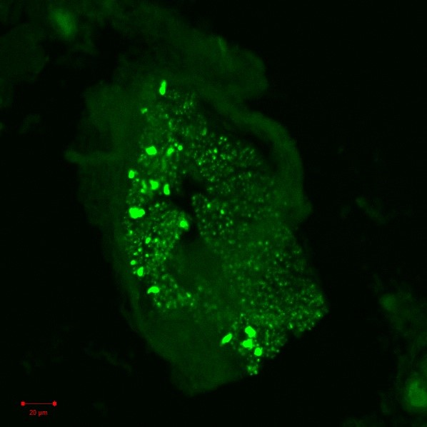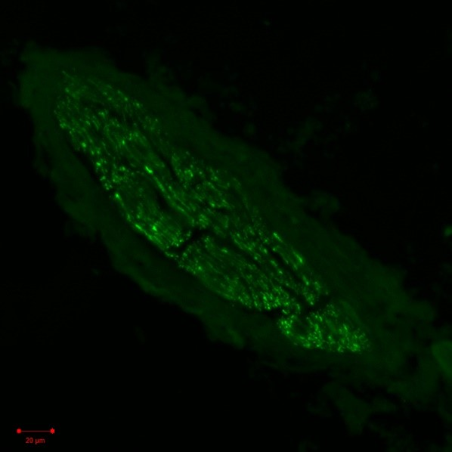
Figure 1. Neurofilament positive vagus-sympathetic connection.

This challenges the concept of a distinct VN and ST within humans; potentially indicating an evolutionary relic where these nerves remain linked at specific points. However, the prevalence of this connection within the population requires further study. As this discovery could indicate the origin of TH-positive fibers within the vagus nerve, TH-immunohistochemistry was completed, but no results were able to be obtained. This opens an avenue for future research as the fibre type of this connection still needs to be determined. If this connection did contain TH-positive fibres, electrode attachment in VNS should be above the connection to avoid stimulating the sympathetic fibres.

[1] - Ruigrok, T.J.H., Mantel, S.A., Orlandini, L., de Knegt, C., Vincent, A.J.P.E. and Spoor, J.K.H. (2023). Sympathetic components in left and right human cervical vagus nerve: implications for vagus nerve stimulation. Frontiers in Neuroanatomy, [online] 17, p.1205660. doi:https://doi.org/10.3389/fnana.2023.1205660.
[2] - Seki, A., Green, H.R., Lee, T.D., Hong, L., Tan, J., Vinters, H.V., Chen, P.-S. and Fishbein, M.C. (2014b). Sympathetic nerve fibers in human cervical and thoracic vagus nerves. Heart Rhythm, 11(8), pp.1411–1417. doi:https://doi.org/10.1016/j.hrthm.2014.04.032.

Other comments: (no more than 300 words)

Data Protection/GDPR: I consent to the data included in this submission being collected, processed and stored by the Anatomical Society. Answer YES or NO in the Box below
YES
Graphical Images: If you include graphical images you must obtain consent from people appearing in any photos and confirm that you have consent. A consent statement from you must accompany each report if relevant. A short narrative should accompany the image. Answer N/A not applicable, YES or NO in the box below
YES

Copyright: If you submit images you must either own the copyright to the image or have gained the explicit permission of the copyright holder for the image to be submitted as part of the report for upload to the Society’s website, Newsletter, social media and so forth. A copyright statement must accompany each report if relevant. Answer N/A not applicable, YES or NO in the box below
YES

Signatureof student: ….Ruaraidh McCulloch………………….Date: 07/09/2024

Signature of supervisor…… Jennifer Clancy ………….............. Date…09/09/2024……….…

END OF FORM
-------------------------------------------------------------------------------------------------------------------------------------
File: USVRS 2024 Report Clancy and McCulloch website version no sig uploaded 230924

