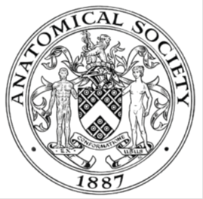
_______________________________________________________________________________________
AWARDEE REPORT FORM
_______________________________________________________________________________________

NAME |  | Isabel Leighton
TWITTER HANDLE* optional
UNIVERSITY |  | University of Liverpool
NAME OF AWARD |  | Barclay-Smith
PURPOSE OF AWARD conference/event attended/organised (full name) with city and dates.
Anatomical Society Winter Meeting
6-8th January 2025
University College of Lancashire, Preston

REPORT: What were your anticipated benefits?
Minimum number of words between 200-400. Please write in coherent paragraphs.
As an undergraduate student, attending academic conferences can be challenging due to financial constraints. Receiving the Barclay-Smith Award allowed me to fund my travel, accommodation, and registration for the Winter Anatomical Society Conference at the University of Central Lancashire – my first-ever conference.
One of the key benefits of attending the conference was the opportunity to present my poster on the research I conducted as a part of the student summer vacation research scholarship. Presenting my findings to experienced researchers in the field of anatomy enhanced my confidence and communication skills while allowing me to receive valuable feedback that could help to refine my work. Engaging with academics and researchers helped to broaden my perspective and deepen my understanding of anatomical sciences.
Beyond presenting, attending talks and networking with professionals expanded my knowledge of current research and potential career pathways. Exposure to the current cutting-edge studies, and the technologies being used within them, reinforced my enthusiasm for anatomy and research, motivating me to seek further opportunities in the field.
Without this award, I would not have been able to participate in such a transformative experience. The conference provided invaluable academic and professional benefits, shaping my aspirations and further solidifying my commitment to anatomical sciences.

COMMENTS: Describe your experience at the conference / lab visit / course / seminar/ event.
Minimum number of words between 200-400. Please write in coherent paragraphs.
I began my conference by participating in a pre-conference workshop organised by Maryam Rajid and Elena Patera. This workshop demonstrated some of the different imaging modalities used in anatomy teaching settings through presentations, group discourse, tutorials and games. I enjoyed attending the pre-conference workshop due to its interactive nature, this gave me a chance to connect with other attendees before the conference began. I also attended the afternoon workshop centred on EDI in anatomical education. In this workshop we were shown resources that had been created by the EDI committee within the anatomical society and was asked to discuss and evaluate them. As one of the only undergraduate students attending, I was able to provide the student perspective on these resources. Discussing my evaluation with the other attendees was a valuable opportunity to develop my communication and critical thinking skills.
I attended every talk given over the course of the conference. This taught me how research is presented to the scientific community and how this is done well. I gained a greater understanding of the current research being done in anatomical education and imaging.
In the evening of the first day, I presented my poster, an experience I thoroughly enjoyed. Sharing my experiences of researching and the results gained to fellow anatomists was exciting. From the conversations I had while presenting my poster I gained confidence and a better understanding of how to convey and discuss my work to scientific peers.
Participating in both the Early career social and Gala dinner were fantastic opportunities to engage with other anatomists. From these events I made excellent connections with not only other early career members but senior members.
REPORT: In relation to skills, what were the most important things you gained? (does not apply to equipment grant. For public engagement/outreach awards what did your audience gain and how did you evaluate success?
Minimum number of words between 200-400. Please write in coherent paragraphs.
Prior to attending the conference, I had not experienced discussing research or networking in an academic setting. One of the most important skills I developed was effective communication with academic peers. Engaging in discussion about my own research, as well as others’ work, helped me to articulate scientific concepts more clearly and confidently. Additionally, listening to experienced anatomists present their research provided valuable insight into how to structure and deliver engaging presentations, thereby improving my own presentation skills.
Attending the workshops also strengthened my teamwork abilities, as a collaborated with peers I would not typically work with. This experience allowed me to adapt to different working styles and contribute effectively within a group setting. Furthermore, evaluating various Equality, diversity and inclusion (EDI) resources expanded my understanding of these issues within anatomy and improved my critical thinking skills.
Beyond these specific skills, the experience as a whole significantly boosted my confidence. I now feel more self-assured when engaging with academic peers, delivering presentations, and asking insightful questions. These skills will be invaluable as I progress in my academic career, particularly in future research projects, conference presentations, and collaborations. Overall, attending the conference has not only improved my academic and professional skills, but has also reinforced my passion for anatomy and research.

REPORT: How do you think you will put this learning experience into practice in the future? For public engagement/outreach awards how with the materials/knowledge generated by this activity be used in the future?
Minimum number of words between 200-400. Please write in coherent paragraphs.
Attending the Winter conference has provided me with invaluable skills that I will apply throughout my future academic and professional journey. One of the most significant takeaways from this experience has been enhancing my ability to deliver effective presentations. Observing experienced professionals present their research has given me insight into structuring and communicating complex ideas clearly to an audience. This will be particularly beneficial when presenting my undergraduate dissertation, allowing me to convey my findings with confidence and professionalism. Additionally, these presentation skills will support me in future conferences, seminars, and even workplace settings where clear communication is essential.
Furthermore, the conference has significantly improved my networking abilities. Engaging with other anatomists has helped me develop the confidence to initiate meaningful conversations and build professional relationships. This will be an essential skill in the future as I progress through my academics and beyond, enabling me to collaborate effectively with peers, mentors and colleagues.
Additionally, the critical thinking skills I developed during the workshops will support my ability to analyse research and resources, ask insightful questions and engage more deeply with my studies. These skills will be invaluable as I pursue further education and professional opportunities. Overall, this experience has prepared me to engage more actively in academic discussions, present my work confidently, and seek new opportunities for growth in the field of anatomy.

Data Protection/GDPR: I consent to the data included in this submission being collected, processed and stored by the Anatomical Society. Answer YES or NO in the Box below
YES

Graphical Images: If you include graphical images you must obtain consent from people appearing in any photos and confirm that you have consent. A consent statement from you must accompany each report if relevant. A short narrative should accompany the image. Answer N/A not applicable, YES or NO in the box below
YES

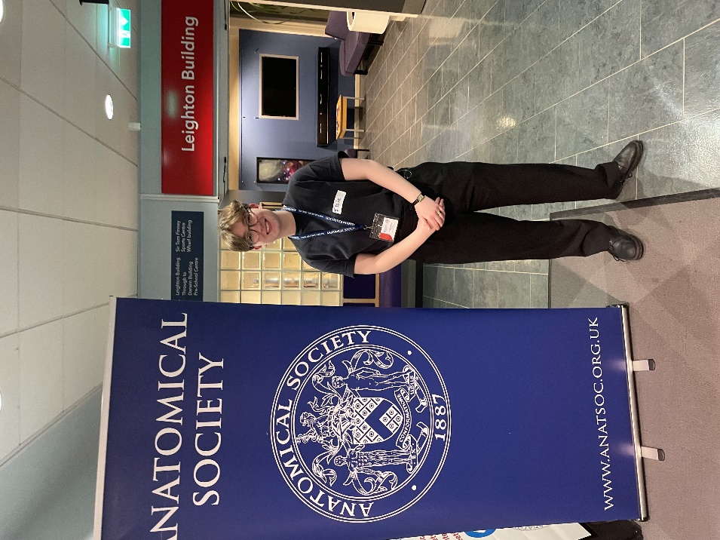

Above is a picture of myself beside the anatomical society banner. I was not able to take pictures beside my poster due to the sensitive nature of the photographs within the poster, therefore I stood next to the banner to show my presence at the conference.

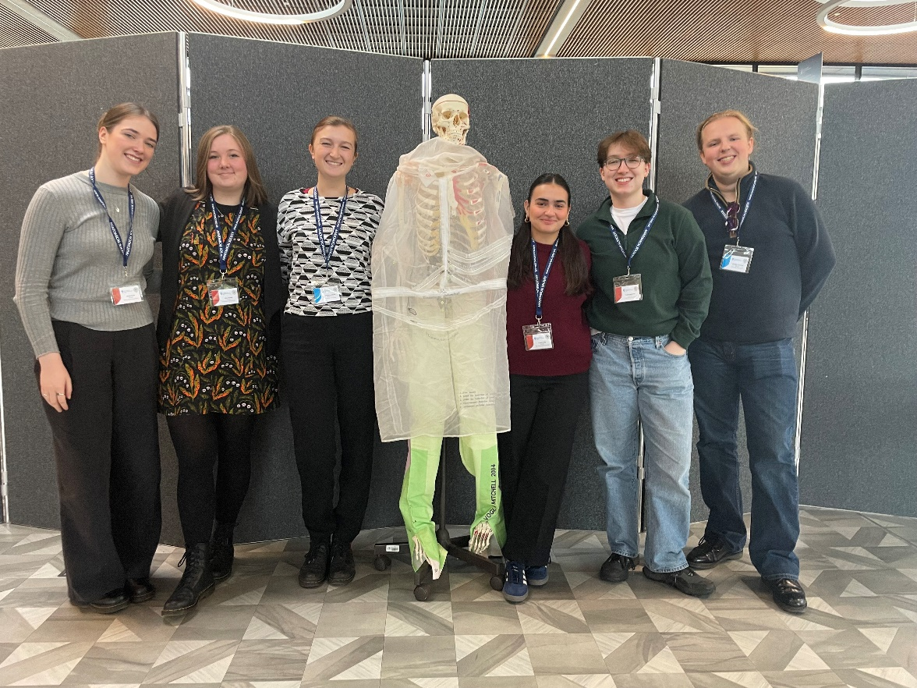

Pictured here is myself and fellow early career anatomists. We became fast friends over the course of the conference. We supported each other during presentations, navigating the conference and during down time.

Copyright: If you submit images you must either own the copyright to the image or have gained the explicit permission of the copyright holder for the image to be submitted as part of the report for upload to the Society’s website, Newsletter, social media and so forth. A copyright statement must accompany each report if relevant. Answer N/A not applicable, YES or NO in the box below
YES
SIGNATURE | Isabel Leighton |  | DATE | 25/02/2025
If submitted electronically, a type-written name is acceptable in place of a hand-written signature
File: AS-Award-Report-Form-171023 – International Conference

